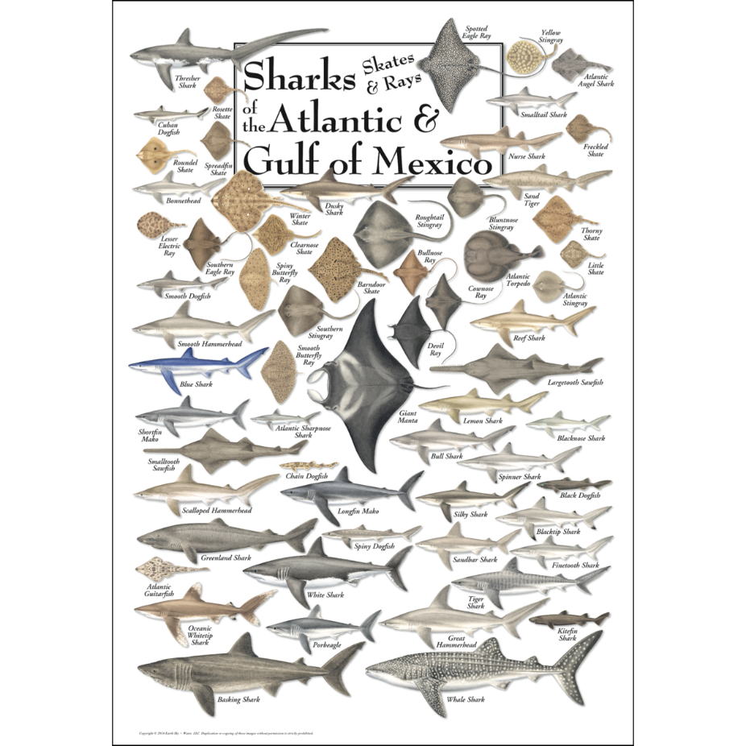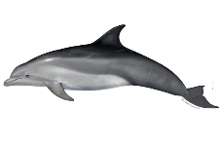**Marine mammals**

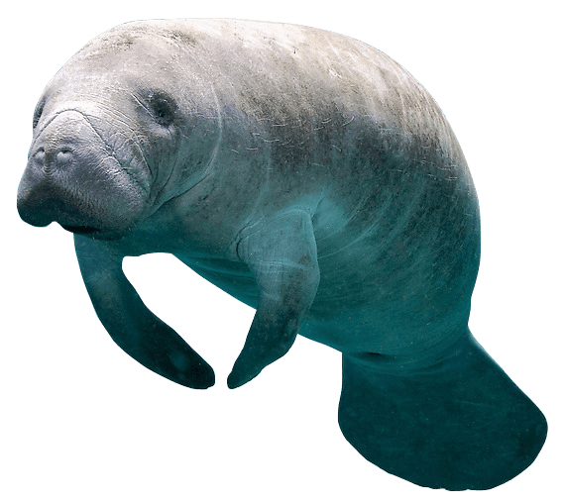1.Dolphin

2.Manatee

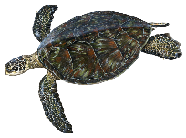**Marine reptiles**

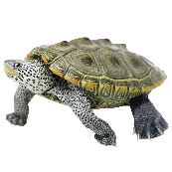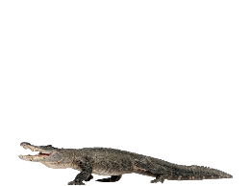1.Sea turtle (green)

2.Diamondback terrapin

3.Alligator

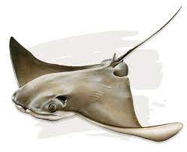**Elasmobranchs**

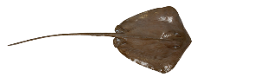Cownose stingray

Southern stingray

Sharks (bull, bonnethead, nurse, tiger,

black tip, hammerhead, lemon, blacknose)

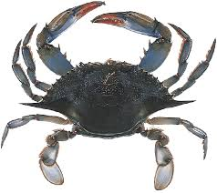**Crustaceans 1**

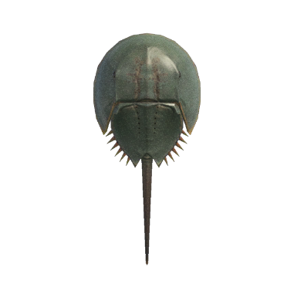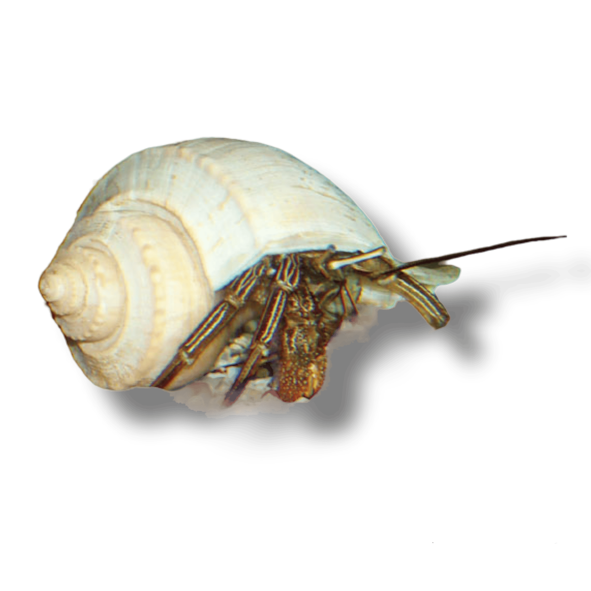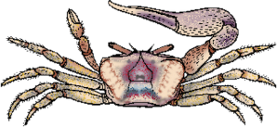1.Blue crab

2.Fiddler crab **2**

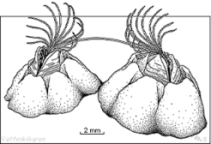3.Hermit crab **3**

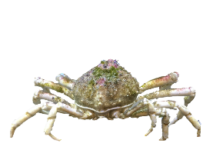4.Horseshoe crab **4**

5.Spider crab **5 6**

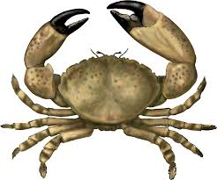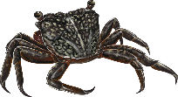6.Barnacle

7.Mangrove tree crab **7 8**

8.Stone crab **9**

9.Mud crab

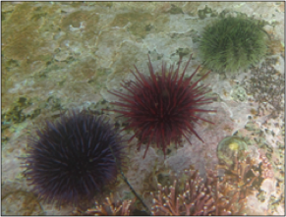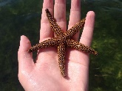**Enchionderms**

1.Sea star **1 2**

2.Sea urchin

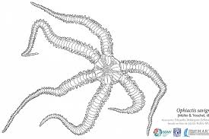3.Brittle stars **3**

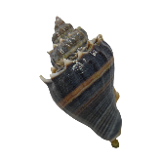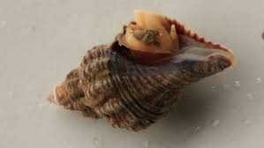**Univalves**

1.Crown conch  **1 2**

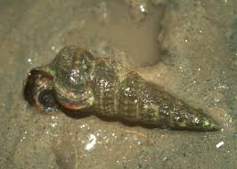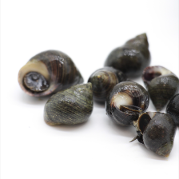2.Oyster drill

3.Periwinkle snail **3 4**

4.Ladder horn snail

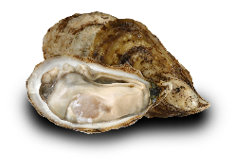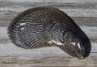**Bivalves**

1.Ribbed Mussel **1 2**

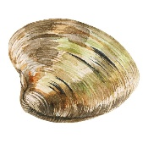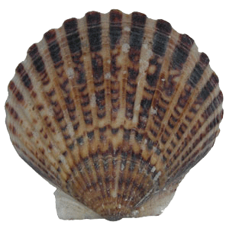2.Eastern Oyster

3.Scallop **3 4**

4.Calm

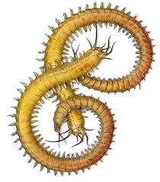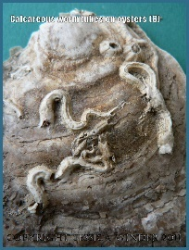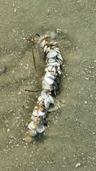**Annelids**

1.Decorator worm **1 2 3**

2.Tube worm

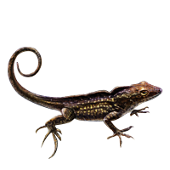3.Polycheate

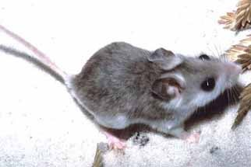**Terrestrial animals**

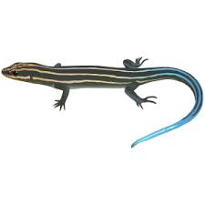1.Lizard (Brown anole) **1 3**

2.5-lined Skink **2**

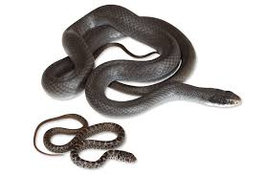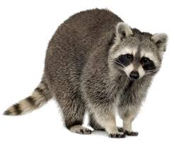3.Mouse

4.Raccoon **4 5**

5.Black racer

**Aves**

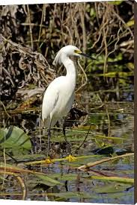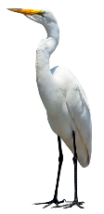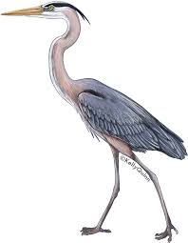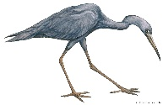1.Little blue heron **1 2 3**

2.Great blue heron  **4**

3.White egret

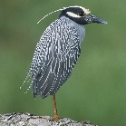4.Snowy egret **5**

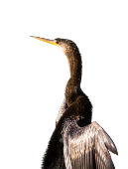5.Double crowned night heron

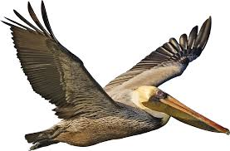6.Cormorant **6 7 8**

7.Anhinga

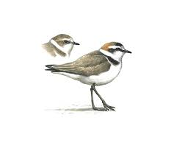8.Pelican

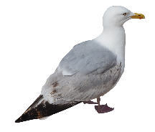9.Common tern **9**  **10** **11**

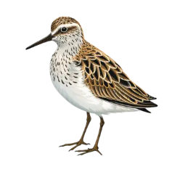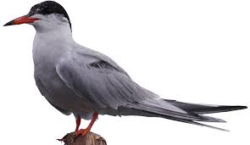10.Seagull

11.Plover **12**

12.Sand piper

13.Clapper rail

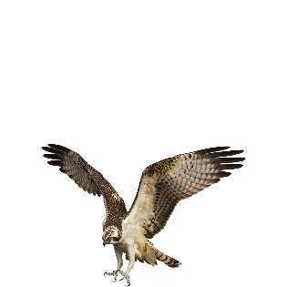14.Osprey  **14**

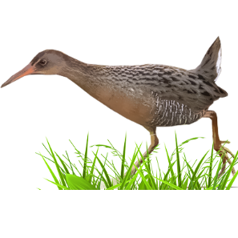15.Bald eagle **1 3 15**

