Zone 1 Plant Map

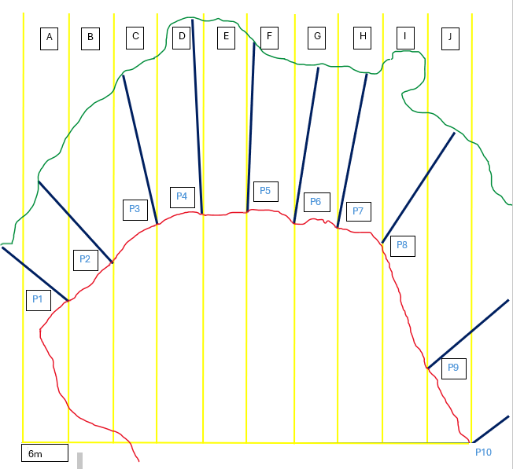
28.283410
82.751834

28.283303
82.751609

28.283362
82.751695

28.283403
82.751764

28.283389
82.751945

28.283376
82.752019

28.283311
82.752091
28.283221
82.752157
28.283168
82.752175
28.283245
82.752145
Key
Mean High Water Line Seagrass Boundary
Intertidal Profile line Zone 1 Plant Section

Native and invasive species

Zone: __________ Section: ____________

Native / Invasive N ______________________ W_______________________
Native / Invasive N ______________________ W_______________________
Native / Invasive N ______________________ W_______________________
Native / Invasive N ______________________ W_______________________
Native / Invasive N ______________________ W_______________________
Native / Invasive N ______________________ W_______________________
Native / Invasive N ______________________ W_______________________
Native / Invasive N ______________________ W_______________________
Native / Invasive N ______________________ W_______________________
Native / Invasive N ______________________ W_______________________

Planted Species
Zone: ___________ Section: ____________

Species: _____________________ N _________________________ W ________________________
Species: _____________________ N _________________________ W ________________________
Species: _____________________ N _________________________ W ________________________
Species: _____________________ N _________________________ W ________________________
Species: _____________________ N _________________________ W ________________________
Species: _____________________ N _________________________ W ________________________
Species: _____________________ N _________________________ W ________________________
Species: _____________________ N _________________________ W ________________________
Species: _____________________ N _________________________ W ________________________
Species: _____________________ N _________________________ W ________________________

