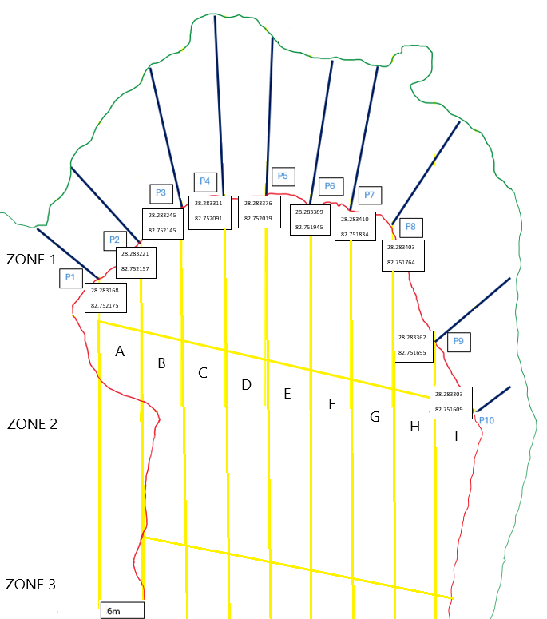
PLANT ZONE 2
Native and invasive species

Species in Zone: _______(1-5) Section: _________(A-I) Removal: _________(kg)

Native / Invasive N ______________________ W_______________________
Native / Invasive N ______________________ W_______________________
Native / Invasive N ______________________ W_______________________
Native / Invasive N ______________________ W_______________________
Native / Invasive N ______________________ W_______________________
Native / Invasive N ______________________ W_______________________
Native / Invasive N ______________________ W_______________________
Native / Invasive N ______________________ W_______________________
Native / Invasive N ______________________ W_______________________
Native / Invasive N ______________________ W_______________________

Planted Species
Zone: ________(1-5) Section: _________(A-I)

Species: _____________________ N _________________________ W ________________________
Species: _____________________ N _________________________ W ________________________
Species: _____________________ N _________________________ W ________________________
Species: _____________________ N _________________________ W ________________________
Species: _____________________ N _________________________ W ________________________
Species: _____________________ N _________________________ W ________________________
Species: _____________________ N _________________________ W ________________________
Species: _____________________ N _________________________ W ________________________
Species: _____________________ N _________________________ W ________________________
Species: _____________________ N _________________________ W ________________________

