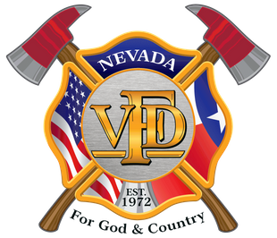

Chili Cook-Off Sponsorship Form

Name: ________________________________
Company: _____________________________
Telephone: ____________________________
Email: ________________________________

Level: (circle one)
Top Sponsor/Chili Cook-Off Judge - $100
(ONLY 6 SPOTS AVAILABLE)

General Sponsor - $50

Information: Deadline September 15, 2018.
Please submit form, money, and company logo by this date.

Inquiries and logos, please send to staci.stough@nevadavfd.org

