Summer

Nativity Lutheran Church
1079 Bethlehem Church Road, Bethlehem GA 30620
nativitybethlehemga.org

GATHERING

Confession and Forgiveness
Blessed be the holy Trinity, ☩ one God, the creator of wind and rain, field and ocean, the bread of life coming down from above, the power at work within us and this world.
Amen.
Before God and in the company of our sisters and brothers, let us confess our sin.
Silence is kept for reflection.
God and Father of all,
we confess that we have sinned against you in thought, word, and deed. We have thought better of ourselves than others. We have told lies, said hurtful things, acted in ways we wish we could take back, and looked the other way when action was needed. In your mercy, O God, forgive us, cleanse us, and heal us, for the sake of Jesus, our Savior. Amen.

If anyone is in Christ, there is a new creation: everything old has passed away; everything has become new! In Christ, ☩ you are a new creation: your sins are taken away and you are made new. Be kind to one another, tenderhearted, forgiving one another, as God in Christ has forgiven you.
Amen.

GATHERING HYMN: Hymn 876

gREETING
We are a people Christ prays for! Feel the power of the Holy Spirit blow through your life! Feel the call, respond with praise!
Thanks be to God!

Kyrie
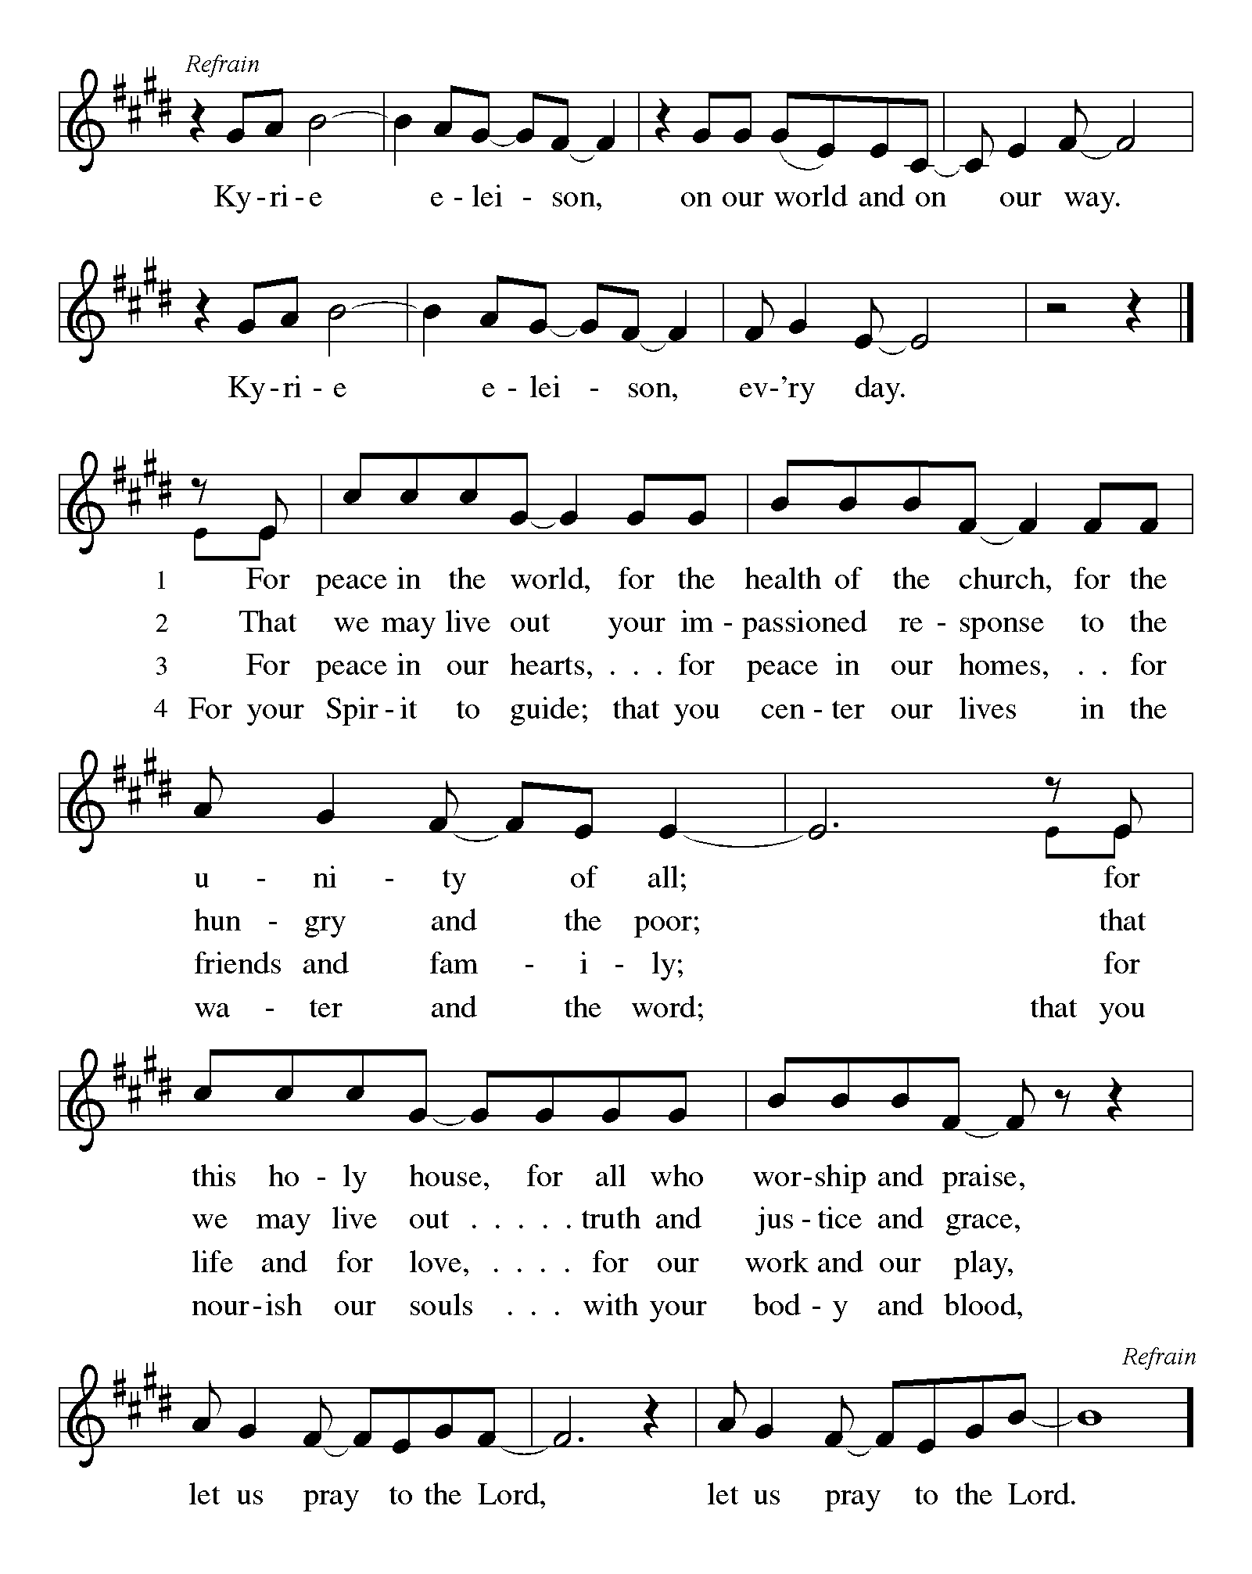

Hymn of praise
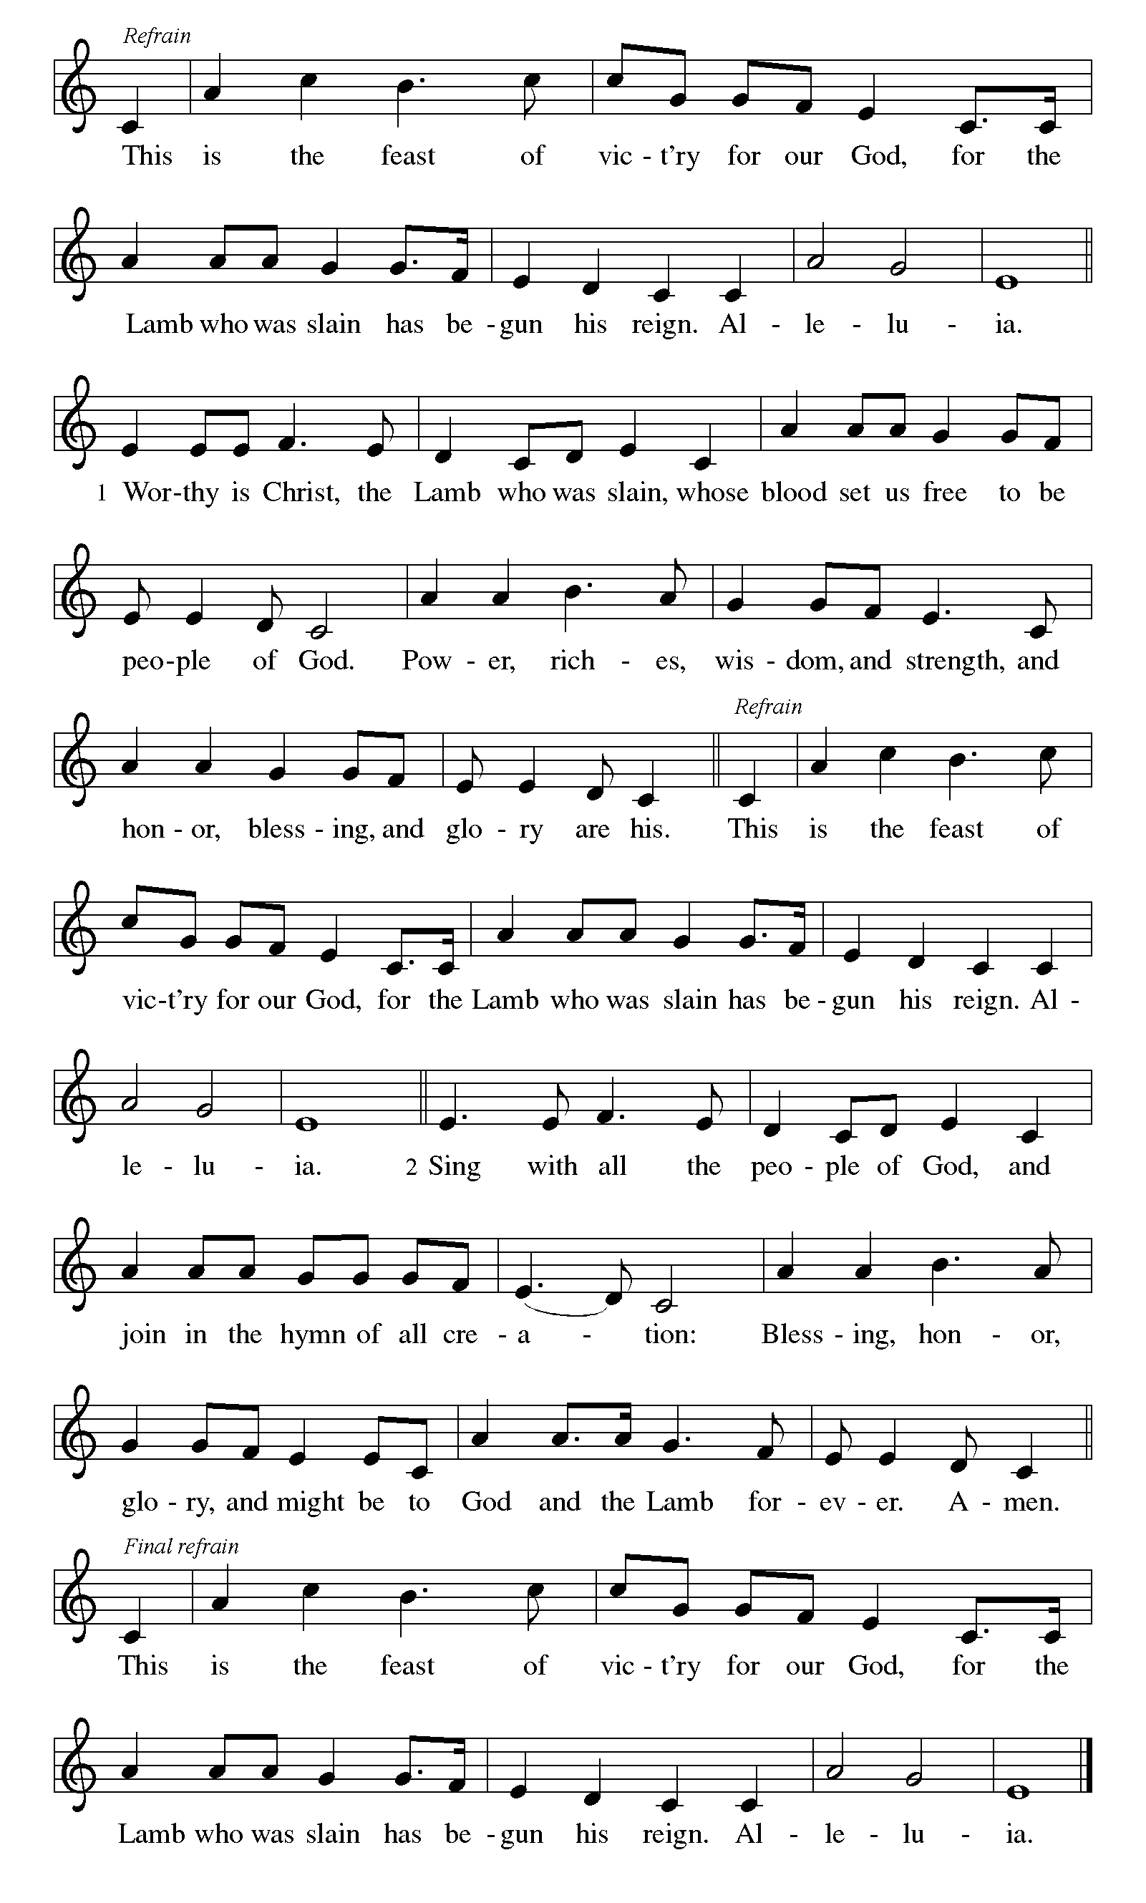
Prayer of the Day
You are great, O God, and greatly to be praised. You have made us for yourself, and our hearts are restless until they rest in you. Grant that we may believe in you, call upon you, know you, and serve you, through your Son, Jesus Christ, our Savior and Lord. Amen.
WORD

first reading: zechariah 9:9-12
⁹Rejoice greatly, O daughter Zion! Shout aloud, O daughter Jerusalem!
Lo, your king comes to you; triumphant and victorious is he, humble and riding on a donkey, on a colt, the foal of a donkey. ¹⁰He will cut off the chariot from Ephraim and the war-horse from Jerusalem; and the battle bow shall be cut off,
and he shall command peace to the nations; his dominion shall be from sea to sea, and from the River to the ends of the earth. ¹¹As for you also, because of the blood of my covenant with you, I will set your prisoners free from the waterless pit. ¹²Return to your stronghold, O prisoners of hope; today I declare that I will restore to you double.

Holy Wisdom, Holy Word Thanks be to God
PSALM: 145:8-14
⁸The Lord is gracious and full of compassion, slow to anger and abounding in steadfast love. ⁹Lord, you are good to all, and your compassion is over all your works. ¹⁰All your works shall praise you, O Lord, and your faithful ones shall bless you. ¹¹They shall tell of the glory of your kingdom and speak of your power, ¹²that all people may know of your power and the glorious splendor of your kingdom. ¹³Your kingdom is an everlasting kingdom; your dominion endures throughout all ages. You, Lord, are faithful in all your words, and loving in all your works. ¹⁴The Lord upholds all those who fall and lifts up those who are bowed down.

SECOND READING: Romans 7:15-24a
¹⁵I do not understand my own actions. For I do not do what I want, but I do the very thing I hate. ¹⁶Now if I do what I do not want, I agree that the law is good. ¹⁷But in fact it is no longer I that do it, but sin that dwells within me. ¹⁸For I know that nothing good dwells within me, that is, in my flesh. I can will what is right, but I cannot do it. ¹⁹For I do not do the good I want, but the evil I do not want is what I do. ²⁰Now if I do what I do not want, it is no longer I that do it, but sin that dwells within me.
²¹So I find it to be a law that when I want to do what is good, evil lies close at hand. ²²For I delight in the law of God in my inmost self, ²³but I see in my members another law at war with the law of my mind, making me captive to the law of sin that dwells in my members. ²⁴Wretched man that I am! Who will rescue me from this body of death? ^{25a}Thanks be to God through Jesus Christ our Lord!

Holy Wisdom, Holy Word Thanks be to God

Gospel Acclamation “Halle, Halle, Hallelujah” ELW 172

Gospel: Matthew 11:16-19, 25-30
The Announcement of the Gospel Glory to You, O Lord

[Jesus spoke to the crowd saying:] ¹⁶“To what will I compare this generation? It is like children sitting in the marketplaces and calling to one another, ¹⁷‘We played the flute for you, and you did not dance;
we wailed, and you did not mourn.’ ¹⁸For John came neither eating nor drinking, and they say, ‘He has a demon’; ¹⁹the Son of Man came eating and drinking, and they say, ‘Look, a glutton and a drunkard, a friend of tax collectors and sinners!’ Yet wisdom is vindicated by her deeds.”
²⁵At that time Jesus said, “I thank you, Father, Lord of heaven and earth, because you have hidden these things from the wise and the intelligent and have revealed them to infants; ²⁶yes, Father, for such was your gracious will. ²⁷All things have been handed over to me by my Father; and no one knows the Son except the Father, and no one knows the Father except the Son and anyone to whom the Son chooses to reveal him.
²⁸“Come to me, all you that are weary and are carrying heavy burdens, and I will give you rest. ²⁹Take my yoke upon you, and learn from me; for I am gentle and humble in heart, and you will find rest for your souls. ³⁰For my yoke is easy, and my burden is light.”
The Gospel of the Lord Praise to you, O Christ

SERMON

HYMN OF THE DAY No. 611

APOSTLES’ CREED
I believe in God, the Father almighty, creator of heaven and earth.

I believe in Jesus Christ, God's only Son, our Lord, who was conceived by the Holy Spirit, born of the virgin Mary, suffered under Pontius Pilate, was crucified, died, and was buried; he descended to the dead. On the third day he rose again; he ascended into heaven, he is seated at the right hand of the Father, and he will come to judge the living and the dead.

I believe in the Holy Spirit, the holy catholic church, the communion of saints, the forgiveness of sins, the resurrection of the body, and the life everlasting. Amen

Prayers of Intercession: Congregational response is “Your Mercy is great”

Called into unity with one another and the whole creation, let us pray for our shared world.
A brief silence.
We pray for the church. Sustain us as we share your word. Embrace us as we struggle to find our common ground. Lift up leaders with powerful and prophetic voices. Free us from stagnant faith. Hear us, O God. Your mercy is great.

We pray for the well-being of creation. Protect the air, water, and land from abuse and pollution. Free us from apathy in our care of creation and direct us toward sustainable living. Hear us, O God. Your mercy is great.

We pray for the nations (especially the United States and Canada, celebrating their nationhood). Guide leaders in developing just policies and guide difficult conversations. Free us from patriotism that hinders relationship-building. Lead us to expansive love for our neighbor. Hear us, O God. Your mercy is great.

We pray for all in need. For all who are tired, feeling despair, sick, or oppressed especially those we name in our hearts and on our lips . . . . Take their yoke upon you and ease their burdens. Give your consolation and free us from all that keeps us bound. Hear us, O God. Your mercy is great.

We pray for this congregation. Bless pastors, deacons, and congregational leaders. Energize children’s ministry volunteers, church administrators, and those who maintain our building. Shine in this place that we might notice the ways your love transforms our lives. Hear us, O God. Your mercy is great.

Drawn into the love of God most high, we pray for the congregations of the Magi Conference. This week we pray for Living Grace Lutheran Church in Tucker and their Pastor David Hardy. May they be guided by Christ’s love for all people as they love and serve their neighbors. Hear us, O God, Your mercy is great.

We give thanks for those who have died in faith (especially). Welcome them into your eternal rest and comfort us in our grief until we are joined with them in new life. Hear us, O God. Your mercy is great.
Receive these prayers, O God, and those too deep for words; through Jesus Christ our Lord. Amen.

peace
The Peace of Christ be with you all And also with you

OFFERING
We ask you to follow the example of unbridled stewardship and generosity of the early church. Many of us are unable to give as we were before the shelter in place order, and it will take time to recover. God knows and understands. Gifts come in many different forms. If you are able to give, fulfill your pledge, or in some way contribute, we can and will use any gifts you give to be God’s hands in our community, as we always have done and always will do. Thank you, in advance, for your generosity, stewardship, and unselfish love of your brothers and sisters.

OFFERING HYMN “Let the Vineyards” ELW 184

OFFERING PRAYER (Please pray together)
God of mercy and grace, the eyes of all wait upon you, and you open your hand in blessing. Fill us with good things at your table, that we may come to the help of all in need, through Jesus Christ, our redeemer and Lord. Amen.

Gathered into one by the Holy Spirit, let us pray as Jesus taught us
Our Father, who art in heaven, hallowed be thy name. Thy kingdom come, they will be done, on earth as it is in heaven. Give us this day our daily bread; and forgive us our trespasses, as we forgive those who trespass against us; and lead us not into temptation but deliver us from evil. For thine is the kingdom and the power, and the glory, forever and ever. Amen

Blessing
Almighty and merciful God, Father, ☩ Son, and Holy Spirit, bless, preserve, and keep you this day and forevermore. Amen

SENDING HYMN No. 888

Dismissal
Go in peace. Live in love, as Christ loved us.
Thanks be to God.

