**FOUR FLAGS APPLE FESTIVAL**

**HARVEST MARKET**

**-CONCESSIONS-**

**2020**

Dear Participant,

The Harvest Market will be held on Saturday, September 26, 2020 thru Sunday September 27, 2020. The market hours are Saturday 10 A.M. until 7 P.M. and Sunday 10 A.M. until 4 P.M. **All times are Michigan time**. The Market is on the corner of 17th St and Lake St. in Niles, Michigan.

We have 20 booths that rent for $250 or $275 (depending on electric needs) per booth for both days. Booth assignments will be based on date application is received and any special requests. The Booths will be spaced out 12 feet to help with physical distancing.

Checks can be made payable and mailed to to: Four Flags Apple Festival

1286 S. 13th St

Niles, MI 49120

If your contract is accepted, you will receive a confirmation and two parking passes. Please submit payment and application by September 4, 2020. You will also receive an informational page that includes directions for parking, hotel and camping information, rules and additional information not included in the application.

The Harvest Market is open to hand-craft, commercial, business, produce, and food vendors.

**ABSOLUTELY NO PETS ALLOWED !!!!!!**

Set-up times are Friday 1 P.M. until 7 P.M. and Saturday 7:30 A.M. until 9:00 A.M.

When you arrive you will need to check in and pickup you **packet**.

Please note that masks are recommended per the governor’s orders. **If the market has to be cancelled due to state restrictions, a full refund will be granted.**

If you have any questions, please contact us. We are hoping to have a great show and look forward to seeing you!

Arts and Craft Vendors Contact:

Christine Konkey

269.845.9012

guigirl@sbcglobal.

Concession Vendors Contact:

Brad Walter

269.340.7450

[iamformsu@gmail.com](mailto:iamformsu@gmail.com)

All other vendors Contact:

Abby Zeider

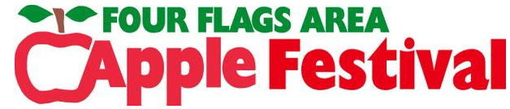269.470.0223

azeider@yahoo.com