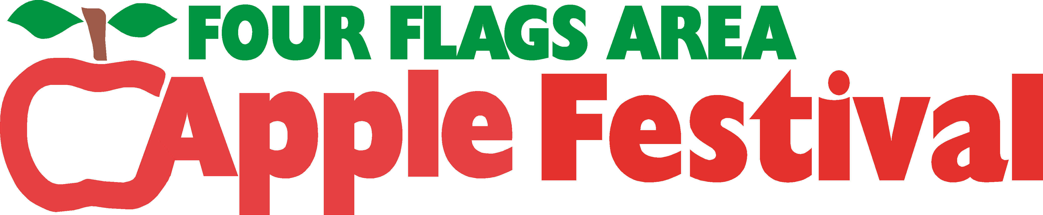

30th Annual Lip Sync Contest
Special Prize Money for 30th!

*Contest will be held on the Apple Festival grounds Sunday, Sept 29th, 2019 at 1:00 p.m.

*Registration & Review will be held at the Apple Festival grounds Sunday, Sept 15th.
Registration from 10:00 to 11:00 am. or by mail postmarked by Sept 13. Review starts at 1:00 p.m.
If you are pre-registered (mailed in form), please be there ½ hr. prior to review (12:30 pm) to check in.

Age Groups: 7-12, 13-17, and 18 Over

- You must be at the review held Sept 15th to be in the contest on Sept 29th!
- Your act must family oriented & acceptable for all ages. Max song time: 4 min.
- Apple Festival has the right to disqualify any acts we deem inappropriate.
- You must wear exactly the same costume and have the same props at the review as at the contest.
- No cassette tapes allowed and CD must be ready at time of review.
- The Four Flags Area Apple Festival will not be responsible for accidents or injuries during the review or contest.
- No more than 4 people per group and only one entry per person per group.
- Insurance disclaimers, available at the review must be filled out before you can be in the review.

FOR MORE INFORMATION CALL: Stacy Walsh 269-591-9858 or Pat Teeter 574-210-7888

Prizes: 1st - $400, 2nd - $200, 3rd - $100 in all 3 age groups
Mail entry forms to: Stacy Walsh P.O. Box 672 Niles, MI 49120

Names(s) & Ages:

Address:

Contact Person: Phone:

Song Title & Artist:
You will be judged on Creativity, Originality, Lip Sync Ability, and Overall Appearance, props included. Be Creative!!

