OFFCIAL ENTRY FORM

AUBURN NY USBC BOWLING ASSOCIATION
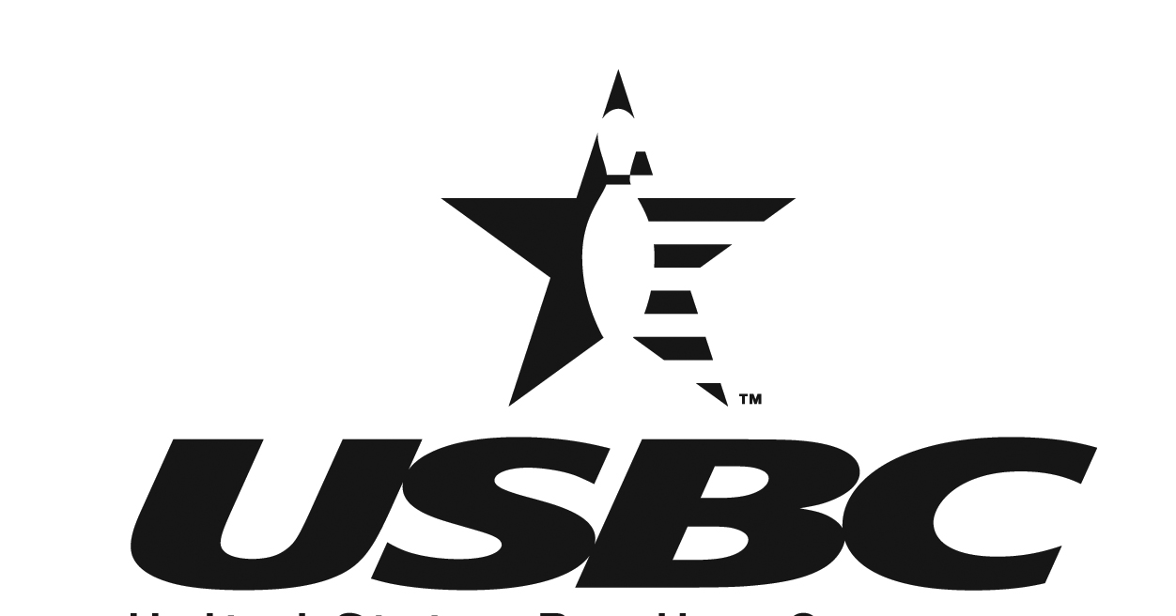
SENIOR SINGLES CHAMPIONSHIP TOURNAMENT

USBC CERTIFIED
OPEN TO BOTH MEN AND WOMEN
You need not belong to a Senior League to enter

ENTRY FEE - $22.00
MARCH 13, 2022 1:00 pm
Rainbow Lanes Auburn, NY

TOURNAMENT CLASSIFICATION ENTRY FEE BREAKDOWN

75 & OVER CLASS AA PRIZE FEE $11.00
70 - 74 CLASS A BOWLING & EXPENSE FEE 11.00
65 - 69 CLASS B
60 - 64 CLASS C TOTAL ENTRY FEE $22.00
55 - 59 CLASS D
50 - 54 CLASS E
Divisions (classification) will be separate for men and women

Prize fee returned 100% - Prize ratio 1 in 10 entries

PLEASE COMPLETE THE ENTRY FORM BELOW

NAME ___________________________________________________

ADDRESS _____________________________________________

CITY ________________________ STATE _______ ZIP _________

PHONE NO. ___________________________

HIGHEST AVERAGE ____________ (See rule #4)

D/O/B ________________ CLASSIFICATION _______________ USBC# __________________

PAIR WITH _____________________________________

Mail entries & entry fee to: Auburn NY USBC BA
c/o Robert Dellostritto
2420 Turnpike Rd
Auburn, NY 13021
Make checks payable to the “Auburn NY USBC BA”
RULES
AUBURN NY USBC BA – SENIOR SINGLES TOURNAMENT
Please retain this portion

- All entrants must be sanctioned bowlers in the Auburn NY USBC BA for the 2021-2022 season.
- Age as of March 1, 2022 will determine which age group the bowler must participate. All entrants must be at least 50 years of age. Proof of age may be required.
- The tournament consists of a handicapped 3- game singles event.
- Entrants shall use their highest USBC average as a regular bowler or as a substitute bowler in the following order:
  - 2020-2021 winter season, 21 games or more.
  - 2021 summer season, 21 games or more.
  - If a & b do not apply average as of January 1, 2022, of 21 games or more.
  - If a-c does not apply average of minimum of 12 games as of the day of the tournament.
  - All others will bowl scratch.
  - USBC rules 319- A-2 (10 pin increase provision), 319-D-E and Rule 319-A-3 will apply. Each bowler must verify their average. Management reserves the right to re-rate or reject any entrant.
      - Women’s handicap will be 100% of the difference between the entrant’s average and 200. Men’s handicap will be 100% of the difference between the entrant’s average and 225.
      - Cash prizes will be awarded on a handicap basis, at least one in every ten entries. All prize fees collected in a division shall be returned 100% in that division.
      - In the event of a tie for first place in any division, prize money will be combined and divided equally.
      - The winner in each division will have their singles event entry fee paid for the New York State USBC Open or Women’s Senior Singles, if they plan to attend. NYS Open Senior Singles October 2022 and NYS Women’s Senior Singles August 2022.
      - The Auburn NY USBC BA representatives to the NYS USBC BA Senior Singles Tournament will be determined by the highest pin fall with handicap in each classification. If the 1st place winner is unable to attend, alternate selections will be made in order of finish from the top three in each division. In case of a tie for first place, the highest single game of the series with handicap will determine the winner.
      - All protests should be filed with the tournament director and must comply with Rule 329. Any variation in the rules shall be decided by the tournament committee.
      - Entrants should arrive 30 minutes prior to the beginning of the squad.

