OFFICIAL ENTRY BLANK
2023 UNC WOMEN’S MASTERS
BOWLING TOURNAMENT
Sanctioned by the United States Bowling Congress
Conducted by the Auburn NY USBC Bowling Association

FIRST PLACE - $500.00
Based on 50 entries
Prize Ratio: At least 1 out of 10: Prize fee returned 100%

ELIGIBILITY RULE: Open to all who are certified in the Auburn NY USBC for the 2022-2023 season and any non-resident bowlers who are certified by the Auburn NY USBC for the 2022-2023 season and are of amateur status. Entries may sanction at the time of the tournament.

QUALIFYING AT FALCON LANES
3 games across 6 lanes
Sunday January 8, 2023 – 11:00 am

MATCH PLAY ROUNDS (Top 16)
Saturday January 14, 2023 – Qualifiers at Starlite Lanes
1:00 pm/4:00 pm
Finals
Saturday January 21, 2023 at King Ferry Bowling Center
(Final 8) 11:00 am - Finish
Sunday January 22, 2023 – Finals at King Ferry Bowling Center
11:00 am until completion

ENTRY FEE - $40.00…………$5.00 deposit must accompany application

ENTRY FEE REAKDOWN - Prize Fee $16.00 – Bowling Fee $23.00 – Expense Fee $1.00

DRESS CODE: PROPER ATTIRE REQUIRED – NO TANK TOPS – NO TORN JEANS

ENTRIES CLOSE WHEN FIRST SQUAD BEGINS

RESERVATION FORM

NAME: ______________________________________ PHONE: ________________

ADDRESS: ___________________________________ E-MAIL: _______________

SANCTION # ___________ PAIR WITH _______________________________________________

SEND ENTRY FORM: Bob DelloStritto
2420 Turnpike Rd
Auburn, NY 13021
(315) 246-

Make checks payable to “Auburn NY USBC ” DO NOT SEND CASH

OUR SPONSORS…

UKRANIAN NATIONAL CLUB OF AUBURN

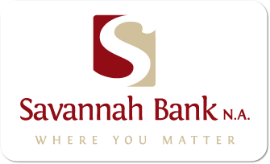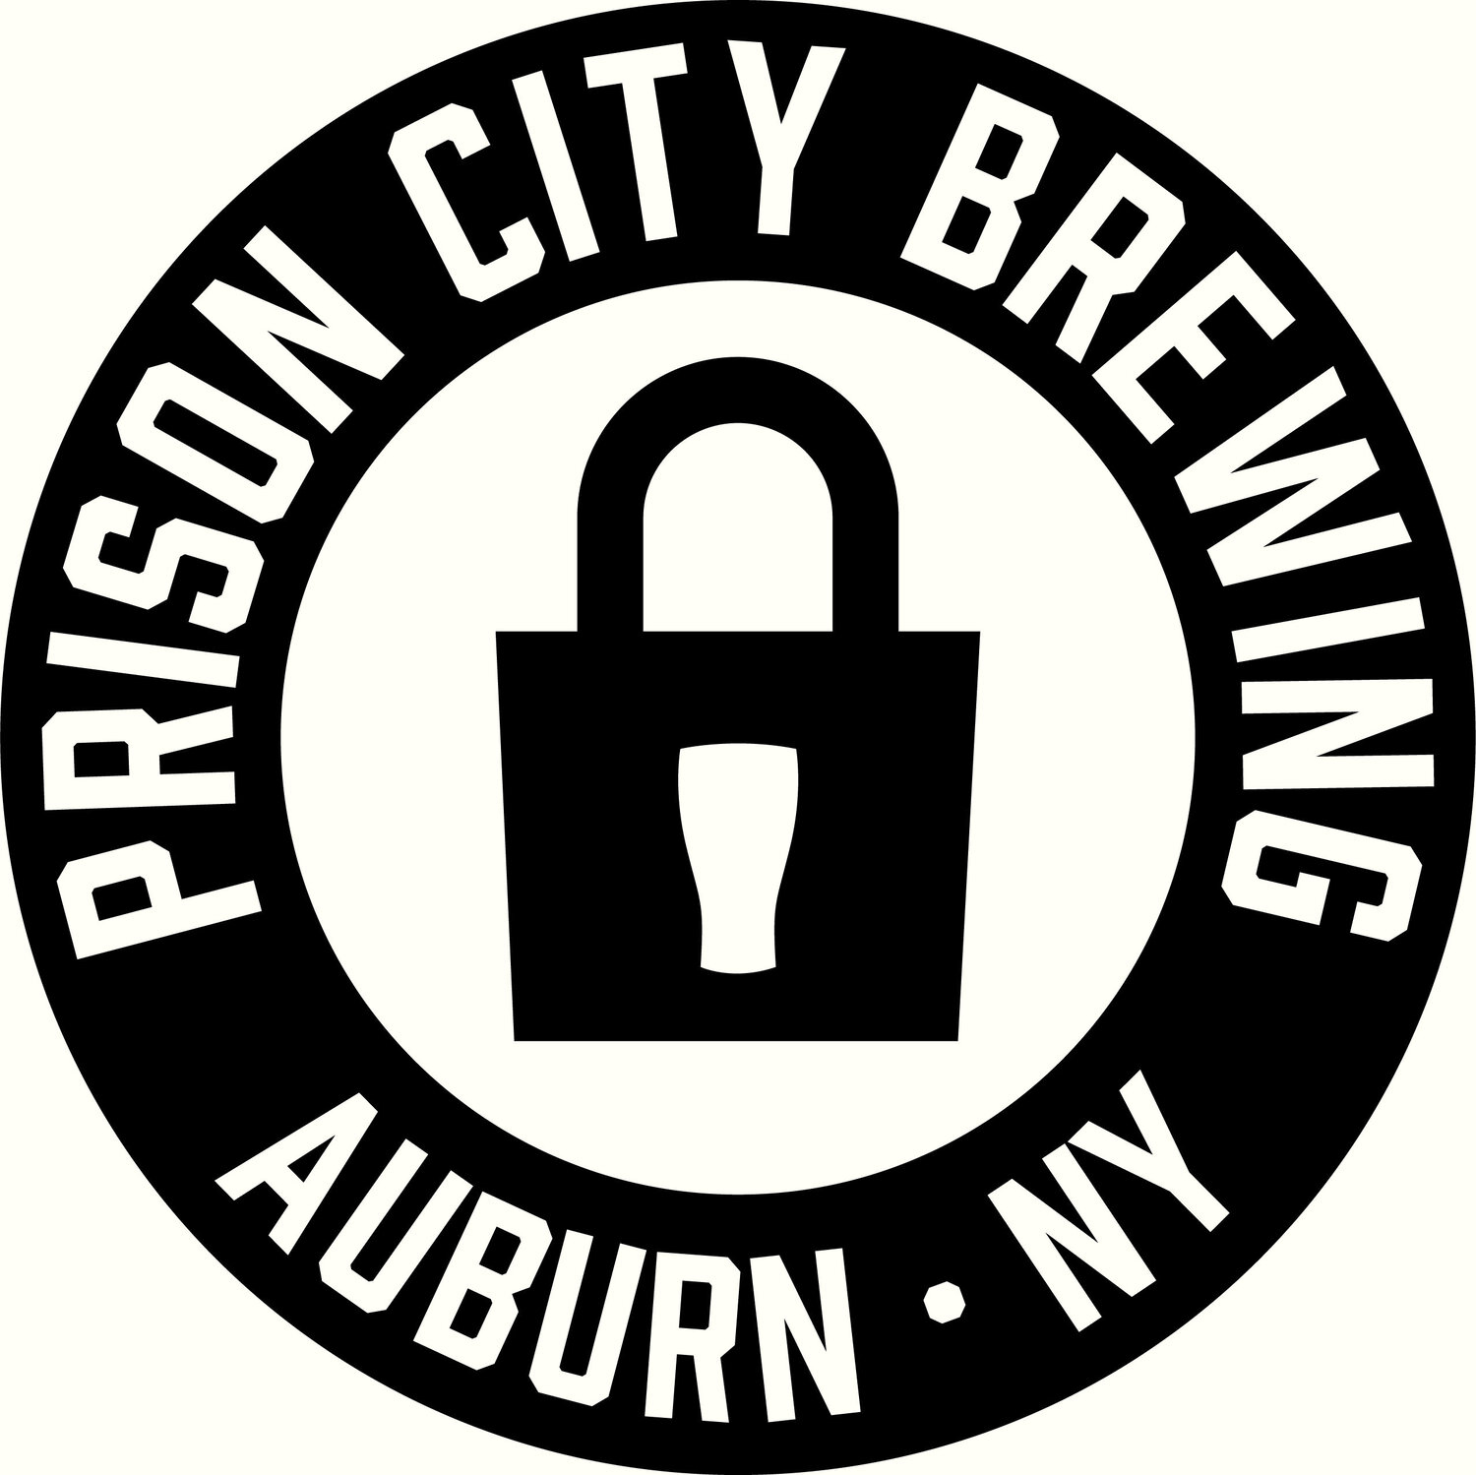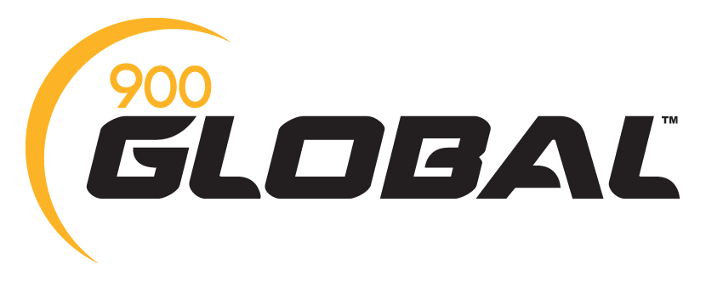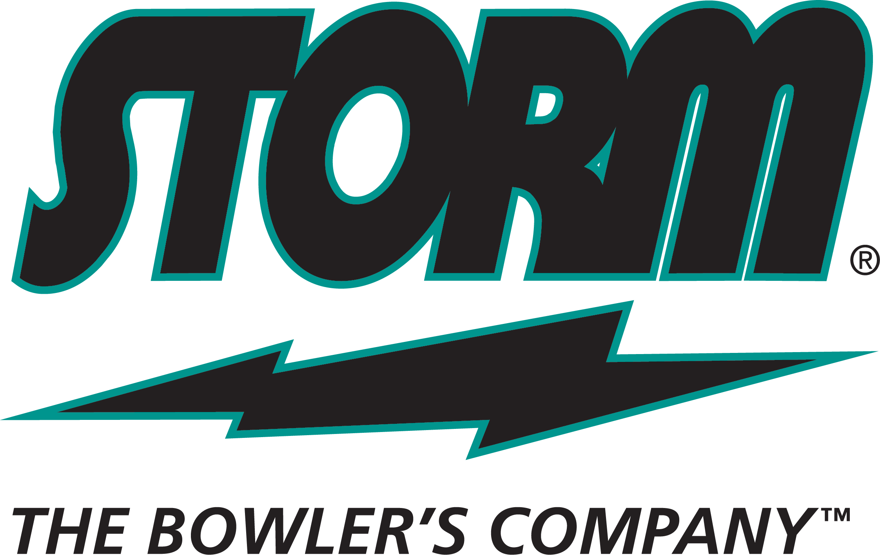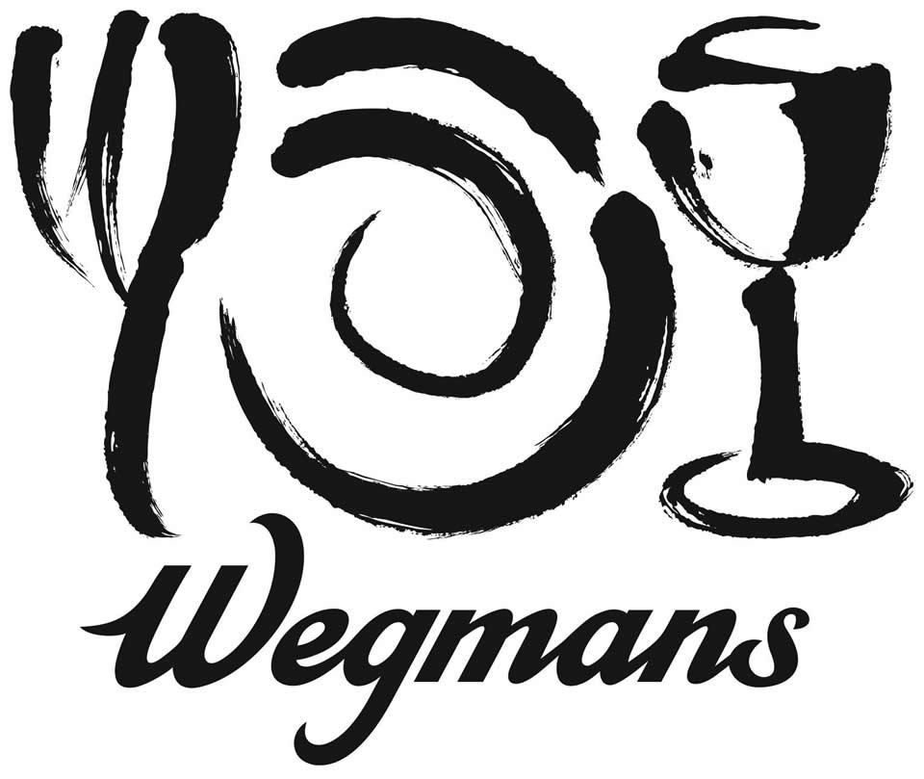

2021 TOURNAMENT RULES
WOMEN’S MASTERS

- Open to all amateur women bowlers who are sanctioned in the Auburn NY USBC Bowling Association for the 2022-2023 season.
- Conducted by the Auburn NY USBC BA.
- Double elimination, scratch tournament. Must lose twice to be eliminated.
- To qualify, bowlers must bowl three games across three sets of lanes.
- The top 23 scratch bowlers will be taken along with the 2022 champion (who is seeded) for a total of 24 qualifiers. If there is a tie for the 24th spot, a three game match will be set up at the earliest convenience between the bowling establishment and bowlers. This match must take place prior to the start of head-to- head competition. If there is not 24 entries for the qualifying round, Plan B will be used to accommodate entries below 24.
- Alternates may be used in head - to - head competition during first round only.
- Each head - to - head match will consist of three games bowled on the same set of lanes. Person bowling the high scratch series score will be the winner of the match. Ties will be determined by a one game roll-off, to be bowled immediately at the end of the match and prior to the start of the next round. The tie-breaker will be bowled on the same set in TV style format with the bowler on the odd lane to start first. The bowler assigned to the odd lane will be based on the bowler with the highest seed from qualifying. If a tie still exists after the one game roll-off, a 9th & 10th frames roll-off will determine the winner. If a tie still exists, a 9th & 10th frames roll-off will continue until a winner is determined.
- First place winner will be awarded $500.00. Prize fee returned 100% at least 1 in 10 payout ratio.
- Walk-ins will be allowed.
- Un-Sportsmanship like conduct will not be tolerated during tournament play. If a tournament participant exhibits this type of behavior, they will be disqualified.
- Dress code: Proper Attire Required – NO TANK TOPS or SLEEVELESS SHIRTS or TORN JEANS
- ALL COVID-19 GUIDELINES WILL BE ENFORCED

