Team Event Doubles & Singles
Date & Time Date & Time

Date___________ Date___________

Time__________ Time__________

Entry Fees
Team Event $125.00 87th Annual USBC Certified
Doubles/Singles $ 100.00 AUBURN NY USBC
All Events $ 10.00 Championships Tournament
Rainbow Lanes
Falcon Lanes

Make check or money order to: Team event Sponsored By:
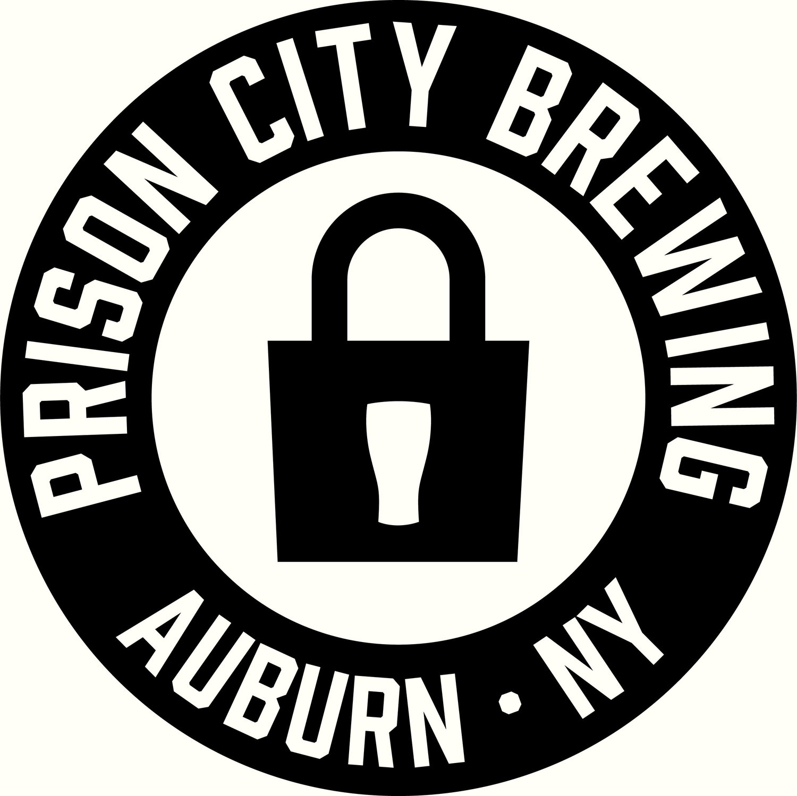
Auburn NY USBC
Mail to: N.Y.S.C.O.P.B.A. & Prison City Brewery
Auburn NY USBC BA
c/o Robert DelloStritto Team Event at Rainbow Lanes
2420 Turnpike Rd February 19th & 20th ,21st, & 23rd-25th – 6:45 Weekday, 12pm Weekend
Auburn, NY 13021 Doubles & Singles Falcon Lanes
February 26 – February 27, 2022
Entries close February 19, 2022

Team lineup must bowl in submitted order. Print first and last names only. Must enter a TEAM NAME -- | (Team Name here) |  |  | Prize Ratio based on number of entries
Enter team line-up | Amount paid | 2020-2021  Average | USBC card # | League where highest average was established
1.
2.
3.
4.
5.
Prize Bowling Expense Total
Doubles & Singles | Amount paid | 2020-2021 average | A.E. (Y or N) | Team | $61.25 | $56.25 | $7.50 | $125
 |  |  |  | Doubles | $24.50 | $22.50 | $3.00 | $50
1. |  |  |  | Singles | $12.25 | $11.25 | $1.50 | $25
2. |  |  |  | All Events | $9.00 |  | $1.00 | $10
1. |  |  |  | I hereby certify that the averages above are the highest
2. |  |  |  | averages in any league and I have read the rules on the back
1. |  |  |  | Captain’s Name:
2. |  |  |  | Address:

Tournament Rules and Regulations
- All entrants must be of the Auburn NY USBC Association. All non-members of the association must pay the nine dollar ($9) local fee to participate in the Tournament. All entrants will use their book average from the 2020-2021 season, based on 21 games. All Lane Managers and League Secretaries have the Auburn NY USBC average yearbook for the 2020-21 season. If no average from previous winter season, average will be based as follows: Highest USBC average of 21 games in a summer league. Highest USBC average in the 2021-2022 season based on, at least, 9 games (in one league) as of February 19, 2022. If no average entrant will bowl scratch. The Tournament Director can re-rate any bowler as he feels necessary, i.e., use average from two or more years ago, or an average from a different association.
All Lane managers and League Secretaries have the Auburn NY USBC Yearbook from 2020-2021 or use www.bowl.com . If a bowler’s average is 10 pins higher in the 2021-2022 season than in the 2020-2021 (based on 9 games), then the 2021-2022 average will be used, based on 9 games, in one league.
- Non-members of the Auburn NY USBC who live within the jurisdiction of the Association and are not members of another USBC affiliate association may enter by paying
an associate membership fee of $23.
3. Membership cards must be presented upon request of tournament management. Dues of $23 shall be assessed to each bowler not in possession of a USBC membership card, and an associate membership card will be issued for fee returned upon submission of proof that the bowler was a member of the Auburn NY USBC for the current season.
- It shall be each bowler’s responsibility to verify the accuracy of their average in a handicap or classified tournament, whether originally submitted by the bowler, their captain, or others. Failure to use proper average shall result in disqualification.
- The handicap allowance for this tournament shall be 90% of the difference between the bowlers entering average and a scratch score of 230. All handicaps will be calculated on an
individual basis for each event. Handicap allowed for determination of all events prize list: all events trophy, however, will be awarded based on actual pin fall without handicap. Only those entrants paying the all-events entry fee will be eligible for participation in the all-events prize fund, but any entrant bowling a series in each of the 3 events will be eligible for the all events trophy without extra charge.
- An individual can bowl doubles only but cannot bowl singles only. If in the singles event, bowlers must bowl both doubles and singles events. Entrants can bowl twice in the doubles event, but not on the same team. Doubles event will be bowled first. If a bowler signs up and competes in 2 doubles events and 1 singles event, they must bowl them consecutively. E.g., If a bowler bowls on Saturday in a doubles event it must be followed by their singles event. Their second doubles event will be on Sunday.
- It shall be each bowler’s responsibility to verify the accuracy of their average in a handicap or classified tournament, whether originally submitted by the bowler, their captain, or others. Failure to use the proper average shall disqualify score if submitted average is lower than actual average. In the case of teams of two or more bowlers, the average shall be combined to determine whether the correct totals are higher or lower than the submitted total.
- When a bowler enters with MORE THAN ONE TEAM OR DOUBLES, their FIRST score bowled in the team and doubles event shall count towards their all events total.
- A bowler may compete with more than one team, but not more than 3 bowlers can compete together more than once in the team event. A bowler may compete in the doubles event twice and singles events only once.
- Teams or individuals who fail to appear on the lanes prepared to bowl at the scheduled time shall forfeit their entry fees. Captains are to register their team 30 minutes prior to squad time. Also, individuals in the doubles and singles are to register 30 minutes prior to their squad time.
- All entrants who qualified for a prize of $300 or more in any tournament event, even though such prize has not been paid, must report the name of each tournament, their actual score, position, and amount won at the time of entry. Failure to accurately report prize winnings for any tournament during the period of February 20, 2022, and February19, 2022 can result in disqualification. In addition, the entrant may be liable for suspension of membership from the Unites States Bowling Congress (see USBC Rule 319d).
- No entry fee will be refunded if it is discovered that a team or individual has failed to comply with any rule or eligibility of this tournament. Tournament Manager had final say in all disputes.
- There will be no substitutes allowed in all events portion.
- A bowler shall adjust their entering average and submit the adjusted average according to the provisions as outlined in USBC Rule 319e to the Tournament Manager and it shall be each bowler’s responsibility to acquaint himself or herself and comply with the other re-rating requirements as outlined in USBC Rule 319e and not appearing here. Any bowler who has been re-rated by any tournament or Association must inform Tournament Management in writing of this re-rating prior to bowling.
- In the event of an emergency, the Tournament Manager has the authority to re-schedule any team or event scheduled or being bowled.
- Entries close on Saturday February 19, 2022, at 6:30 PM. Entries in the tournament (including reservations) will be taken on a first come, first serve basis and are subject to approval and /or confirmation (if made in advance) by the Tournament Director. The Tournament Director reserves the right to cancel any squad times listed below at any time due to an insufficient number of entries registered and/or entered in advance at his discretion. Tournament manager has final say in all disputes.

TEAM EVENT SQUADS AT RAINBOW LANES

Saturday, February 19th * 12 PM
Sunday, February 20th *12 PM
February 21st – 25th *6:45 PM (League Nights except Tuesday)

DOUBLES AND SINGLES EVENT AT FALCON LANES

Saturday, February 26th *11:00 AM
Sunday, February 27th *11:00 AM
* May be subject to change.

