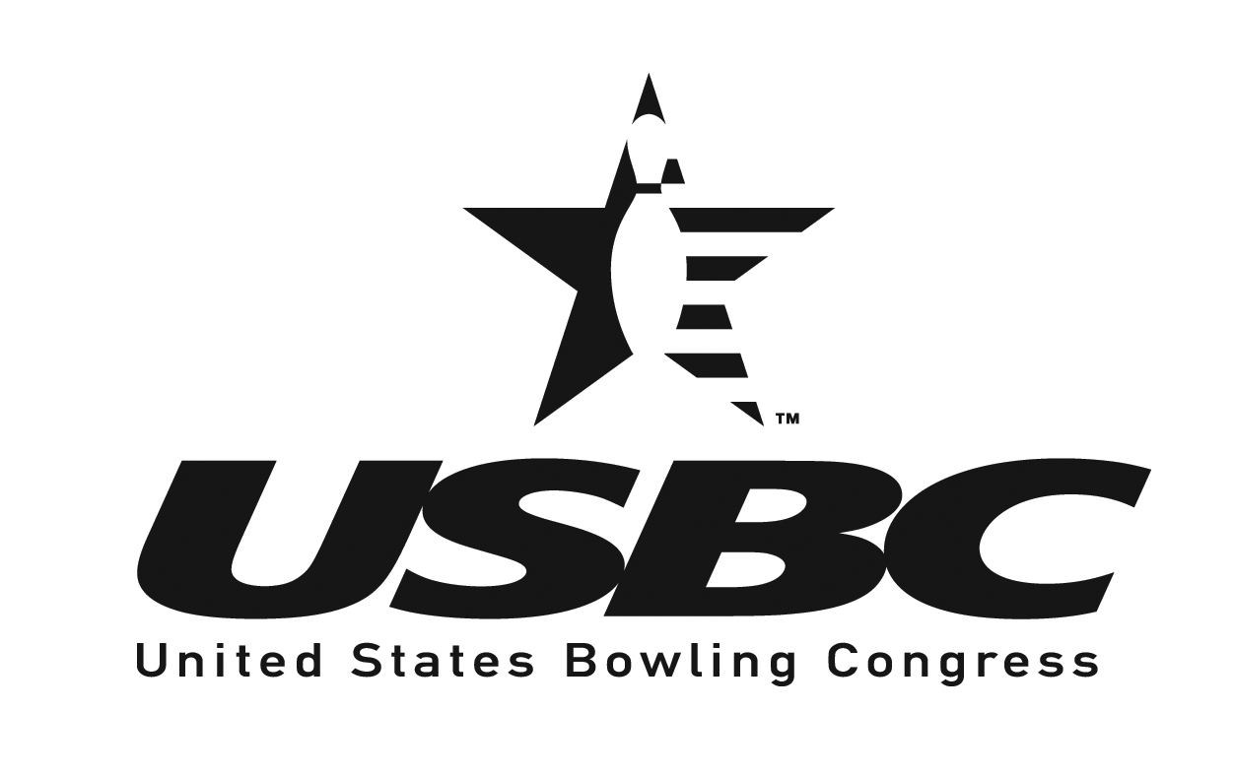

OFFICIAL ENTRY FORM

AUBURN NY USBC BOWLING ASSOCIATION

WOMEN’S ANNUAL TOURNAMENT

FEBRUARY 26-27, 2022 - DOUBLES EVENT
FALCON LANES AUBURN, NEW YORK

RESERVATIONS CLOSE FEBRUARY 26, 2022

MAIL ENTRIES TO:
Auburn NY USBC BA
2420 Turnpike Rd
Auburn NY 13021
--------------------------------------------------------------------------------
AUBURN NY USBC BA
ENTRY FORM – ANNUAL TOURNAMENT
ENTRY FEE PER PERSON/EVENT
BOWLING $ 11.25
PRIZE FUND $ 9.75
EXPENSE FEE $ 1.00
TOTAL PER PERSON $ 22.00

DOUBLES EVENT – FALCON LANES
February 26-27, 2022 11:00 am

DOUBLES
BOWLER’S NAME  $22.00/BOWLER | SANCTION  NUMBER | AVERAGE  (2020-2021 SEASON)
1.
2.
1.
2.
Make Checks Payable to “Auburn NY USBC BA”

I hereby certify that the averages entered are our highest averages in any league and that we bowl only in sanctioned leagues.
Signed __________________________ phone # ________________________

RULES FOR CONDUCTING AUBURN NY USBC BOWLING ASSOCIATION ANNUAL LOCAL TOURNAMENT – PLEASE READ CARFULLY – NO EXCUSES ALLOWED FOR IGNORANCE OF RULES.

- List line-up in EACH EVENT in order of bowling formation. THERE WILL BE NO CHANGES EXCEPT FOR SUBSTITUTIONS.
- Each bowler will receive a handicap of 90% of the difference between the average and 230. All others will bowl scratch.
- AVERAGE: Twenty-one games establishes an average. Entrants shall use their highest sanctioned league average as of the end of the previous winter season in the Auburn NY USBC BA. If an entrant does not have a previous winter season average, average will be based as follows:
  - Highest 21 games or more average in the 2021 Spring League in the Auburn NY USBC BA.
  - Highest average for at least 21 games as of the closing of the tournament in the Auburn NY USBC BA
  - An entrant without an acceptable average under any one of the stated conditions must use the highest average as of the day of the tournament in any USBC certified league.
  - If no average – Bowl scratch.
  - TEN PIN RULE WILL APPLY -
5. Entry blanks must be signed by the team captain and submitted with check or money order (NO CASH) to the Auburn NY USBC BA no later than February 26. 2022 TO HOLD RESERVATION.
6. After an entry has been received and filed, the entry fee in no case shall be refunded.
7. All bowlers shall report line-up to the Secretary’s office 30 minutes before time scheduled to bowl. SQUAD will start promptly as scheduled.
- Any appeal or protest shall, in all cases, be made in writing and submitted no later than 24 hours after the game has been played. This appeal or protest shall briefly state the grounds for appeal or protest. The action of the Board of Directors on this appeal or protest shall be final.
- ALL ENTRANTS MUST BE IN GOOD STANDING AND PROPER ATTIRE IS REQUIRED.
- Awards will be presented to the highest handicap winners.
- At least one prize for every ten entries.
- For further rules and information, consult your Rule Book or Tournament Secretary.
- The entrants whose name appear on the entry form or their authorized replacements hereby agree that the Auburn NY USBC BA, its officers and agents shall be liable only to the extent of returning entry fees if and when these entrants shall be prevented from bowling any event in the tournament through delay, unexpected yet necessary schedule change or premature termination of the tournament, which may be brought about by war, national emergency or emergency of causes relating thereto or resulting there from, fires, strikes, lockouts, labor difficulties or other causes beyond the control of the Auburn NY USBC BA.

