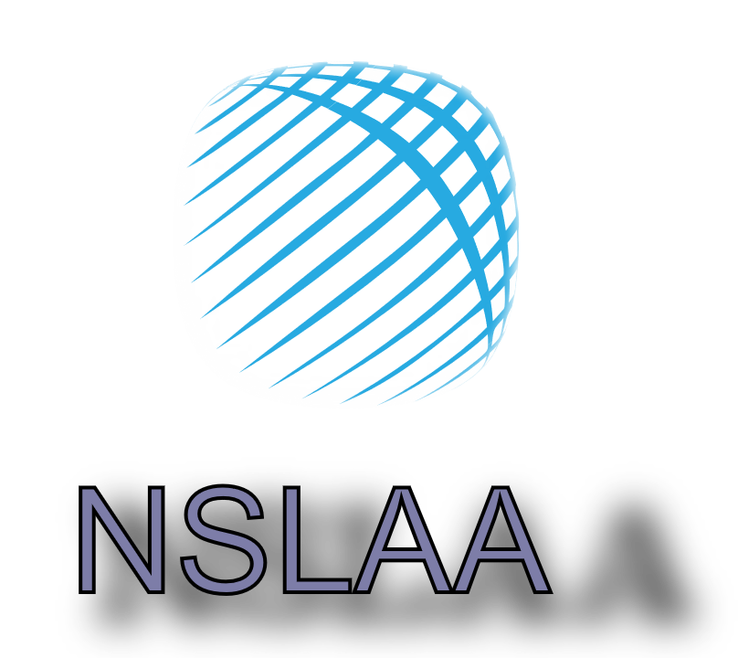

**NSLAA Continuing Education Guide**

**2024-2025**

**Certified Servant Leader (CSL)**

**Certified Servant Leader-Trainer (CSL-T)**

Welcome to the NSLAA Continuing Education Guide. As a CSL/CSL-T certified professional it is important that you are up to date on the latest trends and changes in leadership, mentorship, coaching, training and leadership education.

The CSL and CSL-T certifications are respected through the field of leadership and leader development. You can be confident that your certification will set you apart and send a message of credibility and trustworthiness to your organization, peers and those you lead.

To ensure we uphold the highest standards, professionals are required to obtain continuing education once certified. This guide will help you understand what the requirements are, what can be reported for continuing education and how to report your continuing education units (CEU).

We hope this guide will provide answers to your questions about continuing education and help you create a plan for maintaining your certification.

If you have any questions you can reach us at [admin@nslaa.org](mailto:admin@nslaa.org) or

803-397-9370. Thank you for leading others and serving others.

-The NSLAA Team

**At the NSLAA we have established the standard for Servant Leadership.**

**We lead because we serve and we serve because we lead.**

NSLAA encourages leaders and leadership professionals to use education, interpersonal soft skills, personal experiences and development. Not just because it’s the best thing to do, but because it’s the *right* thing to do.

**It’s right** to demand professionalism and excellence for all people..

**It’s right** to commit to a higher level of knowledge because each person is unique and deserves a customized leadership experience.

**It’s right** to care about those we lead, the organzaitons we work for and with and our communities, and to use our expertise to help them reach life goals and expand opportunities.

**It’s right** to be forward-thinking, to be focused and compassionate, to make a difference not just in leadership, but in people’s lives.

Contents

**1. The Continuing Education Requirement**

**2. Continuing Education Categories**

**3. Volunteer Requirement**

**4. Submitting CEUs**

**The Continuing Education Requirement**

Professional development is a career-long process. Over the course of a career, many changes occur in a field of study or profession that require certificants to update their knowledge and skills. These changes include the introduction of new products and services in the leadership industry, as well as changes in laws and technical knowledge related to all professional industries. The purpose of requiring continuing education of certificants is threefold:

• to enhance the professional’s capacity to serve their clients

• to protect the public interest

• to uphold the rigor of the certification

All courses require certification every 2 years to maintain current levels of your certification. Certification holders are required to complete a recertification application requiring 20 total hours of development. Those hours consist of servant leadership, personal professional development in the workforce that consists of 12 hours of either educational professional, leadership development, mentor development or a mixture of them. These 12 hours must show growth in leadership as a profession. Plus 8 hours of community service that provides for the betterment of their organization or community.

**Renewal Period & Requirements**

Certification must be renewed once every two years to maintain use of the AFC credential.

The two year time period established for renewal is based on both the scope of issues that face financial counseling professionals and the Council’s belief that new practices, research, and information are introduced in the field with enough frequency that professional development activities should be conducted routinely so that certificants remain current with best practices and emerging knowledge.

Certificants who have received the CSL or CSL-T credential are required to complete twenty continuing education units (CEUs) during a two-year reporting cycle. CEUs earned during one reporting cycle do not carry over to future reporting periods.

Renewal of a credential requires:

1. Current certification (active status)

2. Acquire and submit 20 continuing education units that support the NSLAA core principles.

3. Payment of the Certification Fee if needed.

All courses require certification every 2 years to maintain current levels of your certification. Certification holders are required to complete a recertification application requiring 20 total hours of development. Those hours consist of servant leadership, personal professional development in the workforce that consists of 12 hours of either educational professional, leadership development, mentor development or a mixture of them. These 12 hours must show growth in leadership as a profession. Plus 8 hours of community service that provides for the betterment of their organization or community.

*\*Certificants do not need to report CEUs for the year they first become certified.*

| **Year 1 of the Reporting Period**  If you become certified during the first half of the reporting period, then **one-half of the required CEUs** will be due for your inaugural reporting period. | **Year 2 of the Reporting Period**  If you become certified during the second half of the reporting period, **no CEUs** will be due for your inaugural reporting period. |
| --- | --- |
| **Subsequent Reporting Periods**  Full CEUs required. | |

NSLAA strictly adheres to the standards of maintenance requirements for certification. It is the responsibility of the certificant to comply with all requirements and deadlines to maintain their credential. The NSLAA will send email reminders to the email address on file; however, it is the certificant’s responsibility to be aware of and comply with renewal requirements and deadlines. Exceptions to policies, any fees, or deadlines will not be granted.

Late fees will be incurred for each month that any fee is not paid. After six months of non-payment if one is due, your certification will be revoked.

If you fail to maintain your credential by reporting the required CEUs during the two-year reporting period, your status will be listed as “lapsed” for a maximum period of six months with an approved extension application. You must pay an extension fee and obtain the required number of CEUs to reinstate your credential within the extension period. If you do not comply with the reinstatement requirements within the maximum period of six months, the Certification Council will revoke the credential. Professionals may be able to reinstate their credential by paying a reinstatement fee and meeting the requirements for reinstatement.

**Acceptable Continuing Education**

All continuing education must be related to the NSLAA Core Competencies, and the LCTMTCH model. Continuing education may be achieved through any NSLAA sponsored opportunities, however, certificants may meet the CEU requirement by participating in programs or training through other providers.

Post certification requirements are designed to enhance professionals’ abilities to serve their clients. Programs should be of sufficient depth and breadth to increase the skills and knowledge of the professional and vary in program method and content. Programs regarding an organization’s policies & procedures, operational training programs, or programs designed for consumer use are not eligible for CEUs.

Certificants are responsible for maintaining records of their continuing education and may be required to substantiate CEUs during random audits.

For complete information on maintaining certification, please visit the NSLAA Candidate Handbook provided as [www.nslaa.org](http://www.nslaa.org).

**CEUs and Programs Not Hosted by NSLAA**

If you attend a continuing education program that is not hosted by NSLAA, you may submit the program and your verification of attendance via [admin@nslaa.org](mailto:admin@nslaa.org) and the NSLAA will review your request. will consider these requests on a case-by-case basis and may award or decline CEUs at its sole discretion. The program must adhere to the requirements listed in “Accepted CEU Activity and Requirements” to be considered. In considering whether a program is eligible for CEUs, The NSLAA may consider: (i) rigor of the program, (ii) content of the program in light of what the NSLAA expects of an leader professional, (iii) the organization that offered the program, and (iv) any other factors. If the NSLAA awards CEUs, this is not a representation that the program or its hosting organization is CEU approved and it does not guarantee that future programs from the organization (including the submitted program) will be granted CEUs.

**Appeal Policy**

Appeals must be submitted in writing to admin@nslaa.org within thirty (30) calendar days of the decision or notification. The certificant must submit the appeal in writing, and explain in detail: 1) The nature of the request and the specific facts supporting the request, and 2) all reasons why the action or decision should be changed or modified. The certificant must also provide accurate copies of all supporting documents. The appeal will be reviewed within fifteen (15) business days. If the issue can be resolved at the staff level, the Certification Staff will make a determination and will notify the Certification Council of the result.

If the issue cannot be resolved by the Certification Staff, the appeal will be referred to the Council. The appeal will also be referred to the Council if the certificant does not accept a determination by the Certification Staff.

The Council will review the appeal within thirty (30) days and will make a determination within sixty (60) days. The decision of the Certification Council is final.

**Continuing Education Categories**



CSL/CSL-T certified professionals work in many different roles in many different fields. We want to be sure that our continuing education guidelines reflect this diversity. We understand that leaders, managers, educators and community leaders operate in different capacities and we strive to meet our candidates where they are.

In the following pages, you will see the approved continuing education categories for all NSLAA CSL/CSL-T certifications with a detailed description of each. Please use this information while planning your CEU opportunities and reporting your hours at [admin@nslaa.org](mailto:admin@nslaa.org).

Certificants do not need to earn CEUs in every category. Because different types of CEUs have different reporting requirements, certificants are encouraged to review the guidelines to ensure they are submitting their CEUs correctly.

**Conferences and Summits**

These are a great place to get the most up-to-date information from experts in the field. Many conferences can be pre-approved by the NSLAA, so be sure to check with to see if conferences can be used.

To request pre-approval of a conference please contact the NSLAA at admin@nslaa.org .

**Guidelines:**

• A maximum of 4 CEUs will be awarded per day

• A maximum of 15 CEUs will be awarded per conference

• No reporting period maximum

Breakout sessions, general sessions, relevant keynotes, etc.

Networking events, breaks/meals, unrelated content, etc.

**Required Documentation:**

* Certificate of completion from the provider, *or*
* Email or other document from the provider confirming attendance, *or*
* Proof of payment, *or*
* Conference agenda with sessions attended clearly marked

*NSLAA reserves the right to request additional documentation for any CEU request.* **Books/Articles**

CSL/CSL-T certified professionals may request CEUs for developing or reviewing content for publications including research papers, books, articles, journals, and any NSLAA-sponsored material published in a reputable national, regional, or military publication. Submissions must include a copy of the material as well as information on where it was published. Unpublished material, blogs, or newsletters will not be considered for CEUs.

**Guidelines:**

• A maximum of CEUs will be awarded for articles published in a reputable publication

• A maximum of 2 CEUs will be awarded for review of NSLAA-sponsored material

• A maximum of 10 CEUs will be awarded for authoring or reviewing a research paper or book on a relevant topic

• No reporting period maximum

Published research or journal articles, NSLAA newsletter or blog articles, news/lifestyle articles, etc.

Unpublished material, personal blogging, employer newsletters, topics unrelated to the NSLAA Core Competencies, etc.

**Required Documentation:**

• Copy of, or link to, material with publish date.

**Education**

Education is one of the most popular ways to earn CEUs. Through formal coursework, in person training, and online courses, NSLAA certified professionals have many options for obtaining CEUs. All education topics must be relevant to the leader role and relate to the NSLAA Core Competencies.

**Guidelines:**

| **Education Type** | **Units** | **Maximum** |
| --- | --- | --- |
| College/University Coursework | 5 CEUs per credit hour | 18 CEUs per course |
| In-person Training | 1 CEU per hour | 6 CEUs per day; 18 CEUs per course |
| Self-guided Coursework (with measurable evaluation)* | 1 CEU per coursework hour | 18 CEUs per course |
| NSLAA Course | nslaa.org | 4 CEUs per course |

**Required Documentation:**

• Full syllabus or course agenda/schedule, *and*

• Transcript or other proof of completion

*The NSLAA reserves the right to request additional documentation for any CEU request.*

* Must show proof of completion and provide an agenda or other document substantiating the number of hours requested.

**Webinars**

NLSAA currently does not host sponsored webinars , but may do so in the futureWebinars, which can be a very valuable resource for professional development. There are many other opportunities to participate in webinars from other providers. Webinars do not need to be NSLAA-sponsored but must relate to the NSLAA Core Competencies.

**Guidelines:**

* 1 CEU will be granted per hour of instruction time
* A maximum of 3 CEUs will be awarded for any single webinar
* No reporting maximum

**Required Documentation (one of the following):**

* Completion code or phrase (if given)
* Certificate of completion
* Email or other documentation from the providing confirming attendance
* Proof of Payment
* Copy of Slide with notes taken
* A Screenshot of the final training slide with notes taken during training

**Creating Courses or Educational Material**

Creating or updating classes, curriculum, or content (e.g. videos, blogs, podcasts, etc.) for a specific audience may be submitted for CEUs. Submissions with reported hours that are not commensurate with the content will be rejected. CEUs are not granted for instruction time.

**Guidelines:**

•3 CEUs will be granted per 1 hour of content for creation of new materials; a maximum of 10 CEUs will be granted per curriculum.

•1 CEU will be granted per 1 hour of content for updating existing materials; a

a maximum of 5 CEUs will be granted per curriculum.

•No reporting period maximum

**Required Documentation:**

* Copy of, or detailed summary of, curriculum or other material,

*and*

* Description of where and how material is used, including intended audience,

*and*

* Schedule, agenda, or other document estimating the completion time for the end user.

**Community Service Requirement**

NSLAA defines service as giving one's time to help others and the community in a meaningful way. This can be achieved through active participation and/or leadership in organizations, clubs, or community service projects. There is an 8 hour time requirement. The purpose of the Service requirement is to give you the opportunity to apply knowledge and skills you will gain through the CSL/CSL-T certifications to the service that you provide.

**Required Documentation:**

* Proof of volunteer hours via email or letter from community member
* A screenshot of community signup roster
* Proof in other means of volunteer hours (when in doubt contact the NSLAA)

**Submitting CEUs**



Certificants will submit their CEU requests via their email by requesting a CEU submission form at admin@nslaaorg. CEUs may only be submitted for the current reporting period. To be eligible, CEUs must be earned in the 30 months preceding the close of the reporting period. For example, for the reporting period ending January 1, 2024, CEUs earned prior to June 30, 2022 would not be eligible for the reporting period. CEUs may not be resubmitted for double credit if approved in a prior reporting period.

Please see below for step-by-step instructions for submitting a CEU request

**To Submit CEUs**

1. Send email to [admin@nslaa.org](mailto:admin@nslaa.org) to request CEU form
2. Complete all sections of the CEU form

**Completion Code Phrase:**If your CEU opportunity was pre-approved by AFCPE, the CEU provider will provide a code phrase. Enter the phrase and click “Apply.” The form will populate for you. If no code is available, leave this field blank.

**Reporting Period:** Select the current reporting period. Only Lapsed or Revoked professionals will be able to report CEUs for prior reporting periods.

**Completion Date:** When was the CEU completed? This should match your supporting documentation.

**CEUs Requested:** Please see Continuing Education Categories for guidelines on the number of CEUs to request.

**Credit Type:**

* Program Title: What is the name of the training, webinar, conference, etc?
* Sponsor: Who provided the training, webinar, conference, etc.?

-How does the program impact and enhance what you are doing in your organization and as a leader?

-Please provide a description of how this CEU impacts your role.

* Program Agenda: You may upload a file or enter the information into the form boc. Agendas are used to determine the amount of CEUs to award.
* Upload/Email a certificate of completion/participant program schedule

1. Once submitted we will review your submission within 5 business days. You will receive an email notification if additional information is required.

**Tips for submitting CEUs:**

• Each CEU must be submitted separately. A professional completing a graduate degree in financial planning, for example, must submit each course independently.

• Provide a clear description of the content. Submissions with unclear or vague descriptions such as “credit training” or “counseling seminar” will be rejected.

• CEUs may only be earned within the 30 months preceding the close of a reporting period unless an extension has been approved.

• All supporting documentation must provide a date of completion.

• No CEU request will be approved for more than 18 CEUs, regardless of actual training hours.

• No CEU request will be approved for more than 6 CEUs per day.

• Coursework or training that is centered on business or corporate finance will not be approved for CEUs. Content must relate to personal finance and the AFC Core Competencies.

• CEUs should be of sufficient depth and breadth to increase the skills and knowledge of the professional.

• Programs regarding an organization’s policies & procedures, operational training programs, or programs designed for consumer use are not eligible for CEUs.

• General self-improvement or professional development will not be approved for CEUs. The training must ultimately benefit the client, not the counselor.

• CEU requests must have a minimum of 30 minutes of content and are approved in 30-minute increments.