MELROSE UNITED CHURCH
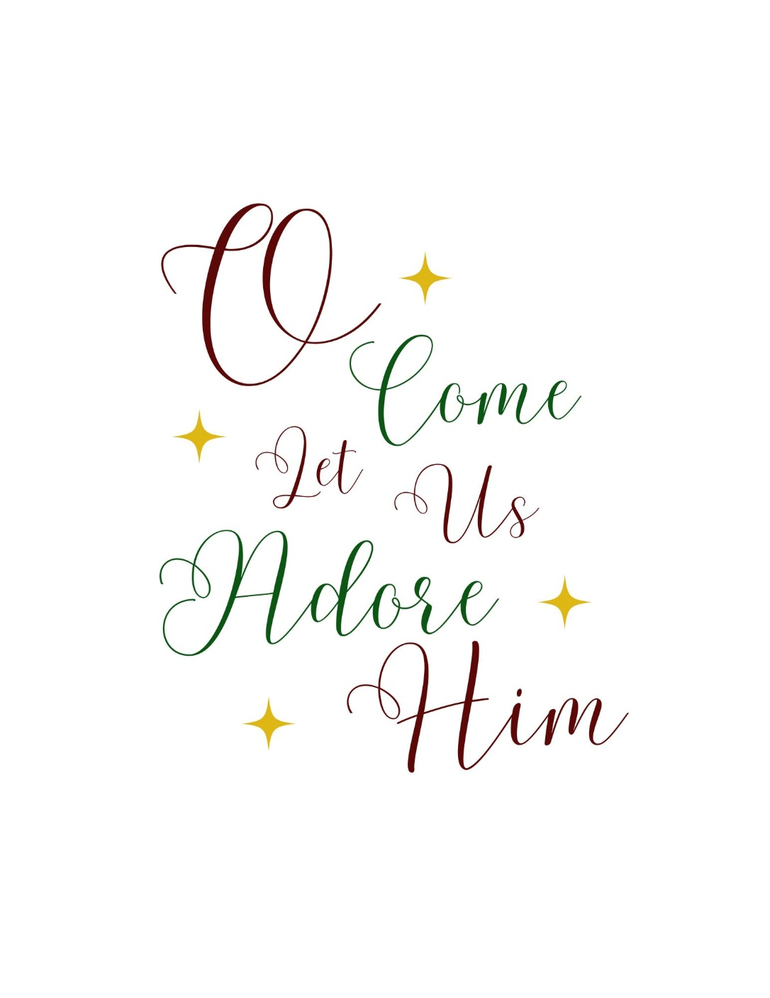
86 Homewood Avenue ~ Hamilton, Ontario ~ L8P 2M4
905 522 1323 ~ melrose@melroseunited.ca
www.melroseunited.ca
www.facebook.com/melroseunitedchurch
Instagram: @melroseu
YouTube channel: Melrose United Church Virtual Service

Worship Leader: | Rev Brenna Baker
Music Director:  Custodian:  Church Administrator: | Alexander Cann  Kevin Geluch  Sue Hawthorne-Bate

Wednesday, December 24, 2025

Christmas Eve
10:30pm

Gathering In Community

The PRELUDES ~ In dulci jubilo, J. S. Bach
O Come, O Come, Emmanuel, H.H. Hopson, arr.
Wachet auf, J. G. Walther, arr.

CAROLS from the GALLERY ~ Deck the Halls
We Three Kings
Ding Dong Merrily on High
It Came Upon a Midnight Clear
O Little Town of Bethlehem

The PROCESSIONAL CAROL~ Hark the Heral Angels Sing VU 44

The WELCOME and the LIFE of the CHURCH

The LAND ACKNOWLEDGEMENT & LIGHTING of CANDLE of PEACE

The LIGHTING of the CHRIST CANDLE

the Christ Candle is lit….

One: We have prepared for the coming of the Holy Child
All: Christ is born!

One: Like Elizabeth and Mary, Simeon and John the Baptist, we open ourselves to God’s plan.
All: Christ is born for us!

One: We light a candle for Christ, the Word Incarnate.
All: Christ is born! Hallelujah!

One: Thanks be to God.
All: Amen.

The INTROIT ANTHEM ~ The Huron Carol, arr. E. Daley
Soloist Tabitha de Bruin, alto

The CALL to WORSHIP

One: Holy people, beloved of God, come.

Come to follow the way prepared for you.
All: Glory to God in the highest, and peace on earth.

One: Once again the earth is surprised at a manger,
as the glory of God transforms the commonplace.
All: Let us go to Bethlehem to see what God has made known to us.

One: Experience the wonder of God’s ways.
Kneel in awe before life newly borne.
Let us bring glory and praise to God.
All: for all that we have seen and heard!

A CAROL ~ Infant Holy, Infant Lowly VU 58

The OPENING PRAYER

Hearing and Responding to the Word

Reader ~ Graeme Luke

The PRAYER of ILLUMINATION

All: Touch our hearts with your words, O God,
as we hear the familiar Christmas story.
Make it new for us again, and open us
to its overpowering potential for our lives. Amen.

The WISDOM of the HEBREW BIBLE ~ Isaiah, Chapter 9 verses 2, 6-7

One: The Word of the Lord
All: Thanks be to God.

An ANTHEM ~ Puer natus, D. Cook

The GOSPEL of LUKE Chapter 2, verses 1-20

One: Hear the Good News!
All: Praise be to Jesus Christ!

A CAROL ~ The First Nowell VU 91

The GOSPEL of JOHN Chapter 1 verses 1-5, 14

One: This is God’s Word for God’s People.
All: Thanks be to God.

The HOMILY

An ANTHEM ~ Torches, B. Emery
Soloist Allana Stevenson, soprano

The INVITATION to the OFFERING

The OFFERING CAROL ~ What Child is This? VU 74

The PRAYER of DEDICATION

Celebrating the Lord’s Supper
(see insert)

Sending Forth

The RECESSIONAL CAROL ~ See Amid the Winter’s Snow VU 76

The SHARING of the LIGHT

Silent night! Holy night! All is calm, all is bright
round yon virgin mother and child. Holy infant so tender and mild,
sleep in heavenly peace, sleep in heavenly peace.

Silent night! Holy night! Shepherds quake at the sight:
glories stream from heaven afar, heavenly hosts sing Hallelujah,
Christ, the Saviour is born, Christ the Saviour is born.

Silent night! Holy night! Son of God, love’s pure light
radiant beams from thy holy face, with the dawn of redeeming grace,
Jesus, Lord, at thy birth, Jesus, Lord, at thy birth.

Please blow out your candle before leaving the pew.

If you would like to light a candle to represent your prayers for a person or situation that is in your heart, you are invited to do so at the beginning or end of any worship service.

