MELROSE UNITED CHURCH
86 Homewood Avenue ~ Hamilton, Ontario ~ L8P 2M4

905 522 1323 ~ melrose@melroseunited.ca
www.melroseunited.ca
www.facebook.com/melroseunitedchurch
Instagram: @melroseu
YouTube channel: Melrose United Church Virtual Service

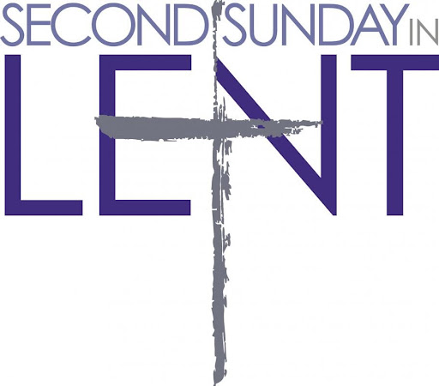

Worship Leader: | Mary Parsons
Music Director:  Custodian:  Church Administrator: | Alexander Cann  Kevin Geluch  Sue Hawthorne-Bate
Sunday, March 1st, 2026
Second Sunday in Lent

Gathering In Community

The PRELUDE

The INTROIT ~ Give the Lord the honour due, G. Thalben-Ball

The PROCESSIONAL HYMN ~
You, Lord, Are Both Lamb and Shepherd VU 210

The WELCOME and the LIFE of the CHURCH

The LAND ACKNOWLEDGEMENT & LIGHTING of CANDLE of PEACE

The LIGHTING of the CHRIST CANDLE

One: As we travel this Lenten pathway, we journey together, a community of faith.
All: We light this candle to remind us of the Light of Christ, calling us to love God and to love our neighbour.
One: We light this candle to remind us of the light that cannot be put out.
All: May this light remind us that we are never alone.

Candle is lit….

The CALL to WORSHIP

One: In this season of Lent, a time of preparation
All: God call us to gather to worship, to pray, to sing, to listen for God’s still, small voice.

One: As we walk with Jesus on the road to Jerusalem,
All: We see looming before us a cross, a shadow on the horizon.

One: We gather as fellow travelers to the city, the cross, and what lies beyond.
All: God has called us together, and so we worship, we pray, we sing, we listen.
A HYMN ~ What Wondrous Love Is This VU 147

The OPENING PRAYER

The INVITATION to CONFESSION

The PRAYER of FORGIVENESS

All: Holy God, you so loved the world that you gave your Son to the world. There are times now where our world seems very unloved – so many places of war and greed and apathy.

We struggle to believe that your love includes each one of us. Sometimes we feel we are alone in the wilderness.

We struggle at times to love one another as you taught us. In a moment of silence, we offer to you our worries about the world, our worries about our own troubles and those around us.

Silence….

We offer these our prayers to your infinite wisdom and care. May we and all people in this beloved world feel the healing and comfort that is so deeply needed. Amen.

The WORDS of ASSURANCE

Time For the Children and the Child Within Us

A CHILDREN’S STORY

A CHILDREN’S HYMN ~ He’s Got the Whole World in His Hands

- He’s got the whole world in His hands,
he’s got the whole wide world in His hands,
he’s got the whole world in His hands,
he’s got the whole world in His hands!

2 . He’s got you an’ me, sister, in His hands,
he’s got you an’ me, brother, in His Hands,
he’s got you an’ me, sister, in His hands,
he’s got the whole world in His hands!

3. He’s got the little tiny baby in His hands.
he’s got the little tiny baby in His hands.
he’s got the little tiny baby in His hands,
he’s got the whole world in His hands!

4. He’s got all of us here, in His hands.
he’s got all of us here, in His hands,
he’s got all of us here, in His hands.
he’s got the whole world in His hands!

5. He’s got the whole world in His hands,
he’s got the whole wide world in His hands,
he’s got the whole world in His hands,
he’s got the whole world in His hands!

Hearing and Responding to the Word

Reader ~ Geoff Harrison

The PRAYER of ILLUMINATION

All: Challenging God, you have guided your people throughout the ages to sing and pray and reflect. You invite us to listen to timeless stories. Help us to receive the ever-new message of radical love. May it find a place to rest deep in our souls, so that we might draw strength and courage. May it stir us to action. May it guide us, always, to live as followers of Jesus Christ. Amen.

The BOOK of GENESIS, Chapter 12, verses 1 to 4a

One: This is the Word of the Lord
All: Thanks be to God.

PSALM 121 VU 844

Refrain: Our help is in the name of our God
who made heaven and earth.

One: One: Hear the Good News!
All: Praise be to Jesus Christ!

The REFLECTION ~ “Just One More Story”

An ANTHEM ~ Prayer from Psalm 139, J. Weaver

The INVITATION TO THE OFFERING

An OFFERING HYMN ~ We Give You but Your Own VU 542

Sing: We give you but your own, what e’er the gift may be;
all that we have is yours alone, we give it gratefully.

The PRAYER OF DEDICATION

All: Holy God, in our giving we release our hold on what we have. We set our gifts free to go where they need to go. We do not know what our giving will do. We do not know what will come of each caring word or deed or thought. But we do know this: In letting go, we fall into the embrace of Holy Mystery – we are surrounded forever with love and light which will not fail us. May it be so. Amen.

The PRAYERS of the PEOPLE

The LORD’S PRAYER

All: Our Father, who art in heaven,
Hallowed be thy name,
Thy kingdom come,
Thy will be done
On earth, as it is in heaven.
Give us this day
our daily bread,
And forgive us our trespasses,
As we forgive those who trespass against us.
And lead us not into temptation,
But deliver us from evil:
For thine is the kingdom,
the power, and the glory
Forever and ever. Amen.

Sending Forth

The RECESSIONAL HYMN ~ My Life Flow’s On VU 716

The BLESSING

All: Let us go forth filled with hope for new life, peace in believing, and compassion for befriending.

May we know and share the blessing of God who loves this world, who turns weeping into rejoicing, and breathes light into places of darkness, that new life may be born in our midst.

The CHORAL BENEDICTION

The POSTLUDE

Today’s Greeters are Libby Cook & Richard Feenstra

If you would like to light a candle to represent your prayers for a person or situation that is in your heart, you are invited to do so at the beginning or end of any worship service.

Personal prayer requests – please write your prayer requests in our Prayer Share Book during the service.

Life and Work of the Church

Saturday, March 7th & 21st ~
Knitting & Crochet @9:30 – 11:30
Bring your current project and materials, beginners welcome! Coffee, tea and snacks will be provided.


Sunday, March 8 ~ Annual General Meeting
Our Annual General Meeting (AGM) will be held next Sunday, March 8th after the 10:30am service in the Sanctuary. Copies were emailed out in a PDF format with the Newsletter on Friday. There are a limited number for pick up today for those who are unable to print a copy at home. You may also view the report on your phone or tablet during the meeting. Please save a few trees!
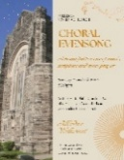
Sunday, March 15 ~ Choral Evensong
A beautiful service of music, scripture and quiet prayer with Rev Dr Philip Garder and the Melrose Chancel Choir.

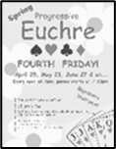
Friday, March 27th ~ Progressive Euchre
Doors open at 7pm, games start at 7:30pm sharp! Beginners welcome!

Saturday, April 11th @ 8:30pm ~
Bach Elgar Choir Presents ~ Der Golum at Melrose!
A 1920’s German masterpiece movie on a large screen with an exhilarating soundtrack. Tickets are available at www.bachelgar.ca.

Fiddes Fresh Food Drive
This is our fourth year of collaborating with our Church Partner on Locke Street to assist those with food security issues in Hamilton. Please help make this outreach a success by ordering through Fiddes in person, by email or by donating any dollar amount to Libby Cook, Gwyn Xagoraris or Sharon Jones who will be happy to purchase fresh veggies or fruit on your behalf! A full list of produce will be available next week! Stay tuned!

Easter Flowers
Every year we decorate our Sanctuary with beautiful flowers for Easter. If you wish to donate towards the Easter flowers in memory of a loved one, there will be envelopes available at the front of the church. Please drop your envelope in the collection plate. You can also email the office at melrose@melroseunited.ca. Please be sure to include the names of your loved ones! We accept cash, cheques or etransfers.

Envelopes!
Giving Envelopes for 2026 are now available! If you would like to have a box of envelopes, please email the office melrose@melroseunited.ca.

Your Help is Needed!
Would you like to help out more on Sunday mornings? We are looking for volunteers to help with reading and greeting. If you can help or would like more information, please speak with Rosella if you are interested in reading or Libby if you are interested in greeting. Thank you!


Social Media at Melrose!
Melrose has an active social media presence on Facebook and Instagram! Check out our pages for information on Melrose events, the wider church and for messages of inspiration! Please visit: www.facebook.com/melroseunitedchurch and www.instagram.com/melroseuc/

News From the Office

Please be sure to submit your church related news items for the bulletin or newsletter by Wednesday of each week. Kindly email the office. Thank you!

