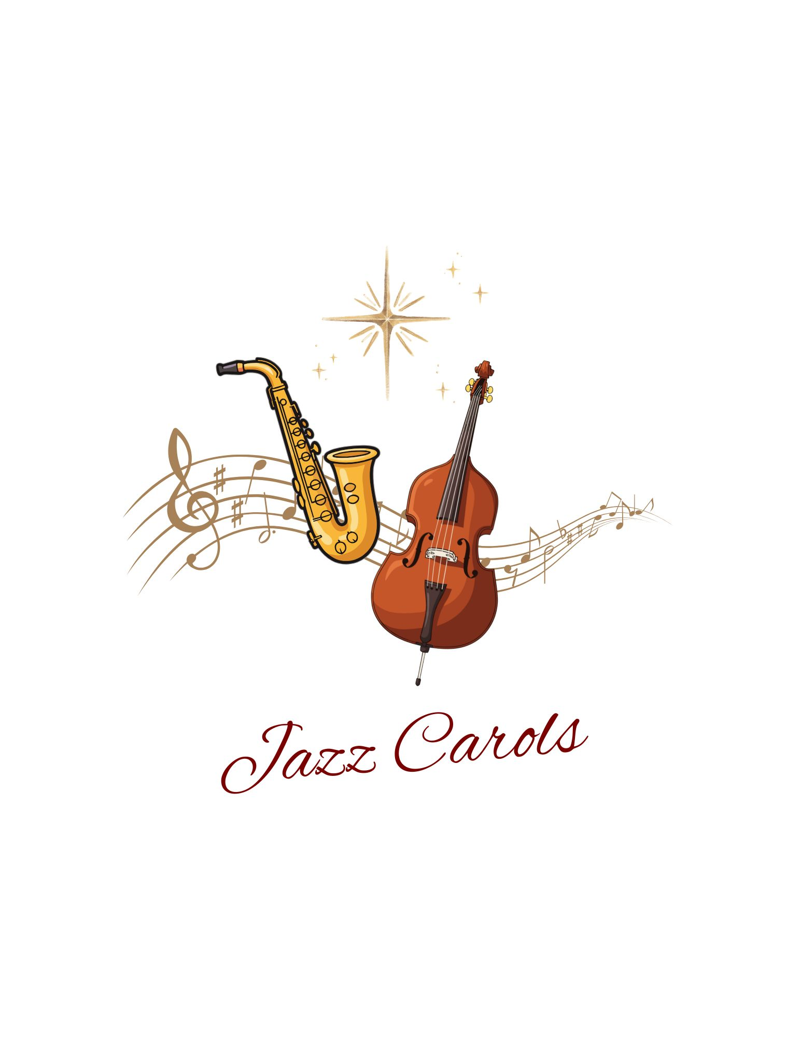
MELROSE UNITED CHURCH
86 Homewood Avenue ~ Hamilton, Ontario ~ L8P 2M4
905 522 1323 ~ melrose@melroseunited.ca
www.melroseunited.ca
www.facebook.com/melroseunitedchurch
Instagram: @melroseu
YouTube channel: Melrose United Church Virtual Service

Worship Leader: | Mary Parsons
Music Director:  Guest Musicians:  Custodian:  Church Administrator: | Alexander Cann  Philip Luke, Samantha Luke  Kevin Geluch  Sue Hawthorne-Bate

Sunday, December 28, 2025
First Sunday after Christmas

Gathering In Community

The OPENING CAROL ~ O Tannenbaum, Ernst Anschütz

The WELCOME and the LIFE of the CHURCH

The LAND ACKNOWLEDGEMENT

The LIGHTING of the CHRIST CANDLE:

The CALL to WORSHIP

One: What a year this has been!
All: So much has happened; some wonderful and some very challenging.

One: In all of this, God journeyed with us, guiding, healing, comforting, and rejoicing.
All: We are filled with gratitude for God’s presence with us.

One: Today we are on the precipice of a new year.
All: In all that is to come, we commit to trusting in God’s love.

One: Together, we walk into this future as a faithful community of generosity, compassion, and joyfulness.

(adapted words from 2023 The United Church of Canada,
‘New Year’s Eve Service and Liturgy)

A CAROL ~ What Child is This, W.C. Dix/Traditional

The OPENING PRAYER

All: God of past, present, and future, we give thanks for the gift of gathering to worship, singing, praying, and hearing how you lead us toward a faith-filled future. At the end of each year, we reflect on all that has been experienced in our lives, moments of joy and wonder, times of anxiety and confusion. Throughout it all we are grateful for your love and guidance. In this new year that is upon us we ask for your continued presence as we strive to live out the Good News of Jesus Christ, to comfort the lonely, attend to the suffering, welcome the stranger, feed the hungry, and speak for those whose voices are being ignored. In a spirit of togetherness and oneness we pray. Amen.

(words from 2023 The United Church of Canada,
‘New Year’s Eve Service and Liturgy)

The WORDS of ASSURANCE:

A CAROL ~ Away in a Manger, W. J. Kirkpatrick

Time for the Children and the Child Within Us

A CHILDREN’S STORY

A CAROL ~ Let it Snow, S. Cahn/J Styne

Hearing and Responding to the Word

Reader ~

The PRAYER of ILLUMINATION
The GOSPEL of Matthew, Chapter 2, verses 1 to 12

The GOSPEL of Luke, Chapter 21, verses 1to 4

One: This is the Word of the Lord
All: Thanks be to God.

The REFLECTION ~ “It’s Only Just Begun”

A MUSICAL OFFERING ~ We Three Kings, J. H. Hopkins Jr

The INVITATION to the OFFERING

An OFFERING HYMN ~ The Christmas Song, R. Wells/M. Tormé

The PRAYER of DEDICATION:

The PRAYERS of the PEOPLE

The LORD’S PRAYER

Sending Forth

A CAROL ~ Silent Night J. Mohr/F. Gruber

The BLESSING
The POSTLUDE ~
Have Yourself a Merry Little Christmas H. Martin/R. Blane
White Christmas I. Berlin

Thank you to our wonderful guest musicians
Philip Luke on bass and Samantha Luke on saxophone!

