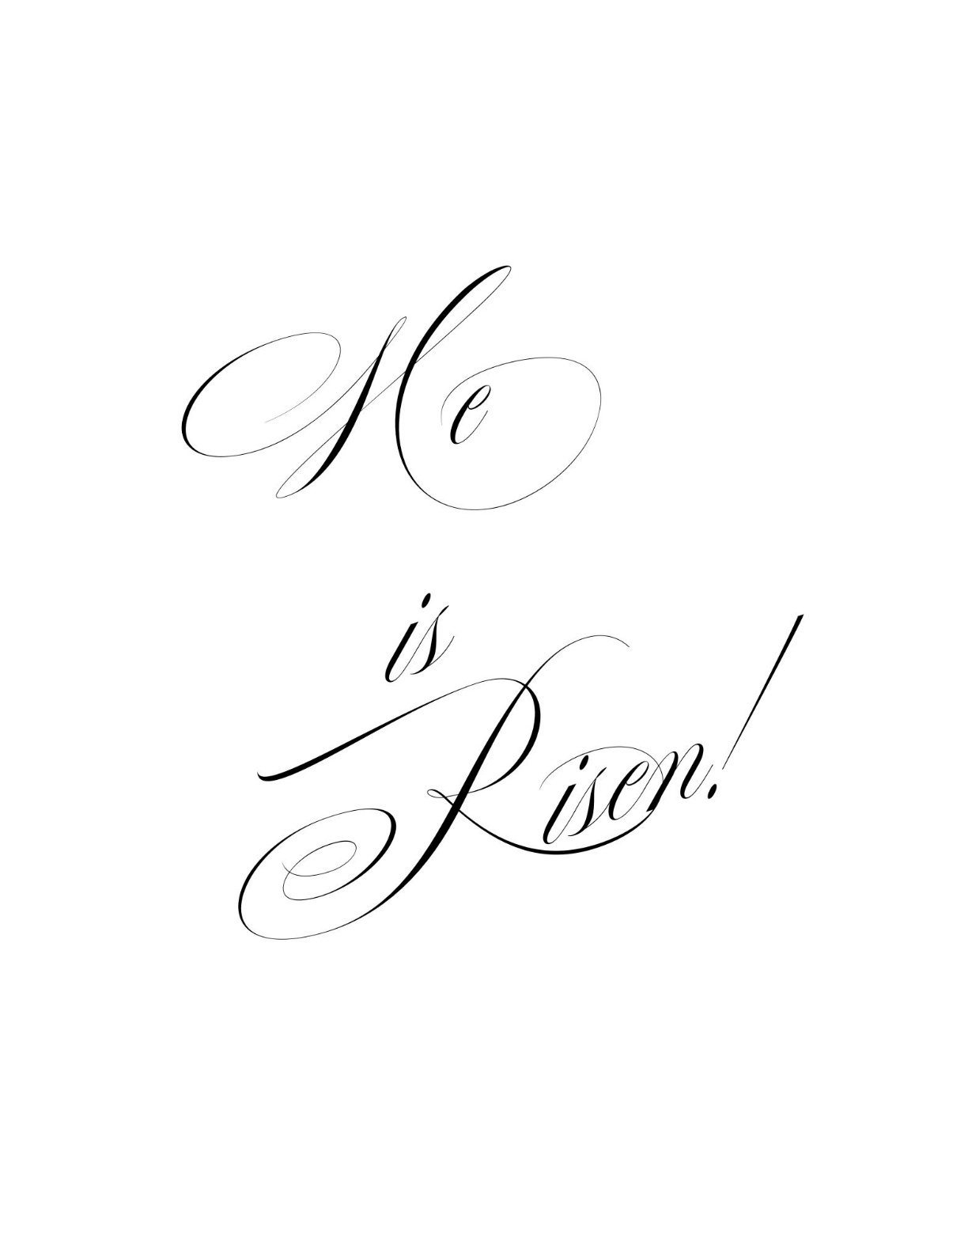**MELROSE UNITED CHURCH**

86 Homewood Avenue ~ Hamilton, Ontario ~ L8P 2M4

🕿 905 522 1323 *~* 🖂 [melrose@melroseunited.ca](mailto:melrose@melroseunited.ca)

🖰 [www.melroseunited](http://www.melroseunited).ca

www.facebook.com/melroseunitedchurch

Instagram: @melroseu

YouTube channel: Melrose United Church Virtual Service

|  |  |
| --- | --- |
| Worship Leader: | Margaret Duff |
| Music Director:  Custodian:  Church Administrator: | Alexander Cann  Kevin Geluch  Sue Hawthorne-Bate |

**Sunday, April 27, 2025**

**Second Sunday of Easter**

# *GATHERING IN COMMUNITY*

*The* PRELUDE ~ Fanfares, R. Pantcheff

*The* INTROIT ~ VU 396 Jesus, Stand Among Us

*The* PROCESSIONAL HYMN ~ VU 190 The Head That Once

Was Crowned

*The* WELCOME *and the* LIFE *of the* CHURCH

*The* LAND ACKNOWLEDGEMENT

*The* LIGHTING OF THE CHRIST CANDLE a*nd*

*the* CANDLE OF PEACE

One: This is the day that God has made

Let us rejoice and be glad in it!

We welcome the light of the Risen Christ into this place!

**All: Christ is with us - Alleluia!**

*the Christ Candle is lit….*

*The* CALL *to* WORSHIP

One: With the Church through the ages,

we speak of God as one and triune:

Father, Son, and Holy Spirit.

We also speak of God as

Creator, Redeemer, and Sustainer

God, Christ, and Spirit

Mother, Friend, and Comforter

Source of Life, Living Word, and Bond of Love,

and in other ways that speak faithfully of

the One on whom our hearts rely,

the fully shared life at the heart of the universe.

**All: We witness to Holy Mystery that is Wholly Love.**

*From the Song of Faith, 2006*

*The* OPENING PRAYER

One: Holy Mystery, Great Spirit, Wisdom Child,

may our hearts overflow with your praise

like our earth overflows with her spring abundance.

**All: God of our lives, in Jesus we find**

**the everyday and the sacred,**

**the death and the resurrection,**

**the human and the divine.**

**Help us, we pray,**

**to notice you in worship and in the world.**

**Help us, we pray, to follow you,**

**wherever we may go. Amen**.

*Written by Richard Bott.* ***Gathering****, Lent/Easter 2022*

*The* PRAYER *of* FORGIVENESS

**All: God of empty tombs and emptier people:  
when we hesitate to speak of your hope,**

**forgive us, and give us a voice.**

**When we find it difficult to love one another,**

**forgive us, and give us fresh compassion.**

**When we want to stand with the high and mighty,**

**forgive us, and seat us next to the poor and oppressed.  
When we stay locked behind our fears and doubts,**

**forgive us, and send us out to share your grace.  
When we cannot believe your Word of new life,**

**forgive us, and fill us with your joy. Amen.**

*The* WORDS *of* ASSURANCE

One: Christ comes into every shadowed corner of our lives with the light of Easter. Christ comes into the locked rooms of our faults and gifts us with grace and hope.

**All: Christ comes to fill us with peace, so we may proclaim the good news of mercy and forgiveness for all. Thanks be to God. Amen.**

*Written by Thom M. Shuman*

*A* HYMN ~ VU 170 O Sons and Daughters, Let Us Sing

*(using Additional verses for the Second Sunday of Easter on facing page)*

***TIME FOR THE CHILDREN AND THE CHILD WITHIN US***

A Children’s Story ~ “Believe it or Not”

***HEARING AND RESPONDING TO THE WORD***

*Reader ~ Rev. Rick Maxwell*

*The* PRAYER *of* ILLUMINATION

**All: Blessed Lord, as we hear these words of scripture, open our hearts and spirits so that we might be willingly shaped for your purposes, by the power of your Living Word. Amen.**

The BOOK of ACTS, Chapter 5, verses 27 to 32

One: May God’s Spirit shape the understanding of these words.

**All: And may they awaken in our hearts.**

PSALM 150 ~ VU 875 Praise to God Your Praises Show *(congregation)*

*The* BOOK *of* JOHN, Chapter 20, verses 19 to 31

One: Hear the Good News!

**All: Praise be to Jesus Christ!**

*The* REFLECTION

*An* ANTHEM ~ O Be Joyful in the Lord, C. Wood

*The* INVITATION TO THE OFFERING

*An* OFFERING HYMN ~ VU 169 Good Christians All,

Rejoice and Sing, v.2

**The Lord of life is risen today!**

**Bring flowers of song, bedeck the way;**

**let every tongue rejoice and say:**

**Hallelujah, hallelujah, hallelujah!**

*The* PRAYER OF DEDICATION

**All: Gracious God, in thanksgiving we bring our gifts to you. For your goodness granted to us, and your invitation into abundant life, we thank you. For the inspiration to share your abundance with others, we praise you. Accept our thanks and strengthen us to bear faithful witness to your spirit working within us; now and always. Amen.**

*The* PRAYERS *of the* PEOPLE

*The* LORD’S PRAYER *(Ecumenical Version)*

**All: Our Father in heaven,**

**Hallowed be your name,**

**Your kingdom come,**

**Your will be done**

**On earth as in heaven,**

**Give us today our daily bread.**

**Forgive us our sins,**

**As we forgive those who sin against us.**

**Save us from the time of trial**

**And deliver us from evil.**

**For the kingdom, the power and the glory are yours**

**Now and forever. Amen.**

***SENDING FORTH***

*The* RECESSIONAL HYMN ~ VU 168 The Risen Christ

*The* BLESSING

*The* CHORAL BENEDICTION ~ VU 833 Hallelujah, H. Hopson

*The* POSTLUDE ~ Festive Scherzo, M. Archer

*If you would like to light a candle to represent your prayers for a person or situation that is in your heart, you are invited to do so at the beginning or end of any worship service.*

*Personal prayer requests – please write your prayer requests in our Prayer Share Book during the service.*

**Announcements**

**Help is Needed!**

Starting April 20th, we need a volunteer for the Coffee Hour role each Sunday for four weeks. Gwyn is stepping away from this role for a short time, and we are looking for a few volunteers to help out. The job takes about 25 minutes each week and involves making

the coffee and tea and setting out the refreshments. Gwyn will provide training. Please speak with Gwyn if you are able to help! Thank you!

**The Duet Club Presents ~ To Be….Is To Sing!**

**Today! Sunday, April 27 ~ 2:30pm at Melrose!**

Come enjoy a tour of the Renaissance, where everything old is new! Featuring local composers, actors and singers! Tickets: Adults $25, Seniors & Students $20, Children under 12 are free! Tickets can be purchased at the door (cash or debit) or by e-transfer to theduetclub@gmail.com. For complete details please visit www.duetclub.ca

**Friday, April 25th ~ Progressive Euchre**

Doors open at 7pm, games start at 7:30 sharp! Beginners welcome!

**Saturday, May 3rd**

**Knitting & Crochet 9:30 – 11:30**

Bring your current project and materials, beginners welcome! Coffee, tea and snacks will be provided.

**Saturday, May 3rd ~ Kirkendall Food Drive**

If you live in the Kirkendall neighborhood, please keep an eye out for a brown paper bag arriving in your mailbox between April 25th and April 30th. If you don’t receive your bag or if you would like an extra one, please email events@kirkendallhood.ca. This food drive will support the Food Bank at Mission Services. For more information, please visit https://kirkendallhood.ca/food-drive/.

**Great Melrose Spring Cleanup!**

Beginning the week of **May 5th**, we will be having a big cleanup event, and we are looking for some volunteers to help in the afternoons or evenings of that week to sort, organize, and carry un-needed items to a big dumpster, or set them aside for recycling or repurposing. Work has already started on the process of identifying

long forgotten or broken items from years past. Your time and talent for a few hours could make a big difference! Please speak to Margaret Duff or email her at margaretduff2143@gmail.com. Thank you!

**Saturday, May 10th @3pm**

**Featuring William Lewans, Baritone & Tom Schilling, Piano ~** Join us for a captivating performance by Canadian Baritone William Lewans, currently studying at Melrose under the mentorship of Tom Schilling. William has graced stages across Canada, taking on roles such as Figaro in "The Marriage of Figaro." Tom Schilling is a highly respected vocal coach who enjoyed a remarkable 50 year career in New York City and has been teaching in Hamilton since 2005. Together, William and Tom will present their favorite arias, with all proceeds supporting the **Melrose Roof Fund!** Admission is Pay-What-You-Can, with a suggested donation of $20. Tickets will be available at the door. For further inquiries, please email William at lewanswilliam@gmail.com.



**Sunday, May 11th 2pm to 5pm ~ Board Games!**

All ages welcome! Bring along your favourite board game. You do not need a partner. Entry fee, $5 for individuals, $10 for families.

**Wesley’s Case for Kids**

Wesley’s 34th Annual Case for Kids event will be held on **Sunday, June 1st**! Melrose will once again be entering a team. Participants are encouraged to walk, run or ride at their own pace around Bayfront Park. Stay tuned for more information!

**News From the Office**

Please be sure to submit your items for the bulletin or newsletter by Wednesday of each week. Kindly email the office. Thank you!