MELROSE UNITED CHURCH
86 Homewood Avenue ~ Hamilton, Ontario ~ L8P 2M4
905 522 1323 ~ melrose@melroseunited.ca
www.melroseunited.ca
www.facebook.com/melroseunitedchurch
Instagram: @melroseu
YouTube channel: Melrose United Church Virtual Service
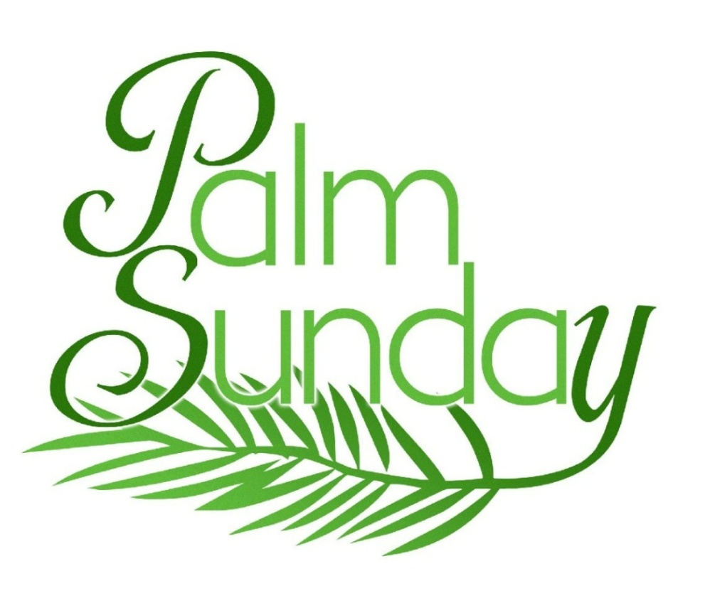

Worship Leader: | Rev Charlie Hogg
Music Director:  Custodian:  Church Administrator: | Alexander Cann  Kevin Geluch  Sue Hawthorne-Bate

Sunday, March 29, 2026
Sixth Sunday in Lent
Liturgy of the Palms

Gathering In Community

The LAND ACKNOWLEDGEMENT

We acknowledge that our church is located on the traditional territories of the Erie, Neutral, Huron-Wendat, Haudenosaunee and Mississaugas. May we continue to live with respect on this land, and to live in peace and friendship with all its people in the spirit of truth and reconciliation.

The PRELUDE

The WELCOME

The INTROIT ~ Lift Up Your Heads, E. Daley

The CALL to WORSHIP

The BLESSING of the PALMS

One: Bless these parade palms, O God of Celebration.
May they remind us of the simple joys of living.
May we remember the excitement that comes with following Christ.

All: Bless these protest palms, O God of Justice.
May they remind us that Empire is not a thing of the past. May they make us bold and brave to stand up against injustice.

One: Bless these funeral palms, O God of Comfort.
May they remind us of the road that lies ahead.
May they encourage us in times of grief and pain.

All: We give you thanks for the parade, the protest, the processional. Guide our steps through this holiest of weeks as we cry out together "Hosanna, Hosanna, Hosanna!"

The PROCESSIONAL HYMN ~
When They Heard That Jesus Was Coming MV 128

~Please be seated!~

The LIGHTING of the CANDLE of PEACE

The LIGHTING of the CHRIST CANDLE

One: When we work for justice,
All: We are the light of the world
One: By acting with love,
All: We are the light of the world
One: When we work to be affirming and inclusive…
All: We are the light of the world
One: By building a community where everyone is welcomed and everyone belongs,
All: We are the light of the world
One: By living as one body in Christ, where everyone is intentionally valued,
All: We are the light of the world
One: When we show our noble nature…
All: We are the light of the world
One: By being compassionate with one another,
All: We are the light of the world
One: By living as God’s children with reverence for the environment and all living things,
All: We are the light of the world

the Christ Candle is lit….

A HYMN ~ Hosanna, Loud Hosanna VU 123

Time For the Children and the Child Within Us

A CHILDREN’S STORY

“Dates and Donkeys” with Chris and Charlie

Hearing and Responding to the Word

Reader ~ Seth Preston

PSALM 118 (chanted by choir)

Refrain: Hallelujah! hallelujah!

The GOSPEL of MATTHEW, Chapter 21, verses 1 to 11

One: For the word of God in scripture, among us, and within us.
All: Thanks be to God

THOUGHTS for LIVING ~ “Is it a C.U.P.E Local?”

An ANTHEM ~ Hosanna Son of David, T. Weelkes

The OFFERTORY HYMN ~
All Glory Laud and Honour v.4 VU 122

The OFFERING PRAYER

The PRAYERS of the PEOPLE and the LORD’S PRAYER

One: …be with us now as we pray, with one voice the prayer of your community of faith.

All: Our Father, who art in heaven, hallowed be thy name; thy kingdom come; thy will be done; on earth as it is in heaven. Give us this day our daily bread; and forgive us our trespasses, as we forgive those who trespass against us. And lead us not into temptation; but deliver us from evil. For thine is the kingdom, the power and the glory, for ever and ever. Amen.

Sending Forth

LIFE and WORK of the CHURCH

The RECESSIONAL HYMN ~ Ride On! Ride On in Majesty! VU 127

The COMMISSIONING and BENEDICTION

The CHORAL BENEDICTION

The POSTLUDE ~

Today’s greeters are Debora Miscione Sandra Groves Winniger

If you would like to light a candle to represent your prayers for a person or situation that is in your heart, you are invited to do so at the beginning or end of any worship service.

Personal prayer requests – please write your prayer requests in our Prayer Share Book during the service.

Life And Work of the Church

Today! Sunday March 29th
Please join us after the Service on Sunday, today for our birthday celebration for all members whose birthdays were in January, February and March!
Easter Flowers
Every year we decorate our Sanctuary with beautiful flowers for Easter. If you wish to donate towards the Easter flowers in memory of a loved one, there will be envelopes available at the front of the church. Please drop your envelope in the collection plate. You can also email the office, melrose@melroseunited.ca. Please be sure to include the names of your loved ones! We accept cash, cheques or etransfers. The deadline is Monday, March 30th.

Your Help is Needed!
There are six more volunteer readers needed to cover all the Sundays until June 28th. Please sign up at coffee time. Speak to Rosella for more information.

Are you available to deliver a plant on Easter Sunday after Church to a stay-at-home member? Please contact Libby Cook at cook_feenstra@hotmail.ca or meet at the front of the church after Easter Sunday service. Thank you!

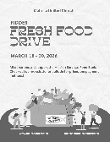
Fiddes Fresh Food Drive ~ March 16th – 30th
This is our fourth year of collaborating with our Church Partners on Locke Street to assist those with food security issues in Hamilton. The list below indicates fresh food items and cost. There are many ways to place an order! Etransfers can be sent to: Dustin@fwp1.ca. Clearly indicate that the purchase is for Melrose United Church -Mission Services. You can also choose to ask Libby or Gwyn to place the order for you and we gladly accept cash/cheque to do so. If you are already a Fiddes Customer, on your next visit ask to have the item added to the Melrose/Mission Services Food Order.

1 case Bananas x 40lbs - $39.50
1 case Granny Smith apples x 40lb - $63.50
1 case Red Delicious apples x 40lb - $63.50
1 case Golden Delicious apples x 40lb- $63.50
1 Bushel Gala apples x 40lb - $59.50
1 case oranges x 40lb - $54.50
1 bag russet potatoes x 50lb - $28.00
1 bag onions x 50lb - $32.00
1 bag carrots x 50lb - $39.50
1 bag carrots x 24x2lbs - $49.50
1 case green cabbage x 40lb - $33.00
1 case broccoli x 20lb - $49.50
1 case butternut squash x 40lb - $49.50
1 case acorn squash x 40lb - $49.50

Please help make our effort to assist in reducing food insecurity in Hamilton a success!

Saturday, April 4th & 18th ~
Knitting & Crochet @9:30 – 11:30
Bring your current project and materials, beginners welcome! Coffee, tea and snacks will be provided.

Easter Sunday, April 5th ~ Easter Brunch
Join us on Easter Sunday for Brunch after the 10:30am Worship Service! The menu will include muffins, fruit, hot cross buns, yogurt, granola and of course tea and coffee! All donations will be gratefully received and will support the United Church of Canada Disaster Relief Fund.


April 5th to April 15th ~ Textile Drive
Do you have used clothing, socks, towels, sheets and other items you no longer need and are no longer usable or wearable? Drop them off between April 5th to 15th in the Auditorium. All bags must be labeled “Fabric Recycling” No usable clothing will be accepted! All clothing items must be unwearable! All items will be recycled and diverted from landfills. Give a little, help a lot!

Saturday, April 11th @ 8:30pm
Bach Elgar Choir Presents ~ Der Golum at Melrose!
A 1920’s German masterpiece movie on a large screen with an exhilarating soundtrack. Tickets are available at www.bachelgar.ca.
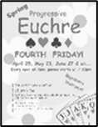
Friday, April 24th ~ Progressive Euchre
Doors open at 7pm, games start at 7:30pm sharp! Beginners welcome!


Social Media at Melrose!
Melrose has an active social media presence on Facebook and Instagram! Check out our pages for information on Melrose events, the wider church and for messages of inspiration! Please visit: www.facebook.com/melroseunitedchurch
and www.instagram.com/melroseuc/

News From the Office
Please be sure to submit your church related news items for the bulletin or newsletter by Wednesday of each week. Kindly email the office. Thank you!

