MELROSE UNITED CHURCH
86 Homewood Avenue ~ Hamilton, Ontario L8P 2M4

905 522 1323 ~ melrose@melroseunited.ca
www.melroseunited.ca
www.facebook.com/melroseunitedchurch
Instagram: @melroseuc
YouTube channel: Melrose United Church Virtual Service

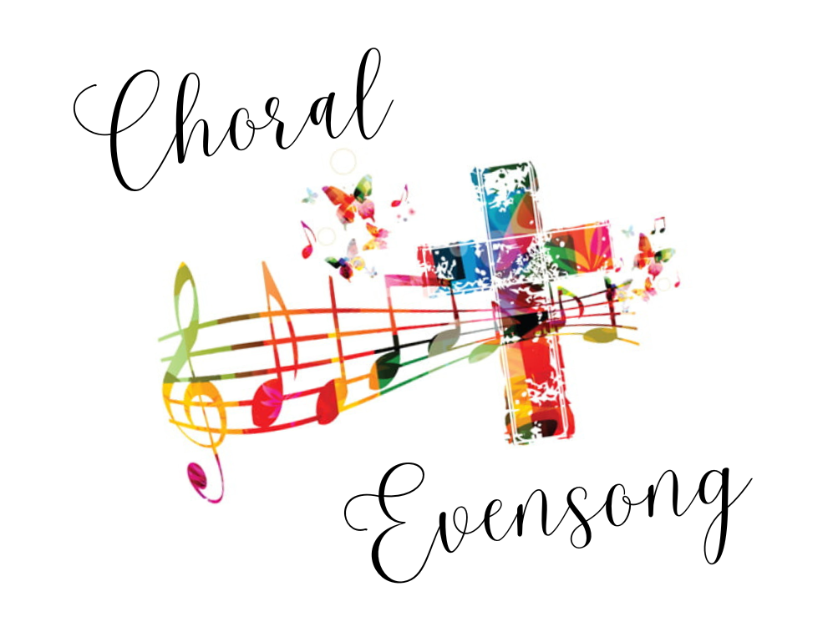

Minister: Rev. Philip Gardner
Music Director: Alexander Cann
Custodian: Kevin Geluch
Church Administrator: Sue Hawthorne-Bate

CHORAL EVENSONG
Sunday, March 15, 5:00p.m.
Offering plates are available at the entrances to the Sanctuary
for your kind donations

The PRELUDE ~ Lied, L. Vierne

The PROCESSIONAL HYMN ~ Hope of the World VU 215

The PRECES and RESPONSES

PSALM 46

God is our hope and strength, a very present help in trouble.
Therefore will we not fear, though the earth be changed,
and though the hills be carried into the midst of the sea;
Though the waters thereof rage and swell,
and though the mountains shake at the tempest of the same.
The Lord of hosts is with us; the God of Jacob is our refuge.
There is a river, the streams whereof make glad the city of God,
the holy place of the tabernacle of the Most High.
God is in the midst of her, therefore shall she not be moved;
but God uttereth his voice and the earth doth melt away.
The Lord of hosts is with us; the God of Jacob is our refuge.
O come hither and behold the works of the Lord,
what wonders he hath wrought upon the earth.
He maketh was to cease in all the world;
he breaketh the bow and snappeth the spear in sunder,
and burneth the chariots in the fire.
Be still then, and know that I am God;
I will be exalted among the nations, and I will be exalted in the earth.
The Lord of hosts is with us; the God of Jacob is our refuge.

The OPENING PRAYER

A READING from EPHESIANS, Chapter 5, verses 8-14

The MAGNIFICAT in D Major, G. Dyson

A READING from the GOSPEL of JOHN, Chapter 6, verses 25-40

One: Let us respond in faith to the Gospel of our Lord
All: Praise be to you, Jesus Christ

The NUNC DIMITTIS in D Major, G. Dyson

The NEW CREED

All: We are not alone,
we live in God’s world.
We believe in God:
who has created and is creating,
who has come in Jesus,
the Word made flesh,
to reconcile and make new,
who works in us and others
by the Spirit.
We trust in God.
We are called to be the Church:
to celebrate God’s presence,
to live with respect in Creation,
to love and serve others,
to seek justice and resist evil,
to proclaim Jesus, crucified and risen,
our judge and our hope.
In life, in death, in life beyond death,
God is with us.
We are not alone.
Thanks be to God.

An ANTHEM ~ O Trinity, Most Blessed Light, C. Kenneth Turner

The PRAYERS and PRAYER of JESUS

All: Our Father, who art in heaven,
Hallowed be thy name,
Thy kingdom come,
Thy will be done
On earth, as it is in heaven.
Give us this day
our daily bread,
And forgive us our trespasses,
As we forgive those who trespass against us.
And lead us not into temptation,
But deliver us from evil:
For thine is the kingdom,
the power, and the glory
Forever and ever. Amen.

The PRAYER of ST. JOHN CHRYSOSTOM

The CLOSING REMARKS

The RECESSIONAL HYMN ~
Guide Me, O Though Great Jehovah VU 651

The BLESSING

The POSTLUDE ~ Consolation, F. Liszt

Tonight’s greeters are Libby Cook & Richard Feenstra
Tonight’s Reader is Margaret Duff

We hope you enjoyed this evening’s service!

Our heartfelt thanks to Reverend Dr. Philip Gardner,
to our Chancel Choir and to Alexander Cann our Music Director
for our beautiful service!

