MELROSE UNITED CHURCH
86 Homewood Avenue ~ Hamilton, Ontario ~ L8P 2M4
905 522 1323 ~ melrose@melroseunited.ca
www.melroseunited.ca
www.facebook.com/melroseunitedchurch
Instagram ~ @melroseuc
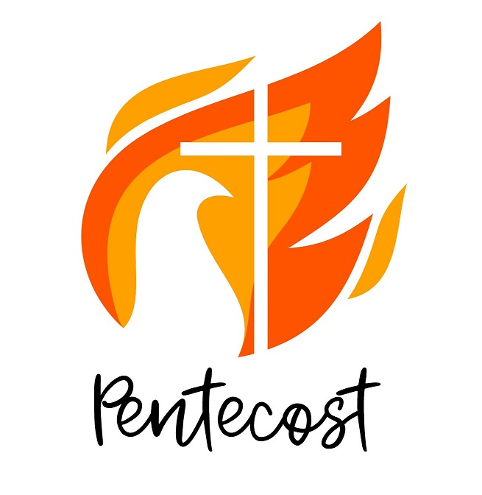
YouTube Channel ~ Melrose United Church Virtual Service

Worship Leader: | Rev. Charlie Hogg
Music Director:  Custodian:  Church Administrator: | Alexander Cann  Kevin Geluch  Sue Hawthorne-Bate
Sunday, May 24, 2026
Pentecost
Holy Communion

Gathering In Community

Please stand as you are able.

We acknowledge that our church is located on the traditional territories of the Erie, Neutral, Huron-Wendat, Haudenosaunee and Mississaugas. May we continue to live with respect on this land, and to live in peace and friendship with all its people in the spirit of truth and reconciliation.

The PRELUDE ~ Flute Solo, T. Arne

The WELCOME

We enter the Sacredness of Worship…

The INTROIT ~ This Is My Commandment, G. Thalben-Ball

The CALL to WORSHIP

The PROCESSIONAL HYMN ~ Welcome, Happy Morning VU 161

The LIGHTING of the CANDLE of PEACE

The LIGHTING of the CHRIST CANDLE

One: We light this candle as a sign to show the presence of the spirit within this sanctuary. Holy One, foster, within us a flame of holy passion for your mission in the world today.
All: Warm us by the Spirit’s dancing cerebral flame, that we may feel your warmth within, urging us to do your greater good.

One: Make us wholly present to experience a new birth,
All: and awaken possibilities within us to share your love in the world. Amen.

The Christ Candle is lit…

Time For the Children and the Child Within Us

A CHILDREN’S STORY

A CHILDREN’S HYMN ~ Halle, Halle, Halle VU 958

The OPENING PRAYER

Hearing and Responding to the Word

Reader ~ Rosella Laux

A READING from the BOOK of ACTS, Chapter 2, verses 1 – 13

One: The Word of the Lord,
All: Thanks be to God.

PSALM 104 VU 826

Refrain: Hallelujah, Hallelujah, Hallelujah.

The GOSPEL of JOHN, Chapter 7, verses 37 – 39

One: For the word of God in scripture, among us, and within us,
All: Thanks be to God.

A HYMN ~ Come Ye Faithful, Raise the Strain VU 165

THOUGHTS for LIVING ~ “Holy Fire! Holy Smoke!”

An ANTHEM ~ Look, Ye Saints, the Sight Is Glorious, M. Sinzheimer

The INVITATION to the OFFERING

A MELROSE MOMENT ~ with Rev. Charlie & Rev. Brenna

The OFFERTORY HYMN ~ VU 342, v.4

Sing: Then let us adore and give as is right,
all glory and power, all wisdom and might,
all honour and blessing with angels above,
and thanks never ceasing and infinite love.

The OFFERING PRAYER

The Communion
Select portions of the liturgy by Jan Richardson, Uniting Church New Zealand.
Used with permission

The INTRODUCTION

The INVITATION to the TABLE.

One: The Lord be with you
All: And also with you.
One: Lift up our hearts.
All: We lift them to the Lord.
One: Let us give thanks to the Lord our God.
All: It is right to give our thanks and praise.

One: In this space and time, we offer God our love and praise. We marvel at the multiplicity of humanity with our complexity of colour and culture, yet we are called into oneness-of-being through Christ. Now with one voice, we praise you and raise our voices to proclaim the glory of your name for ever singing:

The SANCTUS and BENEDICTUS VU 936

Sing: Holy, holy, holy Lord,God of power and God of might,
heaven and earth are full of your glory.
Hosanna, hosanna, hosanna in the highest!
Blessed is he who comes in the name of the Lord.
Hosanna, hosanna, hosanna in the highest.

One: Blessed Trinity, in remembrance of all you have done to save us, we offer ourselves to you in praise and thanksgiving as a holy and living sacrifice, in union with Christ's offering for us, as we sing and proclaim the mystery of our faith:

The MEMORIAL ACCLAMATION VU 939

Sing: Christ has died. Christ is risen. Christ will come again.

One: Remembering his death and resurrection, we offer you this bread and cup, giving thanks that you have made us worthy to stand in your presence to serve you.

We ask you to send your Holy Spirit upon the gifts of your Holy church; and upon all who would eat and drink at this table and who seek to share in the sacred mysteries, filling them with the Holy Spirit.

The INVITATION to the TABLE

The BLESSING & INSTITUTION of the ELEMENTS

One: Lord Jesus Christ, as we do at this table what you did once and for all, breathe your Holy Spirit upon us and upon this bread and wine that they may be heaven’s food, renewing, transforming, sustaining and making us whole, so that we may be your body on earth, loving and caring for your creation where all are welcome and the poorest are fed.

Through Christ, with Christ, and in Christ, in the unity of the Holy Spirit, all glory is yours, almighty Father, now and forever.

The GREAT AMEN VU 939

Sing: Amen, amen, amen.

The SHARING of the ELEMENTS

One: God’s holy gifts for God’s holy people.
All: Jesus Christ is holy, let us come to the table to be fed.

The DISTRIBUTION of the ELEMENTS

The COMMUNION ANTHEM ~ Ave verum corpus, W.A. Mozart

The PRAYER OF THANKSGIVING & the LORD’S PRAYER.

One: Bless us and be ever present to us as we sing and pray the words our Saviour taught us:

All: Our Father, who art in heaven,
Hallowed be thy name,
Thy kingdom come,
Thy will be done.
On earth, as it is in heaven.
Give us this day
our daily bread,
And forgive us our trespasses,
As we forgive those who trespass against us.
And lead us not into temptation,
But deliver us from evil:
For thine is the kingdom,
the power, and the glory
Forever and ever. Amen.

The STATEMENT after COMMUNION

One: God of hope, in bread and wine, you have restored us to relationship with you.

Show us how to be a people that live your reconciling love in the world, so that we may recognize your presence in those we meet, and our hearts like those first disciples may burn within us upon the road of life.

All: Lord Jesus Christ,
You are the Word for us to speak;
You are the Truth for us to tell;
You are the Light for us to illumine the darkness.
You are the Bread of Life for us to share.

Sending Forth

LIFE and WORK of the CHURCH

The RECESSIONAL HYMN ~ I Feel the Winds of God VU 625

The COMMISSIONING and BENEDICTION

The CHORAL BENEDICTION ~
May the Peace of God Be Your Peace, N. McLaren

The POSTLUDE ~ Loure and Gigue, French Suite in G Major, J.S. Bach

Today’s greeters are Geoff Harrison and George Mayhew

If you would like to light a candle to represent your prayers for a person or situation that is in your heart, you are invited to do so at the beginning or end of any worship service.

Personal prayer requests – please write your prayer requests in our Prayer Share Book during the service.

Life And Work of the Church

Spaghetti Sauce Sale!
Did you miss the Spaghetti Dinner? Do you love the flavours of homemade spaghetti sauce? We have frozen meatballs in sauce available for purchase!
- 1 bag of 20 meatballs and sauce $10.00
- 1 500ml container with approx. 10 meatballs and sauce $8.00
Please speak to Gwyn or Libby. All proceeds will support the Roof Fund!

Sunday, May 31st ~ Guest Moments for Mission ~ Please join us in welcoming Ashley Mitchell from Wesley, who will be speaking about Case for Kids and the work of Wesley. Ashley will also be available during coffee hour to answer any questions you may have.

Saturday, June 6th & June 20th
Knitting & Crochet @9:30 – 11:30
Bring your current project and materials, beginners welcome! Coffee, tea and snacks will be provided.

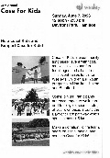
Sunday, June 7th @noon ~ Wesely Case For Kids
Case for Kids is a fun filled fundraiser with music food and face painting at Bayfront Park. Join the Melrose Movers 26 as a walker or a watcher on June 7th. Your donations can be made online at Wesley Case for Kids https://wesley.ca/giving/case-for-kids/. To join our team or for more information see Libby Cook. We hope to reach our goal of $1,000!

Can You Help?
Would you like to canvas for Case for Kids or would you like a t-shirt? Speak with Libby!


Sunday, June 14th ~ Board Games!
Come and play your favourite board game or bring your own! You do not need a partner. Entry fee is $5, children under grade 1 are free!

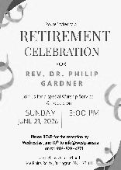
Sunday, June 21st ~ Rev. Dr Philip Gardner Retires!
Friends at Melrose, Rev. Dr. Philip Gardener is retiring at the end of June from active ministry. His retirement service will be held at West Plains United church, where he has served since leaving Melrose. The service will be at 3:00 pm on Sunday, June 21st. All are welcome. If you plan to attend, please RSVP to West Plains United Church at info@westplains.ca or call 905-529-4871.
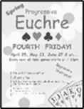
Friday, June 26th ~ Progressive Euchre
Doors open at 7pm, games start at 7:30pm sharp! Beginners welcome!

Social Media at Melrose!

Melrose has an active social media presence on Facebook and Instagram! Check out our pages for information on Melrose events, the wider church and for messages of inspiration! Please visit: www.facebook.com/melroseunitedchurch
and www.instagram.com/melroseuc/

News From the Office
Please be sure to submit your church related news items for the bulletin or newsletter by Wednesday of each week. Kindly email the office. Thank you!
