**MELROSE UNITED CHURCH**

86 Homewood Avenue ~ Hamilton, Ontario ~ L8P 2M4

☎ 905 522 1323 *~* ✉ [melrose@melroseunited.ca](mailto:melrose@melroseunited.ca)

🖰 [www.melroseunited](http://www.melroseunited).ca

www.facebook.com/melroseunitedchurch

Instagram: @melroseu

YouTube channel: Melrose United Church Virtual Service

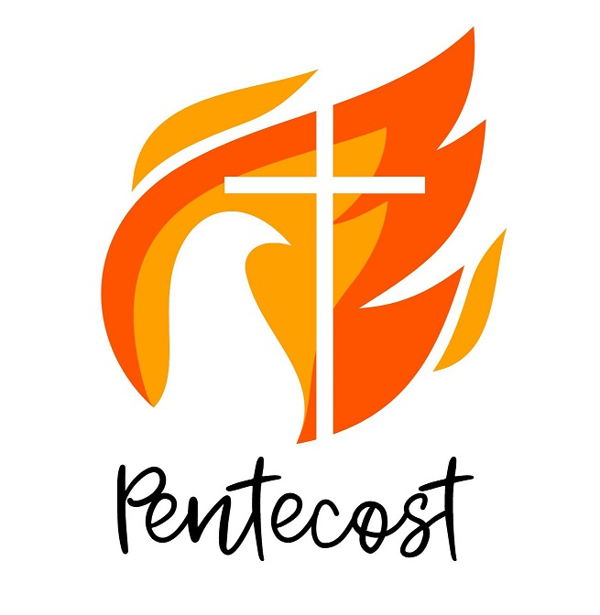

|  |  |
| --- | --- |
| Worship Leaders: | Margaret Duff  Rev. Rick Maxwell |
| Music Director:  Custodian:  Church Administrator: | Alexander Cann  Kevin Geluch  Sue Hawthorne-Bate |

**Sunday, June 8, 2025**

**Pentecost**

# *GATHERING IN COMMUNITY*

*The* PRELUDE ~ St. Anthony Chorale, J. Haydn

*The* INTROIT ~ VU 202 O Breath of Life

*The* PROCESSIONAL HYMN ~ VU 231 I Sing the Mighty Power

*The* WELCOME *and the* LIFE *of the* CHURCH

*The* LAND ACKNOWLEDGEMENT

& LIGHTING *of the* CANDLE *of* PEACE

*The* LIGHTING *of the* CHRIST CANDLE

*the Christ Candle is lit….*

*A* SOLO ~ With verdure clad, from *The Creation*, J. Haydn,

Allana Stevenson, soprano

*The* CALL *to* WORSHIP

One: From the beginning of time, the universe has hummed with creative energy.

**All: The rhythm of love pulses in our veins and echoes in our heartbeat.**

One: With a breath, God began the whisper of life, and it reverberates in our breathing.

**All: We live and breathe and have our being in the One who called us into life.**

One: And we raise our voices to this One with praise and gratitude.

*The* OPENING PRAYER

*The* PRAYER *of* FORGIVENESS *and* *the* WORDS *of* ASSURANCE

One: We have been lit by your Spirit’s fire, O God,

**All: yet too often that fire feels more like heartburn.**

One: As branches of your sculpted driftwood,

**All: we feel desiccated, dry, discarded.**

One: Though your fire once burned fiercely within us,

**All: now it seems like our previous promises are but dust, that we are blowing in the winds of sin and hopelessness.**

One: Rekindle that flame, O Christ,

**All: look into the depths of our broken souls and gently blow your Spirit of forgiveness.**

*Gord Dunbar,**Port Nelson U.C., Burlington, ON*

*…a time of silent reflection…*

*An* ANTHEM ~ Adagio, from *Salve Regina*, J. Haydn

*Hail, Holy Queen, Mother of Mercy, our life,*

*our sweetness and our hope!*

*To thee do we cry, poor banished children of Eve;*

*to thee do we send up our sighs,*

*mourning and weeping in this valley of tears.*

*The* ASSURANCE *of* GOD’S GRACE *and* MERCY

***TIME FOR THE CHILDREN AND THE CHILD WITHIN US***

*A* Children’s Story

*A* HYMN ~ VU 325 Christ is Made the Sure Foundation

***HEARING AND RESPONDING TO THE WORD***

*Reader ~ Dianne Coons*

*The* PRAYER *of* ILLUMINATION

**All: Your voice thunders, O God, in might and in power. Yet it is also the still, small voice of calm. May we experience your voice in scripture today, O God, and may we have the wisdom to discern the message that is from you. Amen.**

*Susan Lukey, High River U.C., High River, Alta.*

*The* BOOK *of* ACTS , Chapter 2, verses 1 to 21

One: May God’s Spirit shape the understanding of these words.

**All: And may they awaken in our hearts.**

PSALM 104 ~ VU 826, Part 2

**Refrain 1: Bless, O my soul, the Almighty, who rules all creation.**

*The* GOSPEL *of* JOHN, Chapter 14, verses 8 to 17 and 25 to 27

One: Hear the Good News!

**All: Praise be to Jesus Christ!**

*The* REFLECTION

*An* ANTHEM ~ Allegro, from *Salve Regina,*  J. Haydn

*Turn then, O most gracious advocate,*

*thine eyes of mercy toward us.*

*The* INVITATION TO THE OFFERING

*An* OFFERING HYMN ~ VU 541 Praise God From Whom All

Blessings Flow

**Sing: Praise God from whom all blessings flow;**

**Praise God all creatures high and low;**

**Give thanks to God in love made known:**

**Creator, Word, and Spirit, One.**

*The* PRAYER *of* DEDICATION

***SERVICE OF THE TABLE***

*The* INVITATION *to* COMMUNION

One: Faith glows like coals within our hearts.

At this table, Jesus makes alive those coals.

Together, gathered as one, we are God’s blaze of joy.

**All: We come; we yearn; we hunger; we thirst.**

One: Join together at this table, Christ’s table, the invitation is for all who burn with Spirit fire, for all who wish to taste and see that God is good.

**All: Wondering wishing for wholeness, welcomed,**

**we accept the invitation and join the fire.**

One: In the name of the One who said,

“I am the bread of life,”

I invite you to come and eat.

In the name of the One who said,

“I am the true vine,”

I invite you to come and drink.

In the name of the One who said

“Love one another as I have loved you,”

I invite you to the table of Jesus Christ.

This is the table of the risen Christ.

**All: In this feast, comes the promise of the earth and the glory of all creation. In this feast, comes the Christ, Saviour and Friend to all.**

One: The celebration of communion is always a festival of friends, a pulling together of our loves and our hopes, our moments of agony and our glimpses of victory.

**All: It is here where bread is broken, and wine shared that we can most fully be ourselves and see others for who they truly are; sons and daughters of the living God.**

One: Here the common things of life – bread and wine, memories and dreams – become touched by God.

**All: Here that which is earthly becomes divine, and that which is human becomes more that it has ever dreamed.**

One: Christ is the living water cleansing, refreshing, making all things new. Christ is the living bread, food for the hungry strength for the pilgrim and the labourer.

**All: We give you thanks, God of peace and promise. Through the works of your prophets and the faith of your followers you prepare the way of our redemption and bring hope to birth.**

One: And though we often grow weary of waiting, your signs call us to keep watch for that day when all things shall be made new. In assurance of this hope, we join with all the company of heaven and earth to give you praise.

**All: Holy, holy, holy Lord,** VU 942

**God of power and might;**

**Holy, holy, holy Lord,**

**God of power and might.**

**Heav’n and earth are full, full of your glory.**

**Hosanna in the highest, hosanna in the highest.**

**Blessed is he who comes in the name of the Lord.**

**Hosanna in the highest, hosanna in the highest.**

One: Jesus asked that we remember his acts of love and the sharing with his friends at table, and we do remember.

On the night he died, Jesus took the loaf of bread and breaking it said: Take and eat; whenever you do this, remember me.

*…bread is broken*

One: Likewise, after supper, he took the cup, saying; “This is the new covenant in my blood, whenever you do this, remember me”.

*….chalice is raised*

One: In the sharing of this meal, Jesus is here amongst us.

**All: Loving God, we rejoice in the gift of your grace, remembering Christ’s life and death, proclaiming his resurrection, waiting in hope for his coming again. Grant that, in praise and thanksgiving we may so offer ourselves to you that our lives may proclaim the mystery of faith.**

**All: Christ has died.** VU 943

**Christ is risen.**

**Christ will come again.**

*A* COMMUNION ANTHEM ~ Largo/Allegretto,

*f*rom *Salve Regina*, J. Haydn

*And after this our exile,*

*show unto us the blessed fruit of thy womb, Jesus.*

*O clement, O loving, O sweet Virgin Mary!*

One: Christ is the living water, cleansing, refreshing, making all things, new. Christ is the living bread; food for the hungry, strength for the pilgrim and the labourer.

**All: On this glorious day celebrating the birth of the Church, Holy Parent, we give you thanks, God of peace and promise. Through the words of your prophets and the faith of your followers you prepare the way of our redemption and bring hope to birth.**

One: Send O God, your Holy Spirit upon us and what we do here, that we and these gifts, empowered by your Spirit may become signs of hope and peace to one another and to all peoples of the earth.

**All: Amen, amen, amen, amen.** VU 943

\*\**Congregational participants will come forward at this time.*

*All are invited! Elements are served by intinction.*

*(Take the bread and dip it in the cup)*

*The* PRAYER AFTER COMMUNION

**All: For the nourishment we receive in recollection of Jesus’ time on earth with us, and in gratitude for his life’s work, teaching, and spirit of love, we recommit ourselves to walking in his Way, as people of Light, who care for one another. And now O God of Grace, on your people pour your power. Amen.**

*The* LORD’S PRAYER

**All: Our Father, who art in heaven,**

**Hallowed be thy name,**

**Thy kingdom come,**

**Thy will be done**

**On earth, as it is in heaven.**

**Give us this day**

**our daily bread,**

**And forgive us our trespasses,**

**As we forgive those who trespass against us.**

**And lead us not into temptation,**

**But deliver us from evil:**

**For thine is the kingdom,**

**the power, and the glory**

**Forever and ever. Amen.**

***SENDING FORTH***

*The* RECESSIONAL HYMN ~ Glorious Things of Thee are Spoken

**Glorious things of thee are spoken,  
Zion, city of our God.  
He whose word cannot be broken  
formed thee for his own abode.  
On the rock of ages founded,  
what can shake thy sure repose?  
With salvation's walls surrounded,  
thou may'st smile at all thy foes.**

**See, the streams of living waters,  
springing from eternal love,  
well supply thy sons and daughters  
and all fear of want remove.  
Who can faint while such a river   
ever flows their thirst to assuage?**

**Grace, which like the Lord, the giver,  
never fails from age to age.**

**Saviour, since of Zion's city  
I through grace a member am,  
let the world deride or pity,  
I will glory in thy name.  
Fading is the world's best pleasure,  
all its boasted pomp and show;  
solid joys and lasting treasures  
none but Zion's children know.**

*The* COMMISSIONING

*The* CHORAL BENEDICTION ~ C. Franck

*The* POSTLUDE ~ Finale from *Trio in E-flat Major*, J. Haydn

🙡🙡🙡🙡🙡🙡

Today’s Choral selection: *Salve Regina in G Minor* Hob.XXIIIb:2,

Joseph Haydn

*Soloists: Allana Stevenson, soprano*

*Tabitha de Bruin, alto*

*Bud Roach, tenor*

*Chris Palmer, baritone*

*Musicians: Paul Barna, Kate Unrau: violin*

*Elspeth Thomson: viola*

*Amber Ghent: cello*

🙡🙡🙡🙡🙡🙡

*If you would like to light a candle to represent your prayers for a person or situation that is in your heart, you are invited to do so at the beginning or end of any worship service.*

*Personal prayer requests – please write your prayer requests in our Prayer Share Book during the service.*

*Today’s Greeter ~ Sandra Groves Winninger*

**Announcements**

**Sunday, June 15th ~ Celebrate the UCC’s 100th Birthday in Style!**

Join us for a special worship service and catered lunch as we celebrate 100 years of the United Church of Canada! Everyone is invited to dress in period costume—think suits and ties for the gentlemen, and hats, gloves, and vintage flair for the ladies.

If you have a family heirloom or item that’s around 100 years old, we’d love for you to bring it along! You can place it on the display table in the Parlour for everyone to enjoy. Let’s make this a joyful and memorable celebration! Questions? Contact Libby or Gwyn.

***Please RSVP regarding the lunch to Sue in the Church office, melrose@melroseunited.ca by June 10th! Thank you!***

******Sunday, June 8th @ 2pm to 5pm ~ Board Games!**

All ages welcome! Bring along your favourite board game. You do not need a partner. Entry fee, $5 for individuals, $10 for families.

**Sunday, June 15th ~ Sundays UnLocked @10am to 5pm.**

Sundays UnLocked returns for 2025! The Locke Street shops will unlock the street for live music, patios, artisans, family fun, shopping, and great food! This will be a pedestrian only event so Locke Street will be close to vehicular traffic between Hunter Street and Herkimer Street so be prepared for a few detours!

**Saturday, June 21st**

**Knitting & Crochet @ 9:30 – 11:30**

Bring your current project and materials, beginners welcome! Coffee, tea and snacks will be provided.

**Friday, June 27th ~ Progressive Euchre** ~ Doors open at 7pm, games start at 7:30 sharp! Beginners welcome!

**Social Media at Melrose!**

Did you know? Melrose has an active social media presence on Facebook and Instagram! Check out our pages for information on Melrose events, the wider church and for messages of inspiration! Please visit: www.facebook.com/melroseunitedchurch

www.instagram.com/melroseuc/

**News From the Office**

Please be sure to submit your items for the bulletin or newsletter by Wednesday of each week. Kindly email the office. Thank you!

**