MELROSE UNITED CHURCH
86 Homewood Avenue ~ Hamilton, Ontario ~ L8P 2M4
905 522 1323 ~ melrose@melroseunited.ca
www.melroseunited.ca
www.facebook.com/melroseunitedchurch
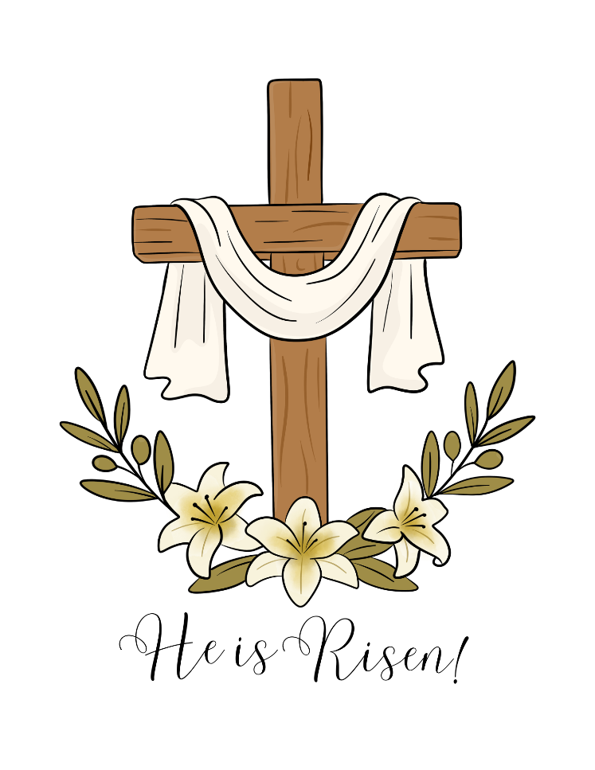
Instagram: @melroseu
YouTube channel: Melrose United Church Virtual Service

Worship Leaders: | Rev Charlie Hogg,  Rev Heather Gilmour,  Rev Rick Maxwell
Music Director:  Custodian:  Church Administrator: | Alexander Cann  Kevin Geluch  Sue Hawthorne-Bate

Sunday, April 5 2026
Easter Communion Service
Sunday of the Resurrection

Gathering In Community

The PRELUDE

The WELCOME

The INTROIT ~ Alleluia, Christ the Lord is Risen, E. Daley

The LITURGY of the LIGHT

Please stand as you are able and face the rear of the church.

One: The Lord be with you.
All: And also with you.

One: Let us pray. Spirit of the eternal, you are like a refiner's fire, and your Spirit kindles the hearts of your faithful people. Bless this flame and those who keep this Easter celebration so that, burning with desire for life with you, they may be found fit to take part in that festival of Light which has no ending.
All: Amen

One: You have turned our mourning into dancing! You have taken away our clothes of suffering and re-clothed us in joy, so that our whole being—body, mind and soul—might sing praise to you and not be silent.
All: Creator of all, we give thanks to you forever!

the Christ Candle is lit….

One: May the light of the one who rises this day in glory scatter the darkness of our hearts and minds.
Let us pray. Almighty and eternal one, pour out your abundant blessing on this lighted candle, so that all who share in your holy mysteries may be filled with your grace and spiritual blessings.
All: Once we were in darkness, but since we have become the Creator's people, we are in the light. Help us to live as people who belong to the light. Amen

As the Paschal Candle is raised,
the Presiding Minister proclaims the resurrection!

One: Christus is verrezen
All: Christ is risen

One: Le Christ est ressuscité
All: Christ is risen

One: Khristos Anésti
All: Christ is risen

One: Voistynu Khrystos Voskres
All: Christ is risen indeed

One: Darkness has been vanquished!
All: The brilliant light of hope has come!

One: Come let us worship and celebrate the Good News!
All: Alleluia! Christ is risen!
Alleluia! Christ is risen!
Alleluia! Christ is risen indeed!

The PROCESSIONAL HYMN ~ Jesus Christ is Risen Today VU 155

The EASTER PRAYER

One: Bring birth within us this day,
a new experience of Easter Power, O creator of all,
the power that can roll away heavy stones that would keep us imprisoned and bound within the tombs or old possibilities that have already failed to give us life.

All: Open our hearts and minds, in our worship, to the reality of your constant presence with us and enable us to speak the words of Easter hope to those around us in the dailiness of our living. Let us revel in the constant presence of Easter not only for ourselves but to all those who may look to your people for signs of hope in a troubled world. Amen.

The LIGHTING of the CANDLE OF PEACE

Time For the Children and the Child Within Us

A CHILDREN’S STORY

A HYMN ~ This is the Day v. 1, VU 412

Hearing and Responding to the Word

Reader ~ Rosella Laux

PSALM 118 parts 2 & 3, VU 837

Refrain: Hallelujah, hallelujah!

The GOSPEL of MARK, Chapter 16, verses 1 to 8

THE RESURRECTION OF JESUS

One: For the word of God in scripture, among us, and within us.
All: Thanks be to God

THOUGHTS FOR LIVING ~ “Just a Stone”

The ANTHEM ~ The Day of Resurrection, T. Matthews

The OFFERTORY

The OFFERING HYMN ~
In Gratitude and Humble Trust VU 544

The OFFERING PRAYER

A HYMN ~ Thine is the Glory VU 173

The Service of the Table
Communion Setting C VU 936 – 939
Co-celebrants Rev Heather Gilmour, Rev Rick Maxwell & Rev Charlie Hogg

The INVITATION and WELCOME

The INTRODUCTION

One: The Lord be with you
All: And also with you.
One: Lift up our hearts.
All: We lift them to the Lord.
One: Let us give thanks to the Lord our God.
All: It is right to give our thanks and praise.
One: May you know and see that the eternal spirit of comfort and hope is with you. Open wide your anxious hearts to God’s peace and let us give Him thanks and share our joy. In this space and time, we offer God our love and praise. We marvel at the multiplicity of humanity with our complexity of colour and culture and gender orientation, yet called into oneness-of-being through Christ. With one voice, we honour you singing:

The SANCTUS and BENEDICTUS VU 936

Sing: Holy, holy, holy Lord, God of power and might,
heaven and earth are full, of your glory.
Hosanna, hosanna, hosanna in the highest.
Blessed is he who comes in the name of the Lord.
Hosanna, hosanna, hosanna in the highest.
One: Blessed Trinity, in remembrance of all you have done to save us, we offer ourselves to you in praise and thanksgiving as a holy and living sacrifice, in union with Christ's offering for us, as we sing and proclaim the mystery of our faith:

The MEMORIAL ACCLAMATION VU 939

Sing: Christ has died.
Christ is risen.
Christ will come again.

The INVITATION to the TABLE

The BLESSING & INSTITUTION of the ELEMENTS

The GREAT AMEN

Sing: Amen, amen, amen.

The SHARING of the ELEMENTS

The ANTHEM ~ Now Is Christ Risen, K Nystedt:
Allana Stevenson, flute

The PRAYER of THANKSGIVING & the LORD’S PRAYER VU 960
One: Bless us and be ever present to us as we sing and pray the words our Saviour taught us:

Sing: Our Father, who art in heaven,
hallowed be thy name;
thy kingdom come; thy will be done;
on earth as it is in heaven.
Give us this day our daily bread.
And forgive us our trespasses,
as we forgive those who trespass against us.
And lead us not into temptation;
but deliver us from evil.
For thine is the kingdom, the power and the glory,
for ever and ever.
Amen.

The STATEMENT after COMMUNION

One: God of hope, in bread and wine, you have restored us to relationship with you.
Show us how to be a people that live your reconciling love in the world, so that we may recognize your presence in those we meet, and our hearts like those first disciples may burn within us upon the road of life.

All: Lord Jesus Christ,
You are the Word for us to speak;
You are the Truth for us to tell;
You are the Light for us to illumine the darkness.
You are the Bread of Life for us to share.

Sending Forth

LIFE and WORK of the CHURCH

The RECESSIONAL HYMN ~ The Risen Christ VU 168

The COMMISSIONING

The BLESSING BEFORE the LUNCHEON

The BENEDICTION

The CHORAL BENEDICTION

The POSTLUDE ~ Preist der Erlösers Güte
(Praise the Redeemer’s Glory) from Christ on the Mount of Olives,
L. van Beethoven; Allana Stevenson, soprano
Today’s greeters are Geoff Harrison and Richard Feenstra

If you would like to light a candle to represent your prayers for a person or situation that is in your heart, you are invited to do so at the beginning or end of any worship service.

Personal prayer requests – please write your prayer requests in our Prayer Share Book during the service.

A special welcome to all who have chosen to join us for our Easter Sunday Communion service. May you be blessed this season of renewal. We invite you to join us in the parlour for the brunch reception after the service.

Eternal gratitude to all who have served in preparation of this Easter service of Celebration, Hope and Joy.
You are so very special and your hard work and creativity are dearly appreciated.

Special lauds to Alex Cann our Music Director and
the choir for their gift of music, above and beyond,
this Holy Week.

Wishing all our Jewish friends and neighbours
“Chag Sameach” on the occasion of Pesach, Passover!
(pronounced “hog samayach”)

*The Icon of Christ Pantocrator, (the risen Christ) hanging on the Cross, is a commissioned work, by Dundas Artist, Guennadi Kalininen, created for Easter Sunday.

Life And Work of the Church

TODAY! ~ Easter Brunch
Join us for Easter Brunch after the 10:30am Worship Service! The menu will include muffins, fruit, hot cross buns, yogurt, granola and of course tea and coffee! All donations will be gratefully received and will support the United Church of Canada Disaster Relief Fund.


Thank you!
Many thanks to Jeff Ogino and Rosella Laux for decorating the Sanctuary so beautifully for Palm Sunday and Easter. Thanks to Rosella for designing the beautiful Easter cards that will be delivered with flowers to our treasured members. Lastly, special thanks to Gwyn Xagoraris for coordinating today’s yummy Easter Brunch!

Your Help is Needed!
There are six more volunteer readers needed to cover all the Sundays until June 28th. Please sign up at coffee time. Speak to Rosella for more information.

Are you available to deliver a plant today after Church to a treasured member? Please meet at the back of the auditorium after the service. Thank you!


April 5th to April 15th ~ Textile Drive
Do you have used clothing, socks, towels, sheets and other items you no longer need and are no longer usable or wearable? Drop them off between April 5th to 15th in the Auditorium. All bags must be labeled “Fabric Recycling” No usable clothing will be accepted! All clothing items must be unwearable! All items will be recycled and diverted from landfills. Give a little, help a lot!

Saturday, April 11th @ 8:30pm
Bach Elgar Choir Presents ~ Der Golum at Melrose!
A 1920’s German masterpiece movie on a large screen with an exhilarating soundtrack. Tickets are available at www.bachelgar.ca.


Saturday, April 18th ~
Knitting & Crochet @9:30 – 11:30
Bring your current project and materials, beginners welcome! Coffee, tea and snacks will be provided.
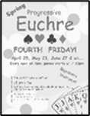
Friday, April 24th ~ Progressive Euchre
Doors open at 7pm, games start at 7:30pm sharp! Beginners welcome!


Social Media at Melrose!
Melrose has an active social media presence on Facebook and Instagram! Check out our pages for information on Melrose events, the wider church and for messages of inspiration! Please visit: www.facebook.com/melroseunitedchurch
and www.instagram.com/melroseuc/

News From the Office
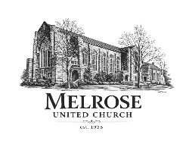
Please be sure to submit your church related news items for the bulletin or newsletter by Wednesday of each week. Kindly email the office. The office will be closed Good Friday and Easter Monday. Thank you!



The Easter Flowers are Dedicated to
The Glory of God
and in Memory of Loved Ones

Rev. Bob & Edna McLauchlin and Gordon & Peg Coons

Jane Fawcett, Ernie Fawcett, Dr. Paul Fawcett,
Benina & Tony Miscione, Laura Miscione,
Freeman & Louisa Furry and John Vasilak,

Adrina Macfarlane, Betty & Blake Macfarlane,
and Blake Macfarlane jr., Helene & Alex Mann

Elizabeth & Jim Sharp, Tina Witte, Loretta Stockton

Fred Saunders, Harold & Gladys Saunders,
William & Kathleen MacFarlane,
Betty & Ron MadFarlane, Helen & George Krick, Doris Barker, Ron & Barbara Temple, Brad Cape, Dora & Jim Gradwell,
Willy Bethea, Ruth McQueen, Flo Longworth,
Ted Lowry, Sylvia Vanderby, Madeline Gibb and Penny Lane

Phil Sr. & Diane Farrauto, Ken, Doris & Malcolm MacGregor

In loving memory of Bruce & Ida Carr, and Elsie North Johns,
loving parents and precious Mother-in-Law of Kathy North Ross

In loving memory of the parents of Carolyn & David Duff

Grandparents of Matthew & Elora Wininnger

Margaret Ruth Mayhew mother of George Mayhew

Helen, Russell & Margaret Landeen

Helen & George Laidman, parents of Ken Laidman
Margaret Kaine & Hilda Little, grandmothers of Anne Laidman

Alex and Mary Ann McRae, parents of Lucy-Jane Hannaford
Norma and Edna Hannaford, parents of Allan Hannaford
Roy Hannaford, beloved brother of Allan Hannaford

In loving memory of Johnnie & Esther Gilmour

In loving memory of London

In memory of Kathy by Ashleigh Leggat

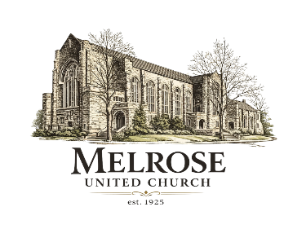
In memory of the parents of Libby Cook and Richard Feenstra

