MELROSE UNITED CHURCH
86 Homewood Avenue ~ Hamilton, Ontario ~ L8P 2M4
905 522 1323 ~ melrose@melroseunited.ca
www.melroseunited.ca
www.facebook.com/melroseunitedchurch
Instagram: @melroseu
YouTube Channel: Melrose United Church Virtual Service


Worship Leaders: | Rev Charlie Hogg  Rev Heather Gilmour
Music Director:  Custodian:  Church Administrator: | Alexander Cann  Kevin Geluch  Sue Hawthorne-Bate
Sunday, March 15, 2026
Fourth Sunday in Lent
PIE Day

Gathering In Community

The LAND ACKNOWLEDGEMENT

We acknowledge that our church is located on the traditional territories of the Erie, Neutral, Huron-Wendat, Haudenosaunee and Mississaugas. May we continue to live with respect on this land, and to live in peace and friendship with all its people in the spirit of truth and reconciliation.

The PRELUDE

The WELCOME

~ We enter the Sacredness of Worship ~

The LIGHTING of CANDLE of PEACE

The INTROIT ~ Give the Lord the honour due, G. Thalben-Ball

The CALL to WORSHIP

The PROCESSIONAL HYMN ~
Immortal, Invisible God Only Wise VU 264

The LIGHTING of the CHRIST CANDLE

the Christ Candle is lit….

A LENTEN PASSION PRAYER of CONFESSION

One: We have been born into a world where Love seems to have vanished.
All: We try to do the right thing, but at times we fail, and indifference seems to win.

One: At other times, we seem to drown in our shortcomings, believing nothing good can come from us.
All: We forget that God has called us to Love one another and to love ourselves first.

One: We confess that there are times when we are blind to the cost of following the light of the world, our prince of peace.
All: We ignore the fork in the road to Jerusalem and choose the one well travelled as our default route.

One: Loving God, help us to walk with you, on the road less travelled, as we journey towards the cross this Lenten season,
All: give us the wisdom to do what we can to help those who cannot walk with you in this way of suffering. Amen

Time For the Children and the Child Within Us

A CHILDREN’S STORY

Hearing and Responding to the Word

Reader ~ Margaret Duff

The BOOK of 1 SAMUEL, Chapter 16, verses 1 to 5

One: The Word of the Lord
All: Thanks be to God.

PSALM 23 VU 747

The GOSPEL of JOHN, Chapter 9, verses 1 to 12

One: For the word of God in scripture, among us, and within us.
All: Thanks be to God.

A HYMN ~ Spirit of the Living God VU 376

THOUGHTS FOR LIVING ~ “There’s Hope in Mud”

An ANTHEM ~ Any How, E.L. Pittman, arr

The INVITATION TO THE OFFERING

The OFFERING HYMN ~ Just as I Am VU 508

Sing: Just as we are, O God, receive
This humble prayer on bended knee
Your Love, so needed, sets us free
And lifts our tongues to sing, “praise be!”

The OFFERING PRAYER



The Service of the Table
Communion Setting C VU 936 to 939

The INVITATION to the TABLE

The GREAT THANKSGIVING VU 936

One: May you know and see that the eternal spirit of comfort and hope is with you. Open wide your anxious hearts to God’s peace and let us give Him thanks and share our joy. In this space and time, we offer God our love and praise.
We marvel at the multiplicity of humanity with our complexity of colour and culture yet called into oneness-of-being through Christ. With one voice, we honour you singing:

Sing: Holy, Holy, Holy Lord, God of power and might,
heaven and earth are full of your glory. Hosanna in the highest. Blessed is He who comes in the name of the Lord. Hosanna in the highest.

The BLESSING and INSTITUTION

The MEMORIAL ACCLAMATION VU 939

Sing: Christ has died, Christ is Risen, Christ will come again.

The GREAT AMEN VU 939

Sing: Amen, amen, amen.

The SHARING of the ELEMENTS

The DISTRIBUTION of the ELEMENTS

A COMMUNION ANTHEM ~ O Heavenly Father, T. Matthews

The PRAYERS of the PEOPLE

The LORD’S PRAYER

All: Our Father, who art in heaven,
Hallowed be thy name,
Thy kingdom come,
Thy will be done
On earth, as it is in heaven.
Give us this day
our daily bread,
And forgive us our trespasses,
As we forgive those who trespass against us.
And lead us not into temptation,
But deliver us from evil:
For thine is the kingdom,
the power, and the glory
Forever and ever. Amen.

Sending Forth

The LIFE of the CHURCH

The RECESSIONAL HYMN ~ Precious Lord Take My Hand VU 670

The COMMISSIONING and BENEDICTION

The POSTLUDE

Today’s greeters are Geoff Harrison and Richard Feenstra
Today’s Communion assistant is George Mayhew

If you would like to light a candle to represent your prayers for a person or situation that is in your heart, you are invited to do so at the beginning or end of any worship service.

Personal prayer requests – please write your prayer requests in our Prayer Share Book during the service.

Life And Work of the Church

Welcome!
Today we joyfully welcome Rev. Charlie Hogg and Rev. Heather Gilmour to our worship. They will lead our services through the rest of Lent and Holy Week. Please be sure to introduce yourself during coffee hour!
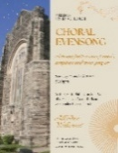
Sunday, March 15 ~ Tonight! Choral Evensong
A beautiful service of music, scripture and quiet prayer with Rev Dr Philip Garder and the Melrose Chancel Choir.

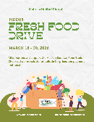
Fiddes Fresh Food Drive ~ March 16th– 30th
This is our fourth year of collaborating with our Church Partners on Locke Street to assist those with food security issues in Hamilton. The list below indicates fresh food items and cost. There are many ways to place an order! Etransfers can be sent to: dustin@fwp.ca. Clearly indicate that the purchase is for Melrose United Church -Mission Services. You can choose to ask Libby or Gwyn to place the order for you and we gladly accept cash/cheque to do so. If you are already a Fiddes Customer, on your next visit ask to have the item added to the Melrose/Mission Services Food Order.

1 case bananas x 40lbs - $39.50
1 case Granny Smith apples x 40lb - $63.50
1 case Red Delicious apples x 40lb - $63.50
1 case Golden Delicious apples x 40lb - $63.50
1 bushel Gala apples x 40lb - $59.50
1 case oranges x 40lb - $54.50
1 bag russet potatoes x 50lb - $28.00
1 bag onions x 50lb - $32.00
1 bag carrots x 50lb - $39.50
1 bag carrots 24x2lb - $49.50
1 case green cabbage x 40lb - $33.00
1 case broccoli x 20lb - $49.50
1 case butternut squash x 40lb - $49.50
1 case acorn squash x 40lb - $49.50

Please help make our effort to assist in reducing food insecurity in Hamilton a success!

Saturday, March 21st ~
Knitting & Crochet @9:30 – 11:30
Bring your current project and materials, beginners welcome! Coffee, tea and snacks will be provided.
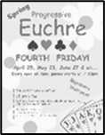
Friday, March 27th ~ Progressive Euchre
Doors open at 7pm, games start at 7:30pm sharp! Beginners welcome!

Easter Sunday, April 5th ~ Easter Brunch
Join us on Easter Sunday for Brunch after the 10:30am Worship Service! The menu will include muffins, fruit, hot cross buns, yogurt, granola and of course tea and coffee! All donations will be gratefully received and will support the United Church of Canada Disaster Relief Fund.

Saturday, April 11th @ 8:30pm
Bach Elgar Choir Presents ~ Der Golum at Melrose!
A 1920’s German masterpiece movie on a large screen with an exhilarating soundtrack. Tickets are available at www.bachelgar.ca.

Easter Flowers
Every year we decorate our Sanctuary with beautiful flowers for Easter. If you wish to donate towards the Easter flowers in memory of a loved one, there will be envelopes available at the front of the church. Please drop your envelope in the collection plate. You can also email the office, melrose@melroseunited.ca. Please be sure to include the names of your loved ones! We accept cash, cheques or etransfers.


Social Media at Melrose!
Melrose has an active social media presence on Facebook and Instagram! Check out our pages for information on Melrose events, the wider church and for messages of inspiration! Please visit: www.facebook.com/melroseunitedchurch
and www.instagram.com/melroseuc/

News From the Office
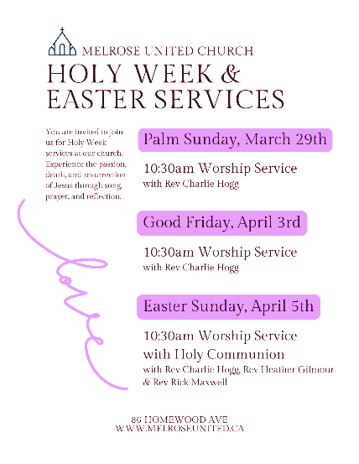
Please be sure to submit your church related news items for the bulletin or newsletter by Wednesday of each week. Kindly email the office. Thank you!

