MELROSE UNITED CHURCH
86 Homewood Avenue ~ Hamilton, Ontario L8P 2M4

905 522 1323 ~ melrose@melroseunited.ca
www.melroseunited.ca
www.facebook.com/melroseunitedchurch
Instagram: @melroseuc
YouTube channel: Melrose United Church Virtual Service

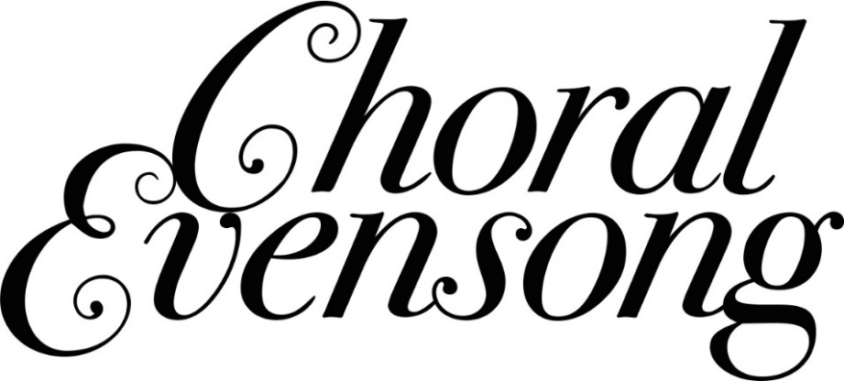

Worship Leader: | Rev. Dr. Philip Gardner
Music Director:  Custodian:  Church Administrator: | Alexander Cann  Kevin Geluch  Sue Hawthorne-Bate
Choral Evensong
Sunday January 25, 5:00p.m.

The PRELUDES ~ Two Versets, L. Marchand
Kyrie, A. P. F. Boëly

The PROCESSIONAL HYMN ~
Come, Let Us to the God of Love VU 653

The PRECES and RESPONSES

PSALM 103 (sung by choir)

Praise the Lord O my soul: and all that is within me praise his holy Name.
Praise the Lord O my soul: and forget not all his benefits;
Who forgiveth all thy sin, and healeth all thine infirmities;
Who saveth thy life from destruction, and crowneth thee with mercy and loving kindness;
The Lord is full of compassion and gracious, long-suffering and of great goodness.
He will not always be chiding: neither keepth he his anger for ever.
For look how high the heaven is in comparison of the earth, so great is his mercy also toward them that fear him.
Look how wide also the east is from the west, so far hath he set our sins from us.
Yes, like as a father pitieth his own children, even so is the Lord merciful unto them that fear him.
For he knoweth wehereof we are made: he remembereth that we are but dust.

The OPENING PRAYER

A READING from the BOOK of ISAIAH 35: 4-7

One: The Word of the Lord
All: Thanks be to God

The MAGNIFICAT ~ Magnificat in C Major, C.V. Stanford

A READING from the GOSPEL of MARK 7: 31-37

One: Let us respond in faith to the Gospel of our Lord
All: Praise be to you, Jesus Christ

NUNC DIMITTIS ~ Nunc Dimittis in C Major, C.V. Stanford

The NEW CREED

All We are not alone,
we live in God’s world.

We believe in God:
who has created and is creating,
who has come in Jesus,
the Word made flesh,
to reconcile and make new,
who works in us and others
by the Spirit.

We trust in God.
We are called to be the Church:
to celebrate God’s presence,
to live with respect in Creation,
to love and serve others,
to seek justice and resist evil,
to proclaim Jesus, crucified and risen,
our judge and our hope.

In life, in death, in life beyond death,
God is with us.
We are not alone.
Thanks be to God.

An ANTHEM ~ I Was Glad, H. Parry

The PRAYERS and PRAYER OF JESUS

All: Our Father, who art in heaven,
Hallowed be thy name,
Thy kingdom come,
Thy will be done
On earth, as it is in heaven.
Give us this day
our daily bread,
And forgive us our trespasses,
As we forgive those who trespass against us.
And lead us not into temptation,
But deliver us from evil:
For thine is the kingdom,
the power, and the glory
Forever and ever. Amen.

The PRAYER OF ST. JOHN CHRYSOSTOM

The CLOSING REMARKS

The RECESSIONAL HYMN ~ O God of Every Nation VU 677

The BLESSING

The POSTLUDE ~ Adagio, Sonata #18 in D Major,
W.A. Mozart

Tonight’s greeters are Libby Cook & Richard Feenstra

Our heartfelt thanks to Reverend Dr. Philip Gardner,
to our Chancel Choir and to Alexander Cann our Music Director
for our beautiful service this evening!

