MELROSE UNITED CHURCH
86 Homewood Avenue ~ Hamilton, Ontario ~ L8P 2M4

905 522 1323 ~ melrose@melroseunited.ca
www.melroseunited.ca
www.facebook.com/melroseunitedchurch
Instagram: @melroseuc
YouTube channel: Melrose United Church Virtual Service

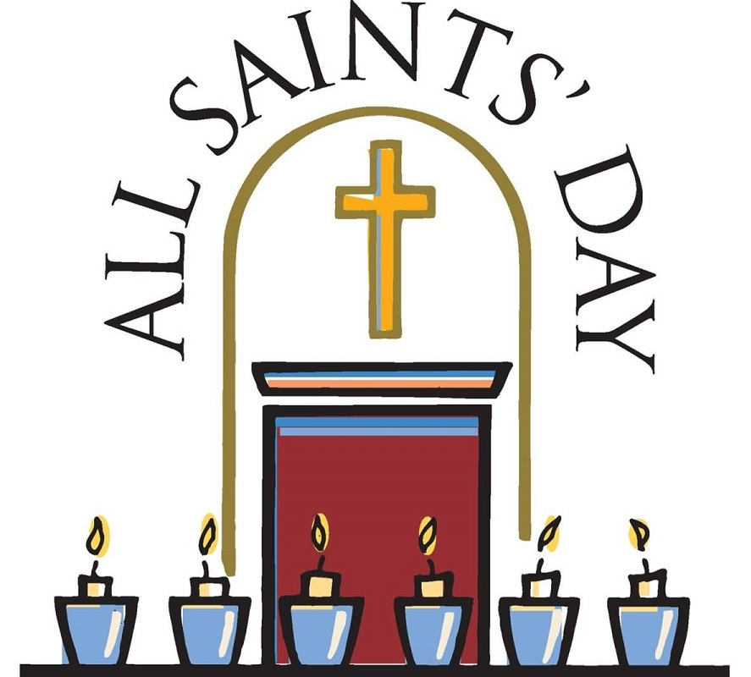

Worship Leader: | Tabitha de Bruin
Music Director:  Custodian:  Church Administrator: | Alexander Cann  Kevin Geluch  Sue Hawthorne-Bate
November 2, 2025
Twenty-First Sunday after Pentecost

Gathering In Community

The PRELUDE ~ Trumpet Air and Interlude, S. Vann

The INTROIT ~ Kyrie Eleison, E. Daley

The PROCESSIONAL HYMN ~ Let Us Build a House MV 1

WELCOME and LIFE of the CHURCH

A HYMN ~ Give Praise to God VU 872

The LAND ACKNOWLEDGEMENT

LIGHTING of the CANDLE of PEACE
& LIGHTING of the CHRIST CANDLE

Christ Candle is lit…

The CALL to WORSHIP

One: We gather together to worship the Lord, our God.
All: We come with hearts full of gratitude and voices raised in praise.

One: Let us celebrate His goodness and proclaim His greatness.
All: For the Lord is our strength and our salvation.

One: Sing to the Lord a new song; sing to the Lord, all the earth.
All: Let the heavens be glad, and let the earth rejoice; let the sea roar, and all that fills it.

One: Let the field exult, and everything in it!
Then shall all the trees of the forest sing for joy.
All: Come, let us worship the Lord in the beauty of holiness!

The OPENING PRAYER

All: Faithful Redeemer,
You are the beginning and ending of all things.
You make your home among us,
and abide with us as our God.
Teach us to live as the saints you call us to be,
that we may truly be your people,
living and doing your will,
in the name of Jesus, who is the Christ. Amen.

The PRAYER of FORGIVENESS

All: Merciful God, we come before You with humble hearts, acknowledging our faults and failures. Help us to forgive ourselves as You forgive us, and to extend that same grace and mercy to others. Give us the strength to turn away from wrong and to walk in the light of Your love and truth. Renew in us a right spirit, O Lord, and lead us on the path of righteousness. May we continually seek Your face, trusting in Your endless mercy and love.

The WORDS of ASSURANCE

Time For The Children And The Child Within Us

A CHILDREN’S STORY

A HYMN ~ This Is the Day VU 412, verse 1

Hearing And Responding To The Word

Reader Margaret Duff
The PRAYER of ILLUMINATION

All: Guide us, O God,
by your Word and Spirit,
that in your light we may see light,
in your truth find wisdom,
and in your will discover your peace,
through Jesus Christ our Lord. Amen.

The BOOK of EPHESIANS, Chapter 1, verses 11 to 23

One: Hear the Good News!
All: Praise be to Jesus Christ!

The GOSPEL of LUKE Chapter 6, verses 20 to 31

One: Hear the Good News!
All: Praise be to Jesus Christ!

REFLECTION ~ Imperfect Saints

The ANTHEM ~ Lo, Round the Throne, K. Bissell

The LIGHTING of MEMORIAL CANDLES

All: Loving and Gracious God,
We remember those Saints who have gone before us.
We lament their passing and honour their legacy, and we give thanks for all we have learned from them.

The INVITATION to the OFFERING

The OFFERING HYMN ~
Praise God From Whom All Blessings Flow VU 541

Sing: Praise God from whom all blessings flow;
praise God all creatures high and low;
give thanks to God in love made known;
Creator, Word and Spirit, One.

The PRAYER of DEDICATION

The PRAYERS of the PEOPLE

The LORD’S PRAYER

All: Our Father, who art in heaven.
hallowed be thy name.
Thy kingdom come,
thy will be done
on earth as it is in heaven.
Give us this day our daily bread;
and forgive us our trespasses,
as we forgive those that trespass against us.
And lead us not into temptation,
but deliver us from evil;
for thine is the kingdom and the power
and the glory,
for ever and ever.
Amen.

Sending Forth

The RECESSIONAL HYMN ~
Christ is Made the Sure Foundation VU 325

The COMMISSIONING

The CHORAL BENEDICTION ~ Hear Thou Our Prayer,
E. Daley

The POSTLUDE ~ Choirs Wandering, Q. Thomas

Today’s Greeters are Libby Cook and Richard Feenstra
If you would like to light a candle to represent your prayers for a person or situation that is in your heart, you are invited to do so at the beginning or end of any worship service.

Please make your prayer requests known to the Worship Committee so that they may be included in our time together.

Life And Work of the Church

Saturday, November 15th ~ Knitting & Crochet @ 9:30 – 11:30
Bring your current project and materials, beginners welcome! Coffee, tea and snacks will be provided.

Sunday, November 16th ~ Choral Evensong
Join us at 5:00pm for a short evening service of beautiful music, quiet prayer and scripture with our Rev Philip Gardner and our Chancel Choir.

Saturday, November 22nd ~ Mistletoe Bazaar 9am to noon

Mark your calendars! This year’s bazaar is shaping up to be the best ever! This means its time to start baking cookies for our cookie walk (and freezing them!) Please also consider baking squares or tasty treats for our bake table. Please speak to Gwyn or Libby if you can help!

Friday November 28th ~ Progressive Euchre
Doors open at 7pm, games start at 7:30 sharp! Beginners welcome!

100TH Anniversary Dinner
Thank you to everyone who came to the Anniversary Dinner! A great time was had by all! Photos to come shortly!

Anniversary T-Shirts
The Anniversary Committee is considering selling t-shirts and bags to celebrate our upcoming anniversary if there is interest from the congregation. Please speak to Libby or Gwyn and let them know what you think!

Can You Help?
If you have any information regarding the quilting group that used to meet at Melrose please speak to Rosella or send her an email at rosellas_moon@yahoo.ca.

Rental Groups at Melrose
Melrose United Church is home to many community rental groups. Now that fall is here many are taking new members or have great services to offer! For the next few weeks, we will highlight one of these groups.
- Bach Elgar Choir
- Human Performance Solutions Mobile
- Royal Scottish Country Dancers
- Basketball
- Steel City Swing
- Women of Song
- Indoor Soccer
- Embers, Guides and Pathfinders
- Carpet Bowling
- Vocalway Vocal Instruction
- Tai Chi
- Music Together, Giggle and Groove
- Ball Hockey
- Sandra Ramunno, Piano Teacher
- Ingelbert Lievaart II Photography
- Little Learning House Daycare
If you are interested in any of these groups or organizations, please contact Sue in the office for more information, melrose@melroseunited.ca.

Girl Guides at Melrose!

Did you know? Melrose is the home of the 19th Embers, Girl Guides and Pathfinders! These groups meet Monday evenings in the parlour, auditorium and gymnasium. “At Girl Guides of Canada, girls discover their potential, build their confidence and embrace their power as changemakers, innovators and leaders. Whether its going on outdoor adventures or building real-life skills, they're learning to be bold, curious and connected – all in a supportive, inclusive space.” If you know of anyone interested in joining one of these groups, please speak to Sue in the office for more information, email melrose@melroseunited.ca.

Social Media at Melrose!

Melrose has an active social media presence on Facebook and Instagram! Check out our pages for information on Melrose events, the wider church and for messages of inspiration! Please visit: www.facebook.com/melroseunitedchurch and www.instagram.com/melroseuc/

News From the Office
Please be sure to submit your items for the bulletin or newsletter by Wednesday of each week. Kindly email the office. Thank you!
