MELROSE UNITED CHURCH
86 Homewood Avenue ~ Hamilton, Ontario ~ L8P 2M4
905 522 1323 ~ melrose@melroseunited.ca
www.melroseunited.ca
www.facebook.com/melroseunitedchurch
Instagram: @melroseu
YouTube channel: Melrose United Church Virtual Service



Worship Leader: | Rev Brenna Baker
Music Director:  Custodian:  Church Administrator: | Alexander Cann  Kevin Geluch  Sue Hawthorne-Bate

Sunday, March 8, 2026
Third Sunday in Lent

Gathering In Community

The PRELUDE

The INTROIT ~ Give the Lord the honour due, G. Thalben-Ball

The PROCESSIONAL HYMN ~
Come Down O Love Divine VU 367

The WELCOME and the LIFE of the CHURCH

The LAND ACKNOWLEDGEMENT
& LIGHTING of the CANDLE of PEACE

The LIGHTING of the CHRIST CANDLE

the Christ Candle is lit….

The CALL to WORSHIP

One: We are a community called by grace.
All: We are a community summoned to pray and praise.
One: We are a community commissioned to compassion and mercy.
All: We are the Body of Christ.
One: Let us worship and live as God’s faithful people.

The OPENING PRAYER

The PRAYER of CONFESSION

One: God of promise and hope,
you call us to trust in your way
and set before us paths of faithfulness.
Sometimes we hesitate to follow you
and to make changes in our lives.
Sometimes our priorities and commitments
reflect personal interests more than
your desire for our lives and world.
All: Free us, O God, that we might be faithful to you
in the name of the Christ, we pray. Amen.

Silence for personal reflection….

The WORDS of ASSURANCE

All: God is merciful and gracious,
slow to anger and abounding in steadfast love.
God has compassion for our fears and failures;
God stays with us on our Lenten journey.
We are a forgiven people.
Thanks be to God!

Time For the Children and the Child Within Us

A CHILDREN’S STORY

A HYMN ~ Amazing Grace, How Sweet the Sound VU 266

Hearing and Responding to the Word

Reader ~ Richard Feenstra

The PRAYER of ILLUMINATION

All: God of call, God of transformation,
God of the Lenten journey;
help us to discern your still, small voice.
Open us to change and growth
that we may walk with Christ. In Jesus’ name.
Amen.
PSALM 95 (chanted by choir)

The GOSPEL of JOHN, Chapter 4, selected verses

One: Hear the Good News!
All: Praise be to Jesus Christ!

The REFLECTION ~

An ANTHEM ~

The INVITATION TO THE OFFERING

The OFFERING HYMN ~ We Give You But Your Own VU 542

Sing: We give you but your own, what e’er the gift may be;
all that we have is yours alone, we give it gratefully.

The PRAYER of DEDICATION

All: Thankful for the faithfulness of those who have gone before us, and those with whom we worship today, grateful that you call us to share in the joy of spreading your love, knowing that what we offer makes a difference in the healing of the world, we bring our gifts, O God.
Bless them, bless us, and bless this church as we seek to serve you in all the places life calls us to be. We pray in Jesus’ name. Amen.

The PRAYERS of the PEOPLE

The LORD’S PRAYER

All: Our Father, who art in heaven,
Hallowed be thy name,
Thy kingdom come,
Thy will be done.
On earth, as it is in heaven.
Give us this day
our daily bread,
And forgive us our trespasses,
As we forgive those who trespass against us.
And lead us not into temptation,
But deliver us from evil:
For thine is the kingdom,
the power, and the glory
Forever and ever. Amen.

Sending Forth

The RECESSIONAL HYMN ~
If You Will Trust in God to Guide You VU 286

The COMMISSIONING and BENEDICTION

The POSTLUDE ~

Today’s Greeters are Geoff Harrison and George Mayhew

If you would like to light a candle to represent your prayers for a person or situation that is in your heart, you are invited to do so at the beginning or end of any worship service.

Personal prayer requests – please write your prayer requests in our Prayer Share Book during the service.

Life And Work of the Church


Today! Sunday, March 8
Annual General Meeting
Our Annual General Meeting will take place today after the 10:30am service. Copies of the Report were recently emailed out in a PDF format. There are a limited number available for pick up for those who were unable to print a copy at home. You may also view the report on your phone or tablet during the meeting.
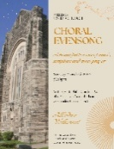
Sunday, March 15 ~ Choral Evensong
A beautiful service of music, scripture and quiet prayer with Rev Dr Philip Garder and the Melrose Chancel Choir.

Sunday, March 15
Next Sunday we welcome Rev Charlie Hogg to Melrose! Charlie and his wife Rev Heather Gilmour will be with us for the next few weeks including Holy Week and Easter! Rev Charlie and Rev Heather will be celebrating Communion together next Sunday!

Fiddes Fresh Food Drive ~ March 18th– 30th
This is our fourth year of collaborating with our Church Partners on Locke Street to assist those with food security issues in Hamilton. The list below indicates fresh food items and cost. There are many ways to place an order! Etransfers can be sent to: dustin@fwp.ca. Clearly indicate that the purchase is for Melrose United Church -Mission Services. You can choose to ask Libby or Gwyn to place the order for you and we gladly accept cash/cheque to do so. If you are already a Fiddes Customer, on your next visit ask to have the item added to the Melrose/Mission Services Food Order.
1 bag Russet potatoes x 50lb - $28.00
1 bag onions x 50lb - $32.00
1 bag Carrots x 50lb - $39.50
1 bag Carrots 24x2lb - $49.50
1 case Green Cabbage x 40lb - $33.00
1 case Broccoli x 20lb - $49.50
1 case Butternut Squash x 40lb - $49.50
1 case Acorn Squash x 40lb - $49.50

Please help make our effort to assist in reducing food insecurity in Hamilton a success!


Saturday, March 21st ~
Knitting & Crochet @9:30 – 11:30
Bring your current project and materials, beginners welcome! Coffee, tea and snacks will be provided.

Friday, March 27th ~ Progressive Euchre
Doors open at 7pm, games start at 7:30pm sharp! Beginners welcome!

Saturday, April 11th @ 8:30pm ~
Bach Elgar Choir Presents ~ Der Golum at Melrose!
A 1920’s German masterpiece movie on a large screen with an exhilarating soundtrack. Tickets are available at www.bachelgar.ca.

Easter Flowers
Every year we decorate our Sanctuary with beautiful flowers for Easter. If you wish to donate towards the Easter flowers in memory of a loved one, there will be envelopes available at the front of the church. Please drop your envelope in the collection plate. You can also email the office. Please be sure to include the names of your loved ones! We accept cash, cheques or etransfers.

Your Help is Needed!
Would you like to help out more on Sunday mornings? We are looking for volunteers to help with reading and greeting. If you can help or would like more information, please speak with Rosella if you are interested in reading or Libby if you are interested in greeting. Thank you!


Social Media at Melrose!
Melrose has an active social media presence on Facebook and Instagram! Check out our pages for information on Melrose events, the wider church and for messages of inspiration! Please visit: www.facebook.com/melroseunitedchurch
and www.instagram.com/melroseuc/

News From the Office
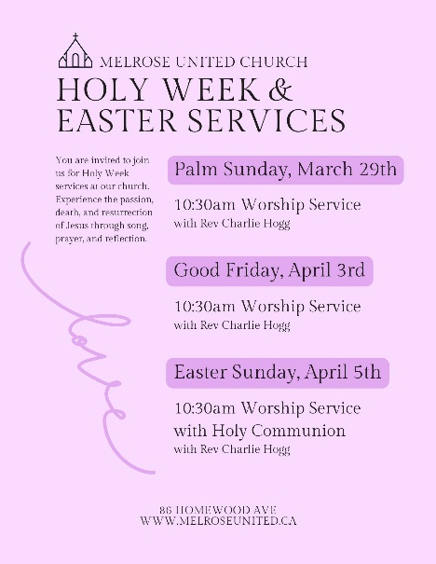
Please be sure to submit your church related news items for the bulletin or newsletter by Wednesday of each week. Kindly email the office. Thank you!

