MELROSE UNITED CHURCH
86 Homewood Avenue ~ Hamilton, Ontario ~ L8P 2M4
905 522 1323 ~ melrose@melroseunited.ca
www.melroseunited.ca
www.facebook.com/melroseunitedchurch
Instagram ~ @melroseu
YouTube Channel ~ Melrose United Church Virtual Service

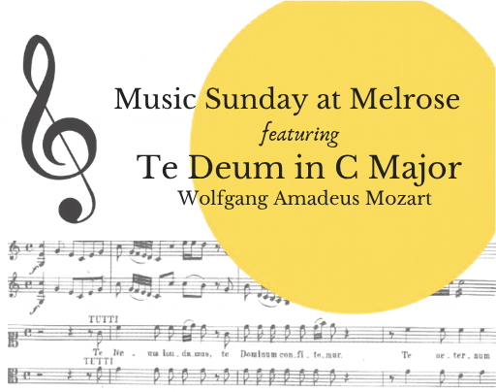

Worship Leader: | Rev. Charlie Hogg
Music Director:  Custodian:  Church Administrator: | Alexander Cann  Kevin Geluch  Sue Hawthorne-Bate

Sunday, May 10, 2026

Sixth Sunday of Easter
Music Sunday

Gathering In Community

Please stand as you are able.

We acknowledge that our church is located on the traditional territories of the Erie, Neutral, Huron-Wendat, Haudenosaunee and Mississaugas. May we continue to live with respect on this land, and to live in peace and friendship with all its people in the spirit of truth and reconciliation.

The PRELUDE ~ Adagio, K 356, W.A. Mozart

The WELCOME

We enter the Sacredness of Worship…

The INTROIT ~ Ave verum corpus, W.A. Mozart

The CALL to WORSHIP (Psalm 100)

One: Make a joyful noise to the Lord, all the earth.
All: Worship the Lord with gladness; come into his presence with singing.

One: Know that the Lord is God. It is he that made us, and we are his; we are his people, and the sheep of his pasture.
All: Enter his gates with thanksgiving, and his courts with praise.

One: Give thanks to him, bless his name.
All: For the Lord is good; his steadfast love endures forever, and his faithfulness to all generations.

The PROCESSIONAL HYMN ~
All Creatures of our God and King VU 217

The LIGHTING of the CANDLE of PEACE

The LIGHTING of the CHRIST CANDLE
The Christ Candle is lit…

A HYMN ~ The Spring Has Come VU 187

Time For the Children and the Child Within Us

A CHILDREN’S STORY

A CHILDREN’S HYMN ~ Halle, Halle, Halle VU 958

A PRAYER for the MUSICIANS and VOCALISTS
~ Prayer adapted from the Orthodox traditional liturgy
for the blessing of Music service~

- Allegro, Te Deum, W.A. Mozart

Hearing and Responding to the Word

Reader ~ Jan Landeen

A READING from Listening, by Amy Lowell

A READING from When Music Sounds, by Walter de la Mare

A READING from The Gift to Sing, by Weldon Johnson

PSALM 150 VU 875

The BOOK of COLOSSIANS, Chapter 4, verses 14 - 18

One: The word of God in scripture, among us, and within us.
All: Thanks be to God.

THOUGHTS for LIVING ~ A Reflection: “Music is what language would love to be ….if it could.”

- Adagio and Allegro, Te Deum, W.A. Mozart
The INVITATION to the OFFERING

The OFFERTORY HYMN ~
How Sweet the Name of Jesus Sounds VU 344, v. 4

Sing: Jesus, my Shepherd, Brother, Friend,
my Prophet, Priest, and King,
my Lord, my Life, my Way, my End,
accept the praise I bring.

The OFFERING PRAYER

- Allegro non tanto, Te Deum, W.A. Mozart

The PRAYERS of the PEOPLE & the LORD’S PRAYER VU 960

All: Our Father, who art in heaven,
Hallowed be thy name,
Thy kingdom come,
Thy will be done.
On earth, as it is in heaven.
Give us this day
our daily bread,
And forgive us our trespasses,
As we forgive those who trespass against us.
And lead us not into temptation,
But deliver us from evil:
For thine is the kingdom,
the power, and the glory
Forever and ever. Amen.

Sending Forth

LIFE and WORK of the CHURCH

The RECESSIONAL HYMN ~ Rejoice, the Lord Is King VU 213

The COMMISSIONING ~
“Rekindle the Gift”, by Steve Garnaas-Holmes

The BENEDICTION

The POSTLUDE ~ Allegro, Trio in C Major, W.A. Mozart

Translations

Te Deum

I. Praise to the Trinity
We praise thee, O God: we acknowledge Thee to be the Lord.
All the earth doth worship Thee, the Father everlasting.
To Thee all Angels cry aloud: the Heavens and all the powers therein.
To Thee Cherubim and Seraphim continually do cry, Holy, Holy,
Holy: Lord God of Sabaoth;
Heaven and earth are full of the Majesty of Thy Glory.
The glorious company of the Apostles praise Thee.
The godly fellowship of the Prophets praise Thee.
The noble army of Martyrs praise Thee.
The holy Church throughout all the world doth acknowledge Thee;
The Father of an infinite Majesty;
Thine honourable, true, and only Son;
Also the Holy Ghost: the Comforter.

II. Praise of Christ
Thou art the King of Glory, O Christ.
Thou art the everlasting Son of the Father.
When Thou tookest upon Thee to deliver man: Thou didst not
abhor the Virgin’s womb.
When Thou hadst overcome the sharpness of death, Thou didst
open the Kingdom of Heaven to all believers.
Thou sittest at the right hand of God in the glory of the Father.
We believe that Thou shalt come to be our Judge.
We therefore pray Thee, help Thy servants whom Thou hast
redeemed with Thy precious blood.
Make them to be numbered with Thy Saints in glory everlasting.
III. Prayers
O Lord, save Thy people: and bless Thine heritage.
Govern them and lift them up for ever.
Day by day we magnify Thee; and we worship Thy Name, ever
world without end.
Vouchsafe, O Lord, to keep us this day without sin.
O Lord, have mercy upon us.
O Lord, let Thy mercy lighten upon us: as our trust is in Thee.
O Lord, in Thee have I trusted: let me never be confounded.

Ave verum corpus

Hail, true Body, born
of the Virgin Mary,
truly suffered, sacrificed
on the cross for mankind,
from whose pierced side
flowed water and blood:
Be for us a foretaste [of the Heavenly banquet]
in the trial of death!
O sweet Jesus, O holy Jesus,
O Jesus, son of Mary,
have mercy on me. Amen.

Thank you to today’s guest musicians Lindsey Herle, violin,
Gwyneth Thomson, violin and Emma Allan, cello.

If you would like to light a candle to represent your prayers for a person or situation that is in your heart, you are invited to do so at the beginning or end of any worship service.
Personal prayer requests – please write your prayer requests in our Prayer Share Book during the service.

Today’s greeters are Libby Cook & Richard Feenstra
Life And Work of the Church

Thank you! ~ Thank you to everyone who joined us for our Community Spaghetti Dinner! We are especially grateful to all the volunteers and cooks who gave their time and talents to make the evening such a great success! We would also like to extend our sincere thanks to those who were unable to attend but generously donated to the Roof Fund. Your support is appreciated!


Thank you! ~ A huge thank you to Rev. Charlie Hogg & Rev. Heather Gilmour, and Al & Marilyn Bentley for their generous donation of roses and plants for the new garden on Locke Street! Special thanks as well to Margaret Duff and Jim Kraemer, who spent a morning this week planting the garden. Be sure to check it out!


Sunday, May 10th ~ Board Games!
Come and play your favourite board game or bring your own! You do not need a partner. Entry fee is $5, children under grade 1 are free!


Saturday, May 16th
Knitting & Crochet @9:30 – 11:30
Bring your current project and materials, beginners welcome! Coffee, tea and snacks will be provided.
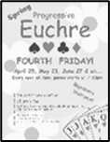
Friday, May 22nd ~ Progressive Euchre
Doors open at 7pm, games start at 7:30pm sharp! Beginners welcome!

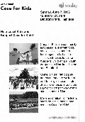
Sunday, June 7th @noon ~ Wesely Case For Kids
Case for Kids is a fun filled fundraiser with music food and face painting at Bayfront Park. Join the Melrose Movers 26 as a walker or a watcher on June 7th. Your donations can be made online at Wesley Case for Kids https://wesley.ca/giving/case-for-kids/. To join our team or for more information see Libby Cook. We hope to reach our goal of $1,000!

Can You Help?
Would you like to canvas for Case for Kids? Speak with Libby!

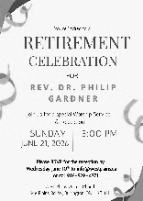
Sunday, June 21st ~ Rev. Dr Philip Gardner Retires!
Friends at Melrose, Rev. Dr. Philip Gardener is retiring at the end of June from active ministry. His retirement service will be held at West Plains United church, where he has served since leaving Melrose. The service will be at 3:00 pm on Sunday June 21st. All are welcome. If you plan to attend, please RSVP to West Plains United Church at info@westplains.ca or call 905-529-4871.

Social Media at Melrose!
Melrose has an active social media presence on Facebook and Instagram! Check out our pages for information on Melrose events, the wider church and for messages of inspiration! Please visit: www.facebook.com/melroseunitedchurch
and www.instagram.com/melroseuc/

News From the Office
Please be sure to submit your church related news items for the bulletin or newsletter by Wednesday of each week. Kindly email the office. Thank you!
