MELROSE UNITED CHURCH
86 Homewood Avenue ~ Hamilton, Ontario ~ L8P 2M4
( 905 522 1323 ~ * melrose@melroseunited.ca
8 www.melroseunited.ca
www.facebook.com/melroseunitedchurch
Instagram: @melroseu
YouTube channel: Melrose United Church Virtual Service

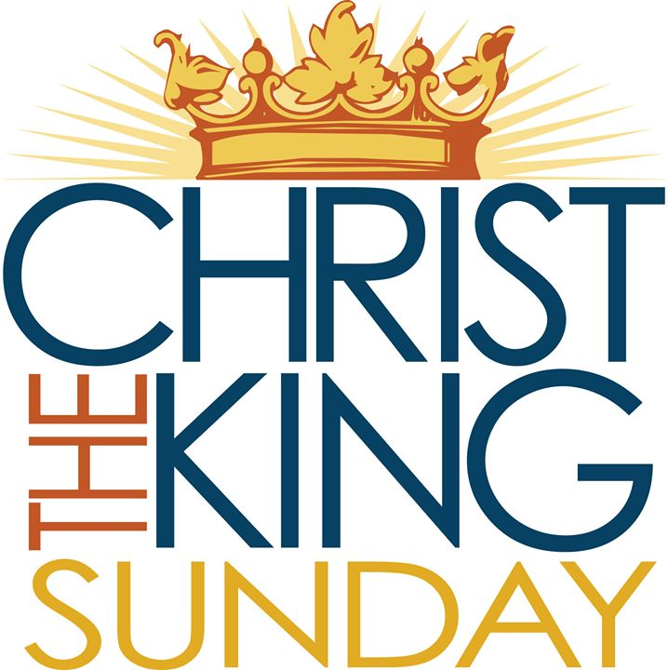

Worship Leader: | Margaret Duff
Music Director:  Custodian:  Church Administrator: | Alexander Cann  Kevin Geluch  Sue Hawthorne-Bate

Sunday, November 23, 2025
Christ the King Sunday

Gathering In Community

The PRELUDE

The INTROIT ~ Kyrie Eleison, E. Daley

The PROCESSIONAL HYMN ~
Crown Him with Many Crowns VU 211

The WELCOME and the LIFE of the CHURCH

The LAND ACKNOWLEDGEMENT &
LIGHTING of CANDLE of PEACE

The LIGHTING of the CHRIST CANDLE

the Christ Candle is lit….

A HYMN ~ At the Name of Jesus VU 335

The CALL to WORSHIP

All: As we seek refuge in God’s house today to worship on this the Reign of Christ Sunday, may we leave our worries and tension outside and enter with peace and love. May our hearts and spirits be open to the message we are offered today. May this time of worship have meaning for each of us and may God grant us the wisdom of the Spirit to understand it. Let us worship God!

The OPENING PRAYER

All: Jesus, Face of God Incarnate,
first word over all creation,
we are born of you and for you.
Alpha, Peace from Truth,
first hope among the dead,
we are reborn of you and for you.
Omega, Redemption, and Reconciliation,
first servant in our action of giving,
we are in relationship of you and for you.
Christ, Ruler of our todays and our tomorrows,
first love in our hearts, minds, and souls,
we are in community of you and for you. Amen.
Ruthanne McLagan, Calvary U.C., London, Ont.

The PRAYER for FORGIVENESS

One: Holy God, when we turn away from those who are vulnerable in order to bow to the mighty,
All: when our words or actions bring havoc instead of wholeness,

One: when those who are hungry are left wanting and strangers are shut out,
All: forgive us and redeem us.

One: Lead us from our pride back to your reign of hope and love,
All: until we live in right relationship with you and with each other again. Amen.
Silence for personal reflection…
The WORDS of ASSURANCE

One: The reign of goodness begins with grace.
Forgiveness is in every breath.
Let go of hurt and take up the work of reconciliation.
All: In the name of the Good Shepherd, we claim our new life.
Robin Wardlaw, Toronto, Ont.

Time For the Children and the Child Within Us

A CHILDREN’S STORY

Hearing and Responding to the Word

Reader ~ Jan Landeen

The PRAYER for ILLUMINATION

All: Guide us, O God,
by your Word and Spirit,
that in your light we may see light,
in your truth find wisdom,
and in your will discover your peace,
through Jesus Christ our Lord. Amen.

The BOOK of COLOSSIANS Chapter 1, verses 11 to 20

One: Hear what the Spirit is Saying to the Church
All: Thanks be to God!

The SCRIPTURE SONG ~
Luke 1:68–79 Song of Zechariah VU 900

The GOSPEL of LUKE, Chapter 23, verses 33 to 43

One: Hear the Good News!
All: Praise be to Jesus Christ!

The REFLECTION ~ “If I had known”

An ANTHEM ~ Christ Hath a Garden, H. Willan

The INVITATION to the OFFERING

The OFFERING HYMN ~
Praise God From Whom All Blessings Flow VU 541

Sing: Praise God from whom all blessings flow;
praise God all creatures high and low;
give thanks to God in love made known;
Creator, Word and Spirit, One.

The PRAYER of DEDICATION

All: Loving God, these offerings are part of our response to your call. We also respond with other ways of supporting our church and community through visits and phone calls made, notes written, food delivered, and prayers on behalf of others. We ask that you bless these offerings and multiply them by your grace so that the work of this congregation may be accomplished to your glory. Amen.
The PRAYERS of the PEOPLE

The LORD’S PRAYER

All: Our Father, who art in heaven,
Hallowed be thy name,
Thy kingdom come,
Thy will be done
On earth, as it is in heaven.
Give us this day
our daily bread,
And forgive us our trespasses,
As we forgive those who trespass against us.
And lead us not into temptation,
But deliver us from evil:
For thine is the kingdom,
the power, and the glory
Forever and ever. Amen.

Sending Forth

The RECESSIONAL HYMN ~ Rejoice the Lord is King VU 213

The COMMISSIONING and BENEDICTION

One: The Realm of God is coming;
All: we will prepare faithfully.

One: The Realm of God is coming;
All: we will work for peace and justice.

One: The Realm of God is coming;
All: we will seek reconciliation and healing.

One: The Realm of God is coming;
All: we will work to end prejudice.

One: The Realm of God is coming;
All: we will share grace and compassion.

One: The Realm of God is coming;
All: we will have hope at last.

One: The Realm of God is coming;
All: we go out in the name of Jesus,
the Reign-maker. Amen.
David Sparks, Summerland, B.C.

The CHORAL BENEDICTION ~ Hear Thou Our Prayer,
E. Daley

The POSTLUDE

Today’s Greeters are George Mayhew and Geoff Harrison

If you would like to light a candle to represent your prayers for a person or situation that is in your heart, you are invited to do so at the beginning or end of any worship service.

Personal prayer requests – please write your prayer requests in our Prayer Share Book during the service.

Life And Work of The Church

Mistletoe Bazaar Thank you!
Thank you to everyone who came out and supported the Mistletoe Bazaar! We are grateful to our wonderful volunteers and bakers and most especially to Gwyn Xagoraris for her untiring dedication to making each bazaar better than the last!

ADVENT AND CHRISTMAS AT MELROSE
November 30 @ 7.30 pm ~ Candlelight Carol Service
A beautiful service of carols and readings for the beginning of the Advent season.
December 14 @ 10.30 am ~ Christmas Giving Sunday
Help us spread the joy of Christmas. If you are able, please bring gifts for Wesley Urban Centre (gloves and socks) and Operation Santa Claus (toys).
December 21 @ 10.30 am ~ Family Christmas
Calling all sheep, shepherds and angels! Join us for our Christmas pageant – everyone is welcome to participate (even the adults)! No rehearsals necessary!
December 24 @ 10.30 pm ~ Christmas Eve Service
A beautiful service of carols and readings to celebrate the birth
of Jesus and the promise of peace, hope, joy and love. All are welcome to take Communion.
December 28 @ 10.30 am ~ Jazz Carols
And now for something completely different! Join us for an informal service in the church parlour.

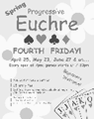
Friday November 28th ~ Progressive Euchre
Doors open at 7pm, games start at 7:30 sharp! Beginners welcome!


Sunday, November 30th
The Duet Club Presents ~
Christmas Time is Here! @ 2:30pm
Join Women of Song here at Melrose and kick-start the holiday season with a delightful afternoon of beautiful music. Women of Song will be joined by special guest Dave Siverns and other local musicians. Ticket Prices, Adults - $25, Students / Seniors - $20, Children 12 and under are free. To reserve tickets, please send an e-transfer to theduetclub@gmail.com. Please include the attendee names in the message field. Tickets will be available at the door by cash or debit card.

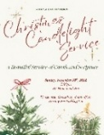
Sunday, November 30th ~
Candlelight Carol Service @7:30
Join us for our annual Candlelight Carol Service with Rev Margot Feyerer. A service of beautiful carols and meaningful scripture for Advent!

Your Help is Needed!
Sweet treats are needed for the reception following the Candlelight Carol Service on November 30th. Assistance is also required with setting up the parlour at 5pm and serving during the event. Please contact Libby if you can help!


Saturday, December 6th ~
Knitting & Crochet @ 9:30 – 11:30
Bring your current project and materials, beginners welcome! Coffee, tea and snacks will be provided.

Friday, December 12 ~

Christmas Movie Party! @5:30pm
Bring your family and friends and enjoy a Christmas Movie! Enjoy crafts, cookies and hot chocolate! A very special guest will be joining us! Speak with Sally for more information.


Sunday, December 14th ~ Board Games @1:00pm
Come on out and enjoy your favourite board or card game! There is a $5 entry fee, Children up to grade 1 are free! Bring along your favourite board or card game! Refreshments will be available.

Can You Help?
Do you have unwanted gently used blankets (single or double) and gently used ladies’ coats that you no longer need? Willow’s Place needs blankets for their ladies in residence. Please bring in your donations by December 1st. Please drop off your donations at the church office or give them to Libby or Gwyn.


Social Media at Melrose!
Melrose has an active social media presence on Facebook and Instagram! Check out our pages for information on Melrose events, the wider church and for messages of inspiration! Please visit: www.facebook.com/melroseunitedchurch www.instagram.com/melroseuc/

News From the Office
Please be sure to submit your church related news items for the bulletin or newsletter by Wednesday of each week. Kindly email the office. Thank you!

