MELROSE UNITED CHURCH
86 Homewood Avenue ~ Hamilton, Ontario L8P 2M4

905 522 1323 ~ melrose@melroseunited.ca
www.melroseunited.ca
www.facebook.com/melroseunitedchurch
Instagram: @melroseuc
YouTube channel: Melrose United Church Virtual Service

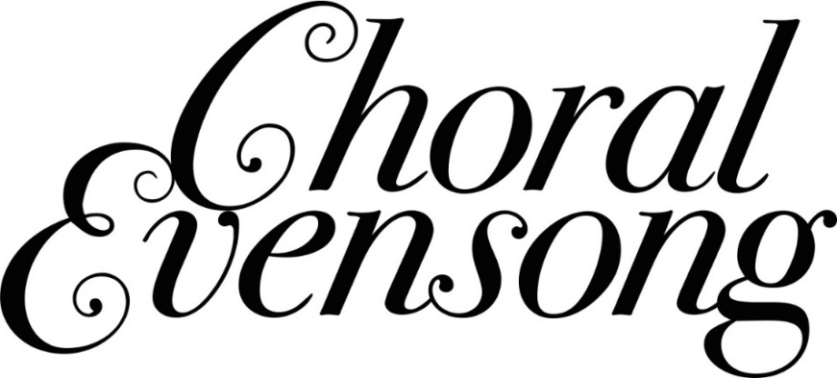

Worship Leader: | Rev. Dr. Philip Gardner
Music Director:  Custodian:  Church Administrator: | Alexander Cann  Kevin Geluch  Sue Hawthorne-Bate

19th Sunday after Pentecost
Sunday, October 19, 5:00p.m.

The PRELUDE ~ “Reflective Processional” ~ C. Mawby

The PROCESSIONAL HYMN ~
“As Comes the Breath of Spring” VU 373

The PRECES and RESPONSES ~ R. Ayleward

The OPENING PRAYER

PSALM 114 (intoned by choir)

1 When Israel came out of Egypt,
and the house of Jacob from among the strange people.
2 Judah was his sanctuary,
and Israel his dominion.
3 The sea saw that, and fled;
Jordan was driven back.
4 The mountains skipped like rams,
and the little hills like young sheep.
5 What aileth thee O thou sea that thou fleddest,
and thou Jordan that thou wast driven back?
6 Ye mountains that ye skipped like rams,
and ye little hills like young sheep?
7 Tremble thou earth at the presence of the Lord;
at the presence of the God of Jacob;
8 Who turned the hard rock into a standing water,
and the flint-stone into a springing well.

A READING ~ 2 Kings 5: 1-14

One: The Word of the Lord
All: Thanks be to God

The MAGNIFICAT ~ H. Brewer

A READING ~ Luke 10: 1-12, 17-20

One: Let us respond in faith to the Gospel of our Lord
All: Praise be to you, Jesus Christ

The NUNC DIMITTIS ~ H. Brewer

The NEW CREED

We are not alone,
we live in God’s world.

We believe in God:
who has created and is creating,
who has come in Jesus,
the Word made flesh,
to reconcile and make new,
who works in us and others
by the Spirit.

We trust in God.
We are called to be the Church:
to celebrate God’s presence,
to live with respect in Creation,
to love and serve others,
to seek justice and resist evil,
to proclaim Jesus, crucified and risen,
our judge and our hope.

In life, in death, in life beyond death,
God is with us.
We are not alone.
Thanks be to God.

An ANTHEM~ “Hear My Prayer” ~H. Purcell

The PRAYERS and PRAYER OF JESUS

Our Father, who art in heaven,
Hallowed be thy name,
Thy kingdom come,
Thy will be done
On earth, as it is in heaven.
Give us this day
our daily bread,
And forgive us our trespasses,
As we forgive those who trespass against us.
And lead us not into temptation,
But deliver us from evil:
For thine is the kingdom,
the power, and the glory
Forever and ever. Amen.

The PRAYER OF ST. JOHN CHRYSOSTOM

The CLOSING REMARKS

The RECESSIONAL HYMN ~
“Today We Are Called to Be Disciples” VU 520

The BLESSING

The POSTLUDE ~ “SORTIE” ~ R. Lloyd

Our heartfelt thanks to Reverend Dr Philip,
to our Chancel Choir and to Alex Cann our Music Director
for our beautiful service this evening!

