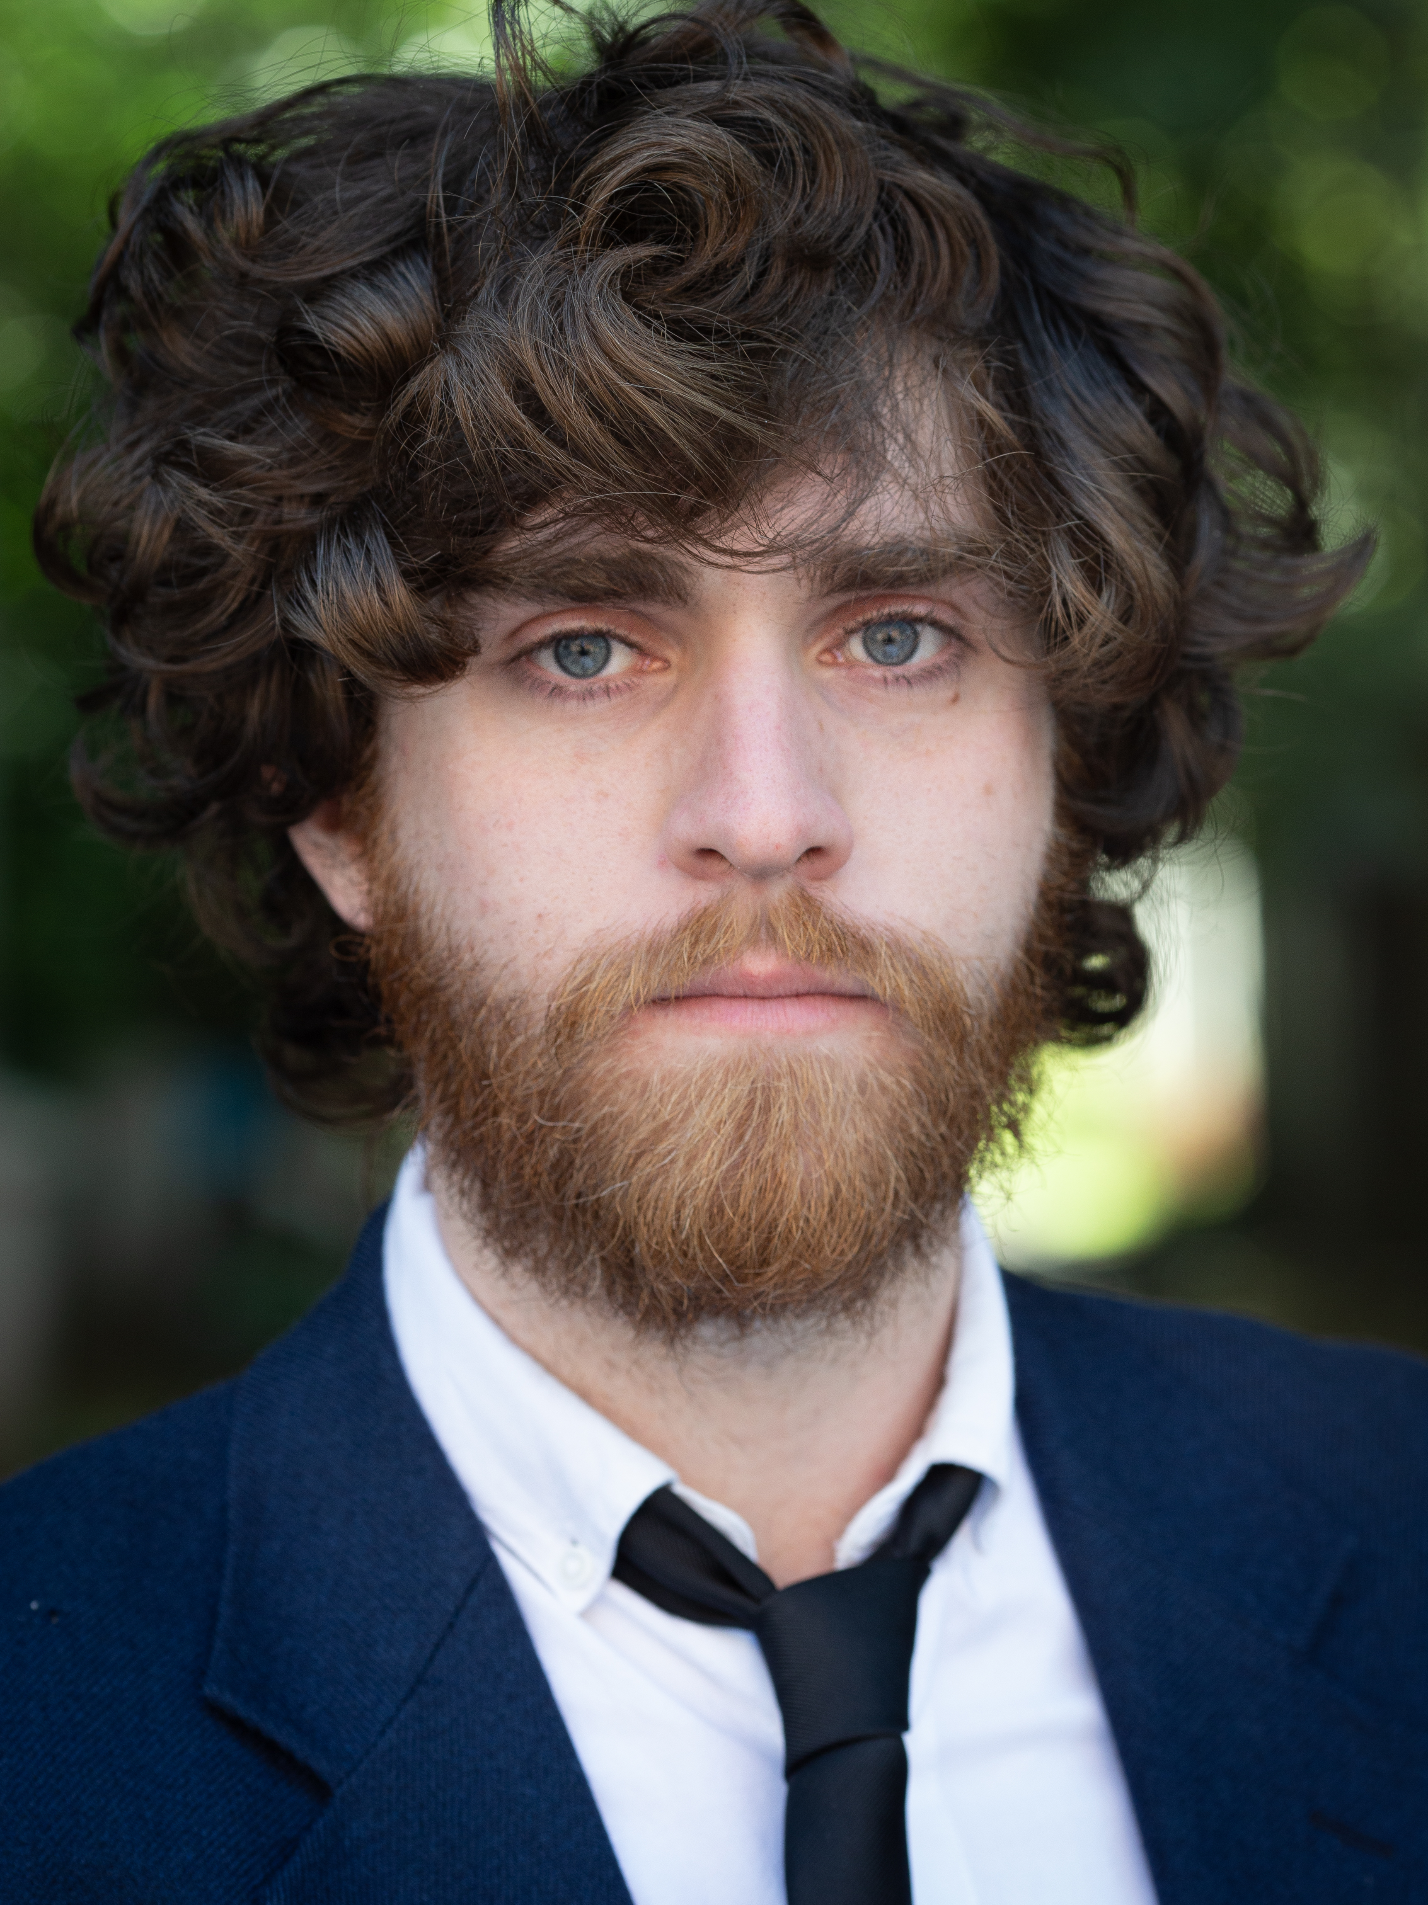   |  | John Crooks
Personal Details  Height: 5’9”  Eye Colour: Blue  Hair Colour: Brown  Nationality: Scottish  Location: Glasgow  Equity Number: 00469460  Training: New College Lanarkshire (BA)  Contact  PHONE:  07806792528  EMAIL:  jcrooks38@gmail.com |  | Performance Credits  2023, Fraser, THE SEAGULL (NOT THAT ONE), Leyla Aycan/Ariana Ferris McLean, The Old Gym Theatre/Museum of Alchemists  2022, Monty, TWISTED FIRESTARTER, Phoebe Byrne, The Old Hairdressers  2019, Sunny, A DAURK MAITER (REHEARSED READING), Guy Hollands, North Lanarkshire Heritage Centre  2019, John, 13, Anthony Kelly, 101 Park Street  2019, Captain Bordy, UBU: A BLOODY PUPPET PLAY, Ed Robson, Cumbernauld Theatre  2018, Grumpy Man, DETAINED VOICES, Gregor Duncan, New CLan Arts Studio  - 2018, Alex, THE ORCHID, Rebecca Low, Assembly Roxy/Café Club Míšeňská  - 2018, Harry, DECADES, Anthony Kelly, New CLan Arts Studio  workshops & Masterclasses  - Audition Preparation – Paul Harper Swan  - In Motion Theatre Company – Lisa Nicholl & Daniel Cameron  - Project DIY – Ali de Souza  SKILLS  - Accents: Scottish*, American, Cockney, RP, Irish, Northern English, West Country, Australian  - Languages: English*, French  - Singing: Baritone  - Music: Cello, Bass Guitar, Guitar  - Sports: Horse Riding, Swimming  - Other Skills: Puppetry, Scriptwriting, Composing, Music Literacy, Improv, Whistling

