Trusted Agent Services Group, LLC
Website Template Wording
Home Page
Section 1
Header Wording
Optional: Promotional Banner Message
“Our thoughts and prayers are with you during this COVID-19 pandemic. Be safe.”
ACCURATE AND SUPERIOR NOTARIAL AND MORTGAGE SERVICES
Trustworthy notarization requires an experienced and impartial notary!
Action Button: Link to webpage – Contact Us [Note this link can be activated after the “Contact Us” page has been created.
Sections 2 – About Your Company and/or You
If you are not a Notary Signing Agent, skip to Section 3 – About (Notary Name, Notary Public)
Section 4 – About (Company Name) [Notary Signing Agent]
About (Name of Company)
MOBILE NOTARY
Image: General image from web builder “Stock Media”
Trusted Agent Services Group provides notarial services to clients at specified or neutral locations.
Mortgage Closing Services
Image: General image from web builder “Stock Media”
(Company Name) provides mortgage closing services by a licensed and background-screened Title Insurance Producer Independent Contractor.
Service Area
Image: General image from web builder “Stock Media”
(Company Name) provides notary and mortgage loans closing services in ________________ County/ies [your service area].
Section 3 – About (Notary Name, Notary Public)
Your name
Image: Your image (Use the “Upload” function.)
[Sample Wording -[Customize wording to describe you]:
I am a retired federal government employee, a commissioned Notary Public, Notary Signing Agent, and a Title Insurance Producer Independent Contractor (TIPIC) in the state of Maryland with 16 years of combined service.
My Credentials
Image: NNA Logo (Use the “Upload” function.)
I am a NNA Ambassador and Certified Signing Specialist. I received Notary Certificate of Course Completion from Prince George’s Community College in Largo, MD. I am also an Adjunct Notary Instructor at Prince George’s Community College. [Customize your credentials.]
Customer Service
Image: General image from web builder “Stock Media”
I am committed to accurate notarizations and superior customer service.
Section 4 – Privacy Policy
Your privacy is very important. I will take all appropriate steps to protect your private information.
NEW! Section 5 (or you can place it anywhere or on any web page you desire)
Section 5 – COVID-19 Precautions
Please note that as a Notary Signing Agent, I am an essential worker and follow recommended COVID-19 health and safety precautions. I will take the following precautionary measures for ensuring our safety from the Coronavirus during the appointment:
- I will have on a mask (and/or gloves).
- You are asked to wear a mask.
- I will have hand sanitizer and wipes.
- You may choose to write with your pen (or stylus); otherwise, I will provide one for you.
- I will practice the 6-ft rule.
- Other precautionary measures are welcomed.
_____________________
This is the article linked to “essential worker” - Link to article “U.S. Treasury Secretary: Signing Agents Are Part Of ‘Essential Services’ during COVID-19 Emergency” - https://www.nationalnotary.org/notary-bulletin/blog/2020/03/us-treasury-signing-agents-essential-services-covid-19#:~:text=U.S.%20Secretary%20of%20the%20Treasury,continue%20to%20perform%20their%20duties.

This article is for your information (you do not have to link it to your website) Link to article “Important Coronavirus Guidance For Signing Agents And Mobile Notaries” - https://www.nationalnotary.org/notary-bulletin/blog/2020/03/notaries-precautions-coronavirus
Section 6 – Unauthorized Practice of Law
Please note, info below is as outlined in the Maryland Notary Handbook. Click here to view the bottom of page 15. If a notary public, who is not an attorney licensed to practice law in the state, advertises or represents that the notary public offers notarial services, whether orally or in a record, including broadcast media, print media, and the internet, the notary public shall include the following statement set forth in State Government Article, § 18-224(d)(2) [The following paragraph should appear on your advertisement.]:
“I am not an attorney licensed to practice law in this state. I am not allowed to draft
legal records, give advice on legal matters, including immigration, or charge a fee for
those activities.”
Copyright – This section automatically appears.
Copyright©2019 (Your name or company name) – All Rights Reserved.
Links at Bottom of Page
When creating page, turn on the links button to show at bottom of page. You will find the “links button” when “creating” the web page.

Notary Public
Image: NNA Logo
NEW! Section 5 (or you can place it anywhere or on any web page you desire)
Section 5 – COVID-19 Precautions
Please note that as a Notary Signing Agent, I am an essential worker and follow recommended COVID-19 health and safety precautions. I will take the following precautionary measures for ensuring our safety from the Coronavirus during the appointment:

Section 1 – Notary Public
What Is A Notary Public?
“A Notary Public is a government officer and public servant who serves as an impartial witness in taking acknowledgments, administering oaths and affirmations, and performs other acts authorized by state law.”
[National Notary Association]
Caption for image - I am committed to accurate notarizations and superior customer service.
Commissioned/Membership
- Commissioned in the State of _________ or Commissioned in the States of _________ and __________.
- Member of the _______________
Coverage Area/Fee Schedule
Coverage Area
- County(ies)
Fee Schedule
- Notarization, mileage and administrative fees are charged as regulated by the State of __________

Notary Services Provided
- Adult Day Care  - Assisted Living  - Churches  - Clubs  - Hospitals  - Hotels  - Independent Living Facilities  - Individuals  - Law Offices  - Nursing Homes  - Organizations | Adult Day Care  Assisted Living  Churches  Clubs  Hospitals  Hotels  Independent Living Facilities  Individuals  Law Offices  Nursing Homes  Organizations

Document Experience
- Acknowledgments  - Affidavits  - Insurance Claims  - Legal Documents  - Living Wills  - Medical Documents  - Mortgage Documents  - Power of Attorney  - School Permission Statements | Acknowledgments  Affidavits  Insurance Claims  Legal Documents  Living Wills  Medical Documents  Mortgage Documents  Power of Attorney  School Permission Statements

Section 2 - Acknowledgments
Affidavits
Insurance Claims
Legal Documents
Living Wills
Medical Documents
Mortgage Documents
Power of Attorney
School Permission Statements

- The document signer(s) requesting the notarization must appear before the Notary Public.
- The signer must present acceptable primary identification, e.g., driver's license, state identification card or passport. The Notary Public assesses competency and willingness of the signer.
- The Notary Public will record the details of the notarization, e.g. date and time of notarization, type of notarial act performed, description of the document, method of identifying the signer and obtain the signer's signature in the Notary's fair register or journal.
- Depending upon the type of notarization performed, the Notary may witness the signer's signature, ask the document signer to acknowledge that he/she signed the document willingly or administer an oath or affirmation to the signer.
The Notary completes the notary certification by dating, signing, writing the notary commission expiration date, and placing the notary seal on the document.

Section 3 -Privacy Policy
As a Notary Public, I am committed to abiding by legal requirement for protecting personal information. Personal information recorded by me will be protected.
Section 4 (or you can place it anywhere or on any web page you desire)
Section 5 – COVID-19 Precautions
Please note that as a Notary Signing Agent, I am an essential worker and follow recommended COVID-19 health and safety precautions. I will take the following precautionary measures for ensuring our safety from the Coronavirus during the appointment:

TIPIC
Section 1 – Title Insurance Producer Independent Contractor (TIPIC) or Notary Signing Agent
I am a licensed Title Insurance Producer Independent Contractor (TIPIC) in the State of Maryland. I can assist you with mortgage loan closings by providing loan closing services at your client's convenience. Your clients will receive the same professional and personalized service that your staff would provide. I will ensure that your mortgage documents are properly executed and promptly returned to you.
Certifications/Insurance/Membership(s)
Certifications
- Maryland Notary Public
- Title Insurance Producer Independent Contractor
- Certified NNA Notary Signing Agent
- Background Screened
Insurance
- Errors and Omissions Insurance
Membership
- Member of the National Notary Association

Training/Awards
[List your training and awards.]
Certificate Available Upon Request
- Notary Public Certificate of Course Completion - Prince George's Community College Largo, Maryland
- NNA Notary Public Essentials Course Completion
- Title Insurance Producer Prelicensing Course
- Title Insurance Producer Continuing Education Training

Document Experience
- Home Equity Line of Credit
- Hybrid Closing
- Loan Modification
- Piggyback Loans
- Purchase
- REO
- Refinance
- Reverse Mortgage

Fee Schedule
- Fees are negotiable

Availability/Coverage Area
Availability
- Monday through Saturday
- Time and location convenient for client
Coverage Area
- Prince George's County
- Montgomery County

Section 2 – Legal Advice

I am not an attorney and therefore, by law, I cannot explain or interpret the contents of any document for the document signer, instruct the signer on how to complete a document or direct a signer on the advisability of signing a particular document. By doing so I would be engaging in the unauthorized practice of law, and could face legal penalties that include the possibility of incarceration. Any important questions about your document should be addressed to the lender, Title Company or an attorney.
Section 3 – Privacy Policy
As a Notary Signing Agent, I take precautionary steps to protect my clients' private information. Every client or individual has the right to have his/her private information protected. I am committed to upholding the mandates of the Graham-Leach Bliley Act. Any personal information that is recorded by me is protected and treated with the highest security possible.

Contact Us (or Me)
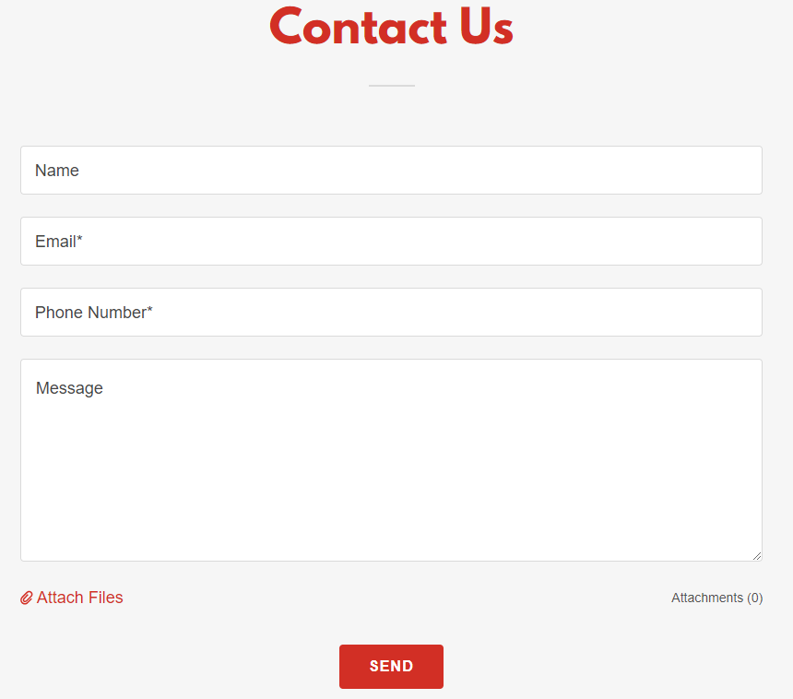

The “Attach Files” feature on the Contact Form allows your clients to attach/upload documents to be sent to your email. This feature has to be first added to your Contact Form, then “activated” [turn the button to ”on”.]

"WhatsApp." It's an app owned by Facebook that allows you to make/receive text messages and phone calls for free. Essentially, you only need Wi-Fi and not a service plan with a mobile company to communicate.

