Sir James Knott Nursery School
Wraparound/30 hour
2020-2021

Welcome to Sir James Knott Nursery School and thank you for taking the time to find out more about our additional care provision.

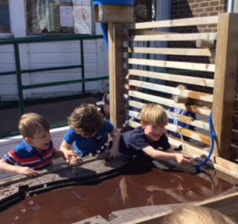
Wraparound is any additional time at Sir James Knott beyond the 15 hour free entitlement. It is provided in our dedicated wrap room and offers additional activities both indoors and out. We offer these extra activities for wrap and 30 hour children so that they are not repeating school activities. Wraparound also make regular visits to the beach, Northumberland Park and Tynemouth boating lake. They have even travelled on the metro to see Fenwick’s window and engaged in daily focussed sessions with the Wraparound team. We are mindful of the fact that children may need a rest during the day and we have quiet areas available to encourage children to have “chill out” time.

How does it work?
You can access wraparound using your 30 hour offer between the hours of 8.30-3.30 with an additional charge for lunch where necessary. Any sessions outside of nursery hours which are not attended under the 30 hour offer can be booked as wraparound and need to be paid for in advance either by term or academic year by completing a booking form indicating which sessions you wish your child to attend. We will require 4 weeks notice of any changes to your childcare pattern. We pride ourselves on being fully flexible and are able to accommodate most special circumstances, please contact the School Office to discuss your needs. One off activity sessions and emergency childcare can also be accommodated to suit parental needs.

How do I register my child?
We need you to complete a booking form and sign a contract which is available in your pack and from the School Office.

What is the cost?
Charges are £6.00 per hour from 8.00am – 6pm. You can also book half hourly sessions at a cost of £3.00. Lunch meal under 30 hour offer is £2.00

Holiday Club is also available during school term holidays at parent request. This is charged at £25.00 for the day and children are required to bring a packed lunch. Please discuss your requirements with office staff as soon as possible as these sessions will only run if required.

Payment Methods
Payments must be made in advance via Parentpay, direct debit and/or Childcare Vouchers. Cash or cheques can be used for emergency session, please deal directly with Nicki in the school office.

What happens if my account is in arrears?
We require wrap payments in advance. You will receive fortnightly letters advising the current balance of your child’s account. You will receive 2 warning letters to remind you of payment needed, if this remains unpaid then we will cease your child’s access to wrap and you will be required you to collect your child outside of their normal 15/30 hours free entitlement until payment is received. This may result in contact with other services if you fail to have your child collected as directed.

