Central Ohio Joint Fire District Annual Program Appraisal and Analysis

Fire Chief

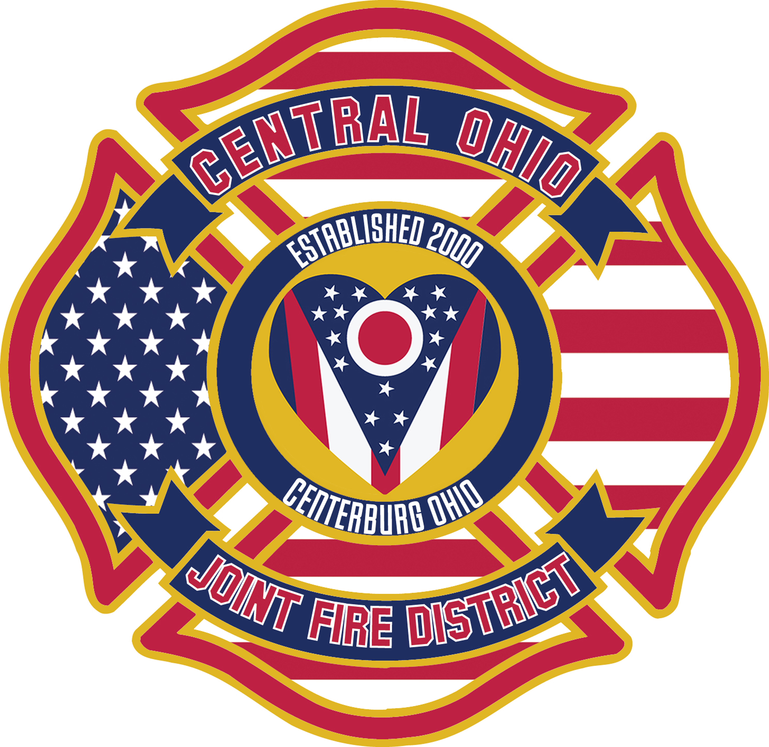

Year End Report: 2019

Program Description. The Office of Fire Chief is tasked to ensure proper administration and oversight at all levels. To serve the public, staff, and outside agencies to better safeguard against disasters and harm that can occur. High levels of effort is spent in planning and ensuring all equipment and members are prepared to safely respond in a fiscally and transparent method. Modern science and data are used as corner stones in decision making

Mission: The COJFD shall safeguard our community and all who call for help. We will do this by: providing protection and preservation of life and property, mindful of acceptable levels of risk, maintaining the highest standards of emergency medical services, fire suppression, fire prevention, and education and safety programs.

Future goals 2020 for specified time (S.M.A.R.T.).
- Create a paperless billing PO system by June 2020
- Become a candidate agency with the Center For Public Service Excellence by December 2020
- Pass two operational levies by Nov 2020

Outcomes and Outputs (Goals) Status of achieving goals of prior year(s)
- E421 was equipped and set up as an ACLS first responder.
- Paramedic staffing minimum is two paramedics per day, but usually are able to staff at least three.
- Initiated Firefighter Out-of-class (OOC) program.
- Remodel of Station 420.
- Re-chassis of M428 (2003 Ford/Road Rescue). Project not completed until 2020.
- Switched completely to MARCS radio dispatching, no longer using VHF radios.

Executive Summary

2019 was a very busy year with the change of leadership from Chief Porter of nearly 20 years to Chief McCann. During that transition the Fire Board and five new firefighters were sworn in. .

The largest and least expensive addition to the department was making the all Central Ohio engines Advanced Live Support (ALS) capable. This means regardless of the call the foregathers, if arriving on a medical call first, can deliver the same care as the medic unit.

The nearly $900,000.00 remodel came to an end with the help of so many. The Community facility will last for two decades with only usual upkeep and repair. With the remodel we increase our station alerting system to include modern light, audible, and visual stimulus.

The department's fleet was serviced to National Fire Protection Agency standards and all emergency medical equipment was inspected per State of Ohio laws. The highlight was the refurbish of a 2003 chassis on one of the medic units. We had several grants awarded from the State Of Ohio which were used for both EMS and fire equipment. These grants combined totaled over $10,000

Finally, As the a Chief and learning the position, I found our department staff and equipment in a state of ready. The community is protected well with a fire prevention division that is both knowledgably and understanding of code enforcement. The community is very supportive of the Central Ohio Fire District. The Fire Board and Clerk help drive departmental goals and are supportive and suggestive on the growth of the District.

Professionally,

Chief McCann

