Central Ohio Joint Fire District Annual Program Appraisal and Analysis

Fire Chief

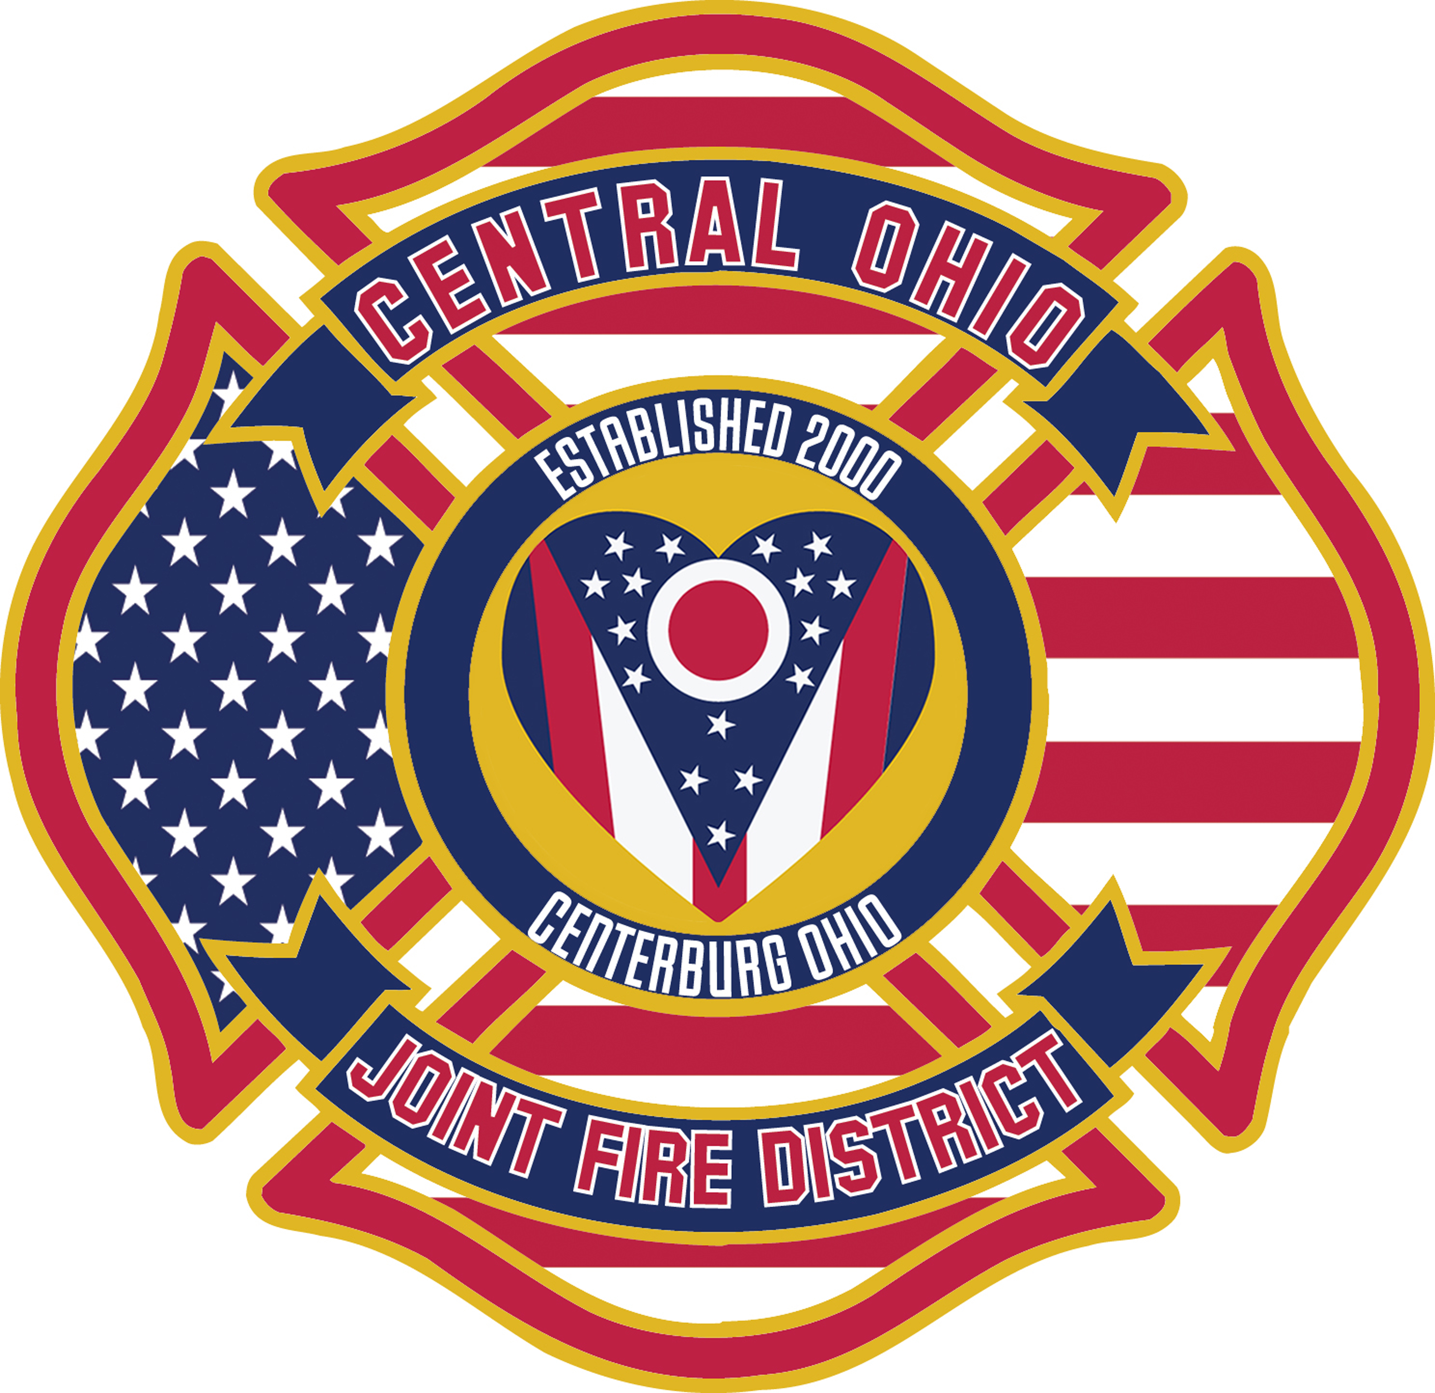

Year End Report: 2020

Program Description. The Office of Fire Chief is tasked to ensure proper administration and oversight at all levels. To serve the public, staff, and outside agencies to better safeguard against disasters and harm that can occur. High levels of effort are spent in planning and ensuring all equipment and members are prepared to safely respond in a fiscally and transparent method. Modern science and data are used as corner stones in decision making and process.

Mission: The COJFD shall safeguard our community and all who call for help. We will do this by: providing protection and preservation of life and property, mindful of acceptable levels of risk, maintaining the highest standards of emergency medical services, fire suppression, fire prevention and education and safety programs.

Future goals 2021 for specified time (S.M.A.R.T.).
- By June 2021 complete updating all policy and procedures.
- Become a candidate agency with the Center for Public Service Excellence by December 2021.
- Secure South Bloomfield contract by Nov. 2021.
- Increase full-time staff by three-line firefighters/paramedics by Dec 2021.
- Replace one emergency vehicle by Dec 2021.

Outcomes and Outputs (Goals Achieved) Status of achieving goals of prior year(s)
- Created a paperless billing PO system by June 2020 – Completed.
- Become a candidate agency with the Center For Public Service Excellence by December 2020 – Not completed. As a District we have elected to update policy and procedures with Lexipol.
- Passage of two operational levies.
- Over 100 hours assistance to Centerburg Seniors.
- Updated hardware and software for emergency vehicles.
- All members certified to Hazmat Operational level.
- Health Heart Program started 3rd Grade

Executive Summary

2020 presented several opportunities to test many processes and growth potential for the Central Ohio Joint Fire District. Those areas were funding, capital improvement completion, major equipment failures and addressing the COVID pandemic.

The District passed two levies which will allow emergency service and equipment to be improved and updated. Several vehicles are over 20 years and replacement schedule is now possible. Staffing increases will allow for industry standards and best practices to be more closely followed.

The District saw catastrophic failure of our front-line fire engine. We had to replace both the generator and fire pump. The fire truck was in repair for over four months and thanks to our neighboring departments we secured a replacement at no cost. Overall, maintenance costs to fleet were nearly $50,000.00.

The year started off as expected and we celebrated by holding a February open house to show the District we serve their new structure. A structure that added safety, modernization, and home to all that work and support Central Ohio Joint Fire District. The fire station can now house seven firefighters, 24 hours a day, seven days a week.

Prior to the renovation firefighters slept on sofas, had no training area, nor a decon area for equipment and staff. The improvements allow the building to be used for a community shelter and secondary Emergency Operations Center for both Knox County EMA and Village of Centerburg.

With help of many local, county and state agencies, the District is addressing ongoing issues as it relates to the pandemic. In the earlier moments, we addressed and planned for issues never thought of. In June, process and issues changed much but answers and expectation came more quickly. Our District, like others, suffered illness related to COVID. The community and staff of Central Ohio Joint Fire District stood strong and we continue to address the pandemic.

Finally, we are saddened by how many have died and proud of those in all industries that continue to support our community and nation. As Fire Chief, the help and knowledge that was given to the District was tremendous from local to National levels. Our goals were set prior to the pandemic and nearly each one was completed. We fortified our partnerships and as a community we are winning. Thank YOU, we are proud and honored to serve this community and protect it.

Professionally,

Chief McCann

