**Central Ohio Joint Fire District Annual Program Appraisal and Analysis**

**Fire Chief**

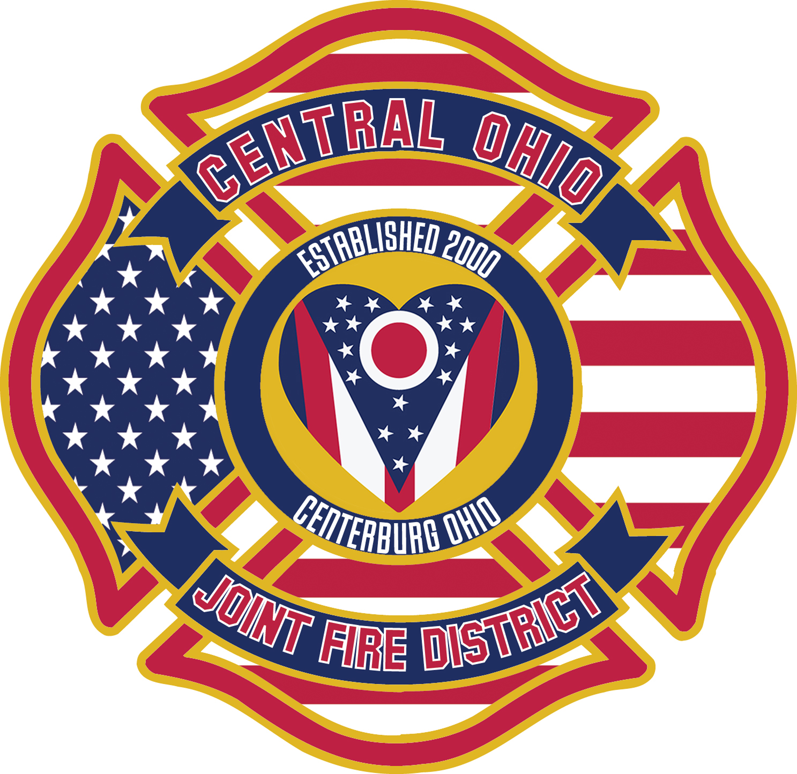

**Year End Report: 2021**

**Program Description**. The Office of Fire Chief is tasked to ensure proper administration and oversight at all levels. To serve the public, staff, and outside agencies to better safeguard against disasters and harm that can occur. High levels of effort are spent in planning and ensuring all equipment and members are prepared to safely respond in a fiscally and transparent method. Modern science and data are used as corner stones in decision making and process.

**Mission**: *The COJFD shall safeguard our community and all who call for help*. We will do this by: providing protection and preservation of life and property, mindful of acceptable levels of risk, maintaining the highest standards of emergency medical services, fire suppression, fire prevention and education and safety programs.

**Future goals 2022 for specified time (S.M.A.R.T.)**.

* Receive bids for Grass Truck and P421 – December 2022
* Promote/hire two new Lieutenants and three new OOC Firefighters - July 2022
* Welcome back Lt Swank - Fall 2022
* Second power cot and load system installed - July 2022
* Secure S. Bloomfield contract for next for years – August 2022

**Outcomes and Outputs (Goals Achieved)** Status of achieving goals of prior year(s)

* By June 2021 complete updating all policy and procedures. Completed
* Become a candidate agency with the Center for Public Service Excellence by December 2021. Not Completed
* Secure South Bloomfield contract by Nov. 2022. In talks.
* Increase full-time staff by three-line firefighters/paramedics by Dec 2021. Completed
* Replace one emergency vehicle by Dec 2021. Ordered with delivery 2023
* Budgeted for fleet replacement – Completed Jan 2022
* Bay doors replaced and entry doors – Completed May 2022
* Rescue boat and equipment – Partially completed
* Passed the South Bloomfield - Completed

***Executive Summary***

Central Ohio Joint Fire District (COJFD) continued much in COVID pandemic mode for the year. The direct impact to the department was seen mostly in firefighter illness associated or contracted COVID 19 medical issues. This did increase overtime by 25 percent from 2020 and 10 percent in comparison to 2019.

The supplies chain for fire, EMS, or simple station supplies had significant impact on or operations both increased costs and quantity allowed. For example, the ordering of both the new ambulance and fire truck could have been $80,000 more simply do to the supply chain to the builders. If we were able to order the fire truck in December 2021 and waited until May 2022, that same truck would have increased $100,000.

Staffing was and will continue to be an issue for COJFD and public services in general. Columbus Fire and Police (CPD) for example, CPD usually receive 3,000 applicants

For 60 police. They only received 670 for those same 60 positions. Mt Vernon Fire needs 20 part-time firefighters to operate. This will drastically effect COJD form the limited pool of applicants in this area. COJFD will need to be vigilant in securing the most attractive pay packages we can offer. The new fire levies will be need more than expected when we developed the strategic plan.

The department is currently undergoing a large administrative change for the first time in the history of the department. First, a full-time fire prevention position was created an filled. This turns out to be more important with the expecting growth impart do to Knox Community and potential Intel secondary impacts for housing. Knox County according to MORP is the third fastest growing township in Knox County of the 22.

Secondly, COJFD will have a collective bargaining with full implementation in 2022. This will have impact in the areas of payroll, staffing, and daily operations to an extent. The Fire Board will have full management rights and privileges. This allowed COJFD to partner with a private law firm which has helped in so many areas already and far beyond this report to share. The takeaway is this, Ret. Chief Porter recommended this and I agree, having our own legal counsel is very important. The County Prosecutor’s office is very busy and has gone without an assistant for nearly one year. COJFD cannot depend 100 percent on that office.

Finally, the pandemic did continue to impact how we operated internally. We had both physical and financial issues to content with that have never really been seen before.. Our daily delivery of service continued to the public seamlessly. This was do to the commitment of the firefighters and Fire Board to staying focused on the COJFD mission and vision statements.

**Professionally,**

**Chief McCann**