**DIESEL ENGINE OUTLINE**

**Warning: Before performing maintenance on this unit, exercize the STOPPING THE ENGINE PROCEDURE (page 20)**

25 Gallon Hydraulic Reservoir

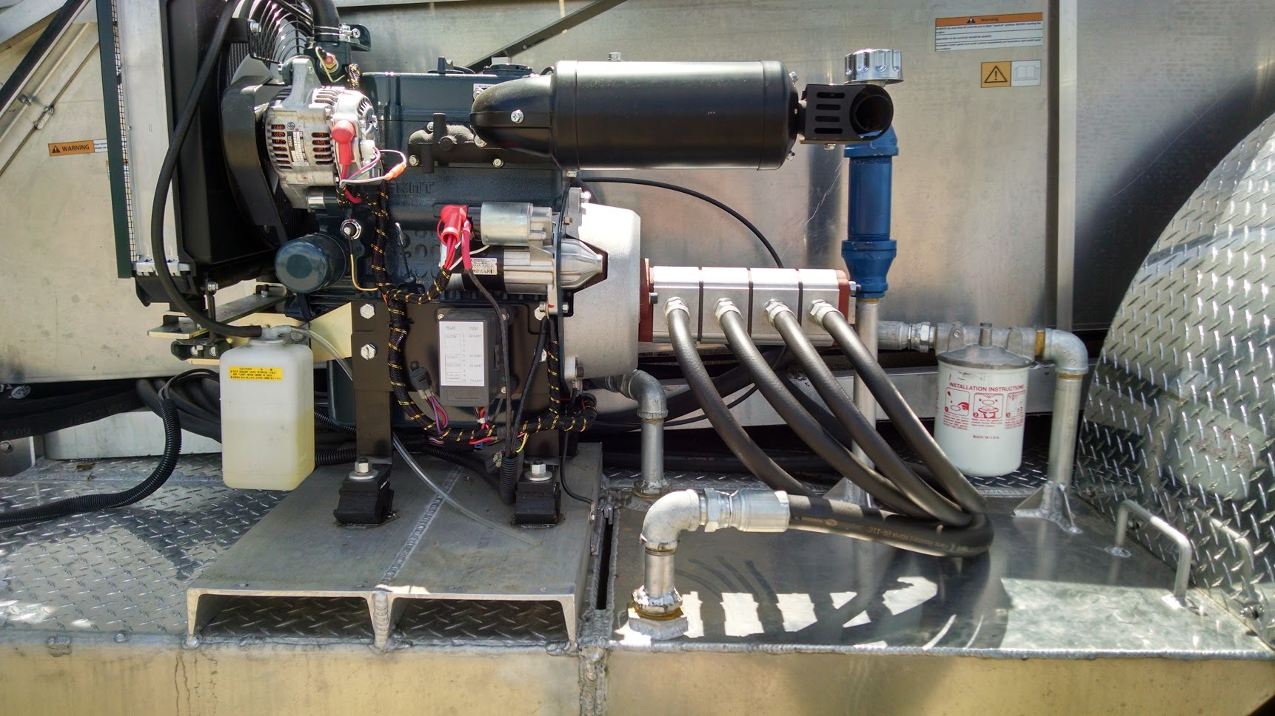

2

1

3

7

6

5

4

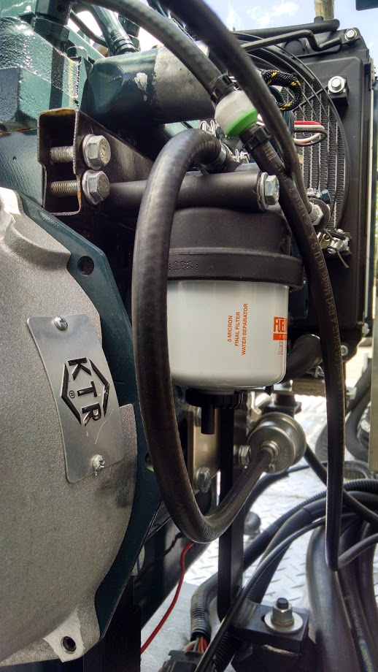 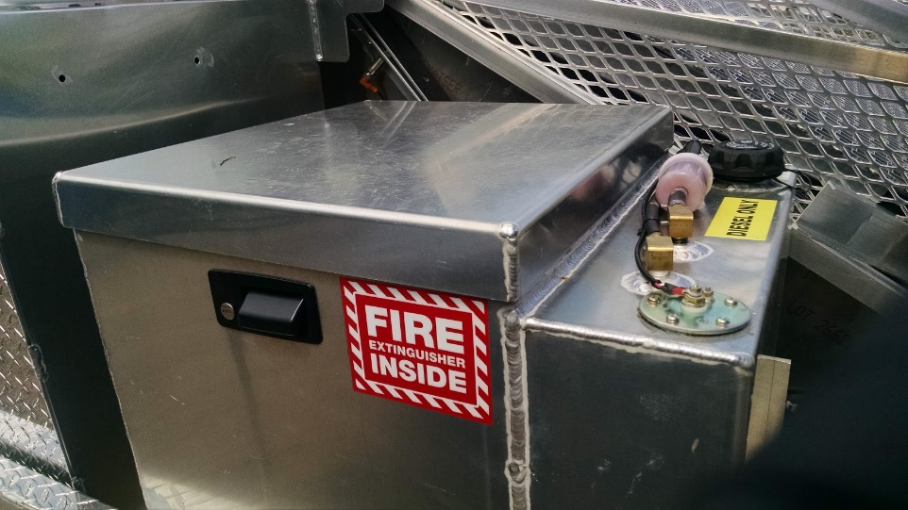

10

14

13

12

11

9

8

1. Fuse Box 8. Fuel Filter
2. Oil Dipstick 9. Fuel Pump
3. Engine Oil Filter 10. Fuel Filter Return
4. Oil Fill Cap 11. Fuel Cap
5. Oil Fluid/Fill/Level Check 12. Fuel Filter (located at engine)
6. Hydraulic Oil Filter 13. Battery Storage Box
7. Coolant Reservoir 14. Coolant Reservoir