**BRITISH ROLLER** **SPORTS FEDERATION**

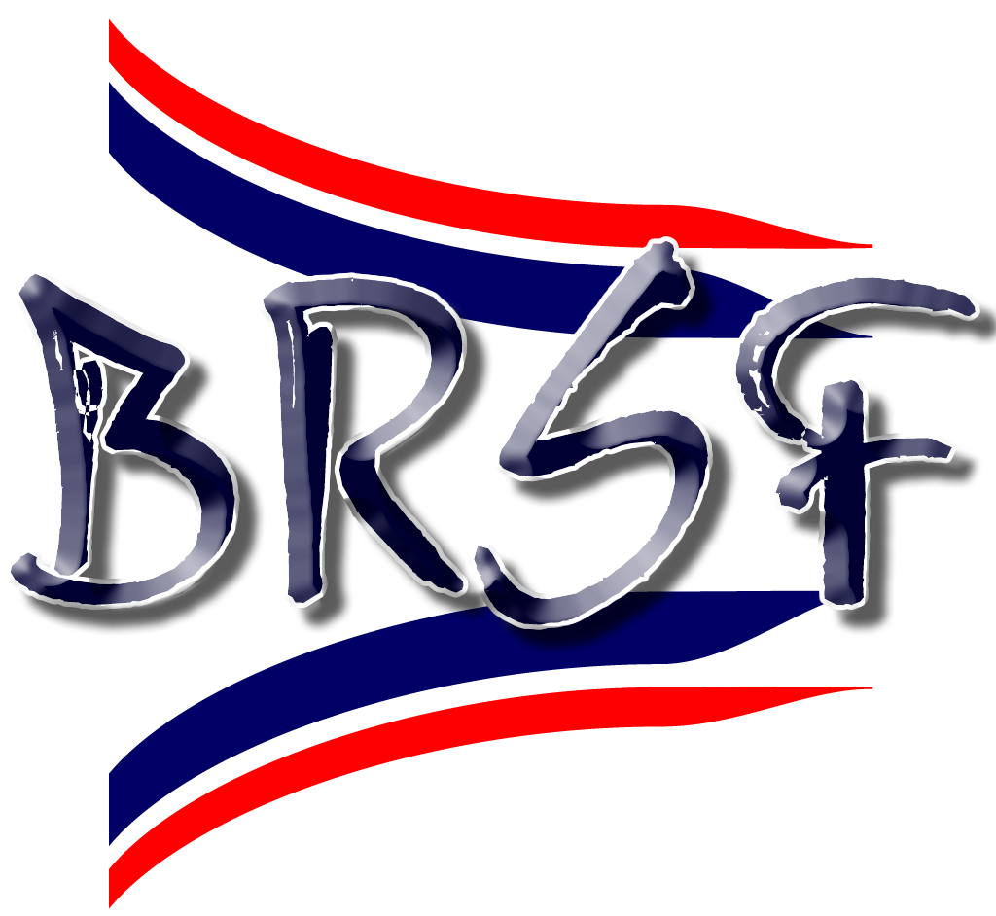

Affiliated to World Skate and World Skate Europe

Company Secretary

Room 23

The Storeroom Offices

Rotherham

S65 1SL

brsf@btinternet.com

[www.brsf.co.uk](mailto:President@brsf.co.uk)

**Application for Associate Membership**

|  |  |  |  |
| --- | --- | --- | --- |
| Name of Association/Club |  | | |
|  |  |  |  |
| Main Contact Name |  | | |
|  |  |  |  |
| Contact Address |  | | |
|  |  | | |
|  |  | | |
|  |  |  |  |
| Contact Telephone |  | | |
|  |  |  |  |
| Email Address |  | | |
|  |  |  |  |
| Discipline |  | | |
|  |  |  |  |
| Date Association Formed |  | | |
|  |  |  |  |
| To be accepted as an Associate Member of the BRSF, governing bodies should be able to enclose a copy of the documents listed below with this application. Newly formed governing bodies may not have these documents; therefore, they may tick Working Towards and give an estimated month and year that the documents will be available. | | | |
|  |  |  |  |
|  |  | Please tick | |
|  |  | Attached | Working Towards (please give expected date of completion) |
| Club Constitution (or Memorandum and Articles) | |  |  |
|  |  |  |  |
| Child Protection Policy | |  |  |
|  |  |  |  |
| Please complete this form and return it, along with supporting documents to [brsf@btinternet.com](mailto:brsf@btinternet.com). Annual membership costs £50. If your application is accepted, you will receive an invoice within 21 days. | | | |

Is there any further information you would like to provide to support your application? This section can include details about your club's achievements, community involvement, unique programs, or any other relevant information that showcases your dedication and commitment to the sport. Providing comprehensive and detailed information will help the BRSF understand the value and impact of your club, assisting in the assessment of your membership application.