BPCC STUDENT EMAIL

Student emails will be available 24 hours after enrollment date.

- Go to www.bpcc.edu and click on Email in ribbon at top of page, on resulting
screen click on Student Email Portal, the resulting screen will be Microsoft, type your username at “Email, phone, or Skype”. Note you must use email credentials.
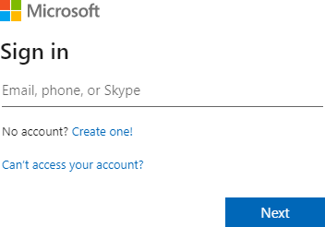

- Your username: Your BPCC username@student.bpcc.edu and Next
*If you don’t know username, go to LoLA home screen and select “I don’t know my username”, on resulting screen select “Verify Personal Information” and follow prompts.
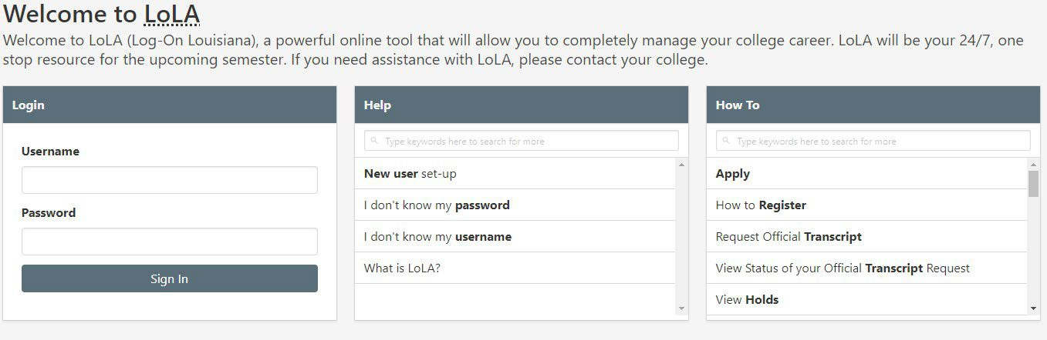

- Your password: First 3 letters of your last name (lowercase), last 4 numbers of your student ID, and + symbol
If your last name is less than 3 letters it will be letters followed by – symbol

Example 1:
Last Name = Smith Student ID = L00012345 Password = smi2345+ Example 2:
Last Name = So Student ID = L00012345 Password = so-2345+

- On initial login to student email you will be required to provide alternate contact information in the event you need to change your password.

You will be required to reset password at initial login
Passwords must contain characters from 3 of the following categories and be a minimum of 8 characters:
  - Uppercase letters (A-Z)
  - Lowercase letters (a-z)
  - Digits (0-9)
  - Non-alphanumeric characters (special characters) (~!@#$%^&*_-+=`|\(){}[]:;"'<>,.?/) Once logged into Microsoft, click on Outlook icon  Depending on device, you may be presented with M365 Copilot. To navigate M365 Copilot after download, tap 3 horizontal lines at top left, tap on wheel (settings icon) to left of your name at bottom of screen, on resulting screen tap “Microsoft Apps” then tap “Get” or “Open” on Outlook.
Please note the password for BPCC computer login, student email, and BPCC Wi-Fi are the same; therefore, if you reset your password from a BPCC computer or your student email, it will automatically reset to the others.

If you have any questions, please email studentmail@bpcc.edu or call Computer Services at 318-678- 6418.

BPCC COMPUTER

You will be assigned a BPCC username and password to log in to computers on BPCC campus at the same time that your student email is assigned.

At initial login you will be required to reset your password. Please note the password for BPCC computer login, student email, and BPCC Wi-FI are the same; therefore, if you reset your password from a BPCC computer or your student email, it will automatically reset to the others.

- Your username: Your BPCC username
*If you don’t know username, go to LoLA home screen and select “I don’t know my username”, on resulting screen select “Verify Personal Information” and follow prompts.

- Your password: First 3 letters of your last name (lowercase), last 4 numbers of your student ID, and + symbol
If your last name is less than 3 letters it will be letters followed by – symbol

Example 1:
Last Name = Smith Student ID = L00012345 Password = smi2345+ Example 2:
Last Name = So Student ID = L00012345 Password = so-2345+

If you have any questions, call Computer Services at 318-678-6418.

BPCC WIFI

You will be granted access to BPCC Wi-Fi at the same time that your student email is assigned.

Please note the password for BPCC computer login, student email, and BPCC Wi-Fi are the same; therefore, if you reset your password from a BPCC computer or your student email, it will automatically reset to the others.

- Select and connect to the wireless network BPCClink2 on your laptop, smartphone, Tablet, or other wi-fi device.

- In not presented immediately with a log on page, open any web browser to access.

- Your username: Your BPCC username
*If you don’t know username, go to LoLA home screen and select “I don’t know my username”, on resulting screen select “Verify Personal Information” and follow prompts.

- Your password: First 3 letters of your last name (lowercase), last 4 numbers of your student ID, and + symbol
If your last name is less than 3 letters it will be letters followed by – symbol

Example 1:
Last Name = Smith Student ID = L00012345 Password = smi2345+ Example 2:
Last Name = So Student ID = L00012345 Password = so-2345+

If you have any questions, please call Computer Services at 318-678-6418.

It is advisable to log in to your LOLA, myBPCC, and Student Email accounts prior to arriving to your first class to ensure successful login. You may also want to come to BPCC campus to ensure successful login of BPCC computers and Wi-Fi, you will be able to access campus computers at the Learning Commons/Library.

