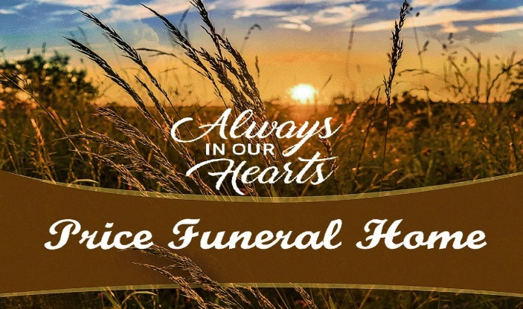
January 25, 2022v2
……………………………
GENERAL PRICE LIST
The goods and service showed below are those we could provide to our customers. You may choose only the items you desire. However, any funeral arrangements you select will include a charge for our basic services and overhead. If legal or other requirements mean you must buy any items you did not specifically ask for, we will explain the reason in writing on the statement we provide describing the funeral goods and services you selected.

BASIC SERVICES OF FUNERAL DIRECTOR & STAFF………………….……………$1800.00
Our fee for the services of funeral director and staff includes, but is not limited to, staff to respond to initial request for service; arrangement conference with family or responsible party; arrangement of funeral; preparation and filing of necessary authorizations and permits; recording vital statistics’ preparations and placement of obituary notices; staff assistance prior to, during and following the funeral, e.g. cemetery, crematory and others. Also including in these charges are overhead expenses, secretarial and administrative costs, and equipment and inventory costs. This fee for our basic services and overhead will be added to the total cost of the funeral arrangements you select. (This fee is already included in our charges for direct cremation, immediate burials, and forwarding or receiving remains.)

EMBALMING…………………………………………………………$650.00
Except in certain special cases, law does not require embalming. Embalming may be necessary, however, if you select certain funeral arrangements, such as a funeral with a viewing. If you do not want embalming, you usually have the right to choose an arrangement that does not require you to pay for it, such as direct cremation or immediate burial.
Pennsylvania Death certificates ………………………….… $20.00
Out Of State Certificate service charge………………..… $75.00
TRANSFER OF REMAINS TO FUNERAL HOME…………………………………………. $300.00
Transfer of remains to funeral home from decedents home___________$350.00
PREPARATION OF BODY
COSMETOLOGY, DRESSING, CASKETING, HAIR STYLING……………. $150.00 and up
USE OF FACILITIES & STAFF FOR VIEWING/VISITATION…………………………. $250.00
Our services include setup of visitation area, placement of encased remains, and display of floral arrangements, supervision of and attendance at visitation. (Charge per day)
USE OF FACILITIES & STAFF FOR FUNERAL CEREMONY………………………… $550.00
Our services include coordinating the funeral arrangements, supervision of funeral, and staff to attend ceremony.
USE OF FACILITIES & STAFF FOR MEMORIAL SERVICE…………………..…….… $550.00
Our services include coordinating the memorial service arrangements, supervision of the memorial service and staff to attend the service.
USE OF EQUIPMENT & STAFF FOR GRAVE SERVICE…………………………………$550.00
Our services include accompaniment of remains to cemetery, supervision of graveside service, and staff to attend service.
USE OF EQUIPMENT & STAFF FOR CHURCH SERVICE………………….……………$600.00
Our services include coordinating the funeral arrangements, supervision of funeral, and staff to attend ceremony.
USE OF EQUIPMENT & STAFF FOR NIGHT CEREMONY, EXTRA…………….…. $200.00
HEARSE (CASKET COACH)……………………………………………………………………... $475.00
Beyond 10 miles, add $1.50 per mile.
LIMOUSINE (Van)PER 4 HOUR USE………………………………. 12 passenger……………$675.00
LIMOUSINE PER 4 HOUR USE…………………………………………………………………$475.00
Beyond 10 miles, add $1.50 per mile. ($30.00 per hour overtime)
SERVICE/UTILITY VEHICLE 1ST VIEWING………….……………..………….…………… $350.00
Beyond 10 miles, add $1.50 per mile.
CASKETS……………………………………………………………………….…………… $550.00 and up
CASKET RENTAL for service for cremation………………….……………… $550.00 and up
OUTER BURIAL CONTAINER………………………………………………………. $950.00 and up
Air Tray……………………………………………………………………….……………………………$375.00
MISCELLANEOUS MERCHANDISE
Cremation Urns…………MUST ADD 7% Tax…………………………………….. $95.00 and up
Cremation Jewelry…… MUST ADD 7% Tax ……………………….…………… $90.00 and up
Acknowledgement Cards
Type A- per fifty………………………………………….………………………….. $9.50 and up
Type B- per fifty……………………………………..………………………………$20.00 and up
Register Book(s)……………….……………………………………………………………..$45.00 and up
Announcement Cards………………………………………………………………………$15.00 and up
$15.00 and up additional 50. …………………………..……………..…………………..… $15.00 and up
Prayer Cards (100)…………………………………………………………..$40.00 and up
Memory Cards (Book Markers Laminated)……………………….……………………………… $50.00 and up
Memorial Package (memorial, thank you cards & book)…………….… $150.00 and up
Programs (minimum 100) Black & White & Color……………………….… $150.00 and up
Trifold (minimum 100) Color…………………….……………………………….…. $300.00 and up
Name Plates………………………………………………………………………………..…. $60.00 and up
Flag Case
Soft Plastic…………………………………………………………………………….…………. $25.00
Solid with brass nameplate………………………………………………….………… $60.00
Veteran Package (flag case, thank you cards & book)…………………………..….. $275.00
Organist…………………………………………………………………………………………………... $150.00
Minister………………………………………………………………………………….……. $150.00 and up
Singer (soloist)……………………………………………………………………………$150.00 and up

FORWARDING REMAINS TO ANOTHER FUNERAL HOME
These charges include removal of remains, necessary services of funeral director and staff, embalming, necessary authorizations and local transportation to airport.
With minimum shipping container…………………………………………………..………. $965.00
With casket selection from our funeral home
(In addition to the cost of casket) ……………………………………………………………. $850.00
Air Tray……………………………………………………………………………………….……………. $325.00
RECEIVING OF REMAINS FROM ANOTHER FUNERAL HOME
This charge includes temporary shelter of remains, transportation of remains to cemetery and necessary services of funeral director and staff…………………………………………………………………………………. $850.00
IMMEDIATE DISPOSITION
Our charge for an immediate dispositions, without ceremonies, includes removal and shelter of remains, local transportation to cemetery, necessary services of funeral director and staff and authorizations.
IMMEDIATE BURIAL
Immediate burial with casket provided by purchaser…………………………….. $1550.00
Immediate burial with minimum container provided by Price’s…………….. $1850.00
PRICE DOES NOT INCLUDE GRAVE & OPENING
DIRECT CREMATION…………………………………………………………………………… $1250.00+ county charges
Our charge for a direct cremation includes removal of remains, local transportation to crematory, and Funeral Home Urn, minimum container required by crematory and necessary services of funeral director and staff, authorizations and $275.00 cremation fee for Ivy Hill Crematory.
(Crematories other than Ivy Hill may have different cremation fees.)
If you want to arrange a direct cremation, you can use an alternative container. Alternative containers encase the body and can be made of material like fiberboard or composition materials (with or without an outside covering).
The containers we provide are a fiberboard container or an unfinished wood box.
a. Direct cremation with container provided by the purchaser _____$1200.00
b. Direct cremation with a fiberboard container_________________$1200.00
c. Direct cremation with an unfinished wood box________________$1450.00

