Escambia County Utilities
Morrow Water Technologies
Innerarity Island, FL
April 29, 2020

To whom it may concern,
This letter is to let the home owners at the Innerarity Island Project as well as Escambia County Utilities that Environment One Corporation will warranty for a period of 5 years the stations being installed by Talcon Construction with the Start-ups being conducted by Morrow Water Technologies. The Stations that were installed before this letter was sent will also be under this 5-year warranty.
The stations for this project should be ballasted with a minimum of 200 lbs of concrete going forward and the discharge line shall be bedded coming out of the tank for a minimum of 18”. If these procedures are not followed and executed on all future stations the warranty will be investigated by Environment One and its Certified Service Partner Morrow Water Technologies at the time of failure.
A start-up form shall be completed for every station and will have each Serial number documented and checklist completed. This is a requirement of every E/One Pump and station installed.
Please let me know if you have any questions or concerns about this process or the Innerarity Island Project.

Sincerely,
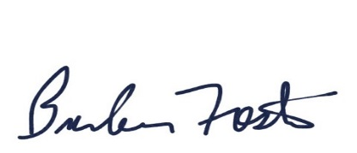
Brandon Foster
Regional Sales Manager
bfoster@eone.com
Cell- 281-217-7928

