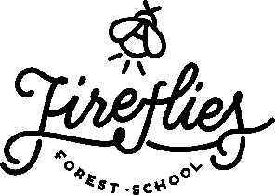

Parent/Carer Handbook

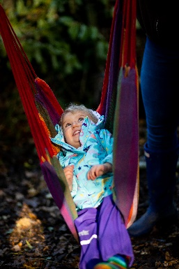
Welcome to the Fireflies community!
We look forward to meeting you and welcoming you into our Forest School provision at Hinchingbrooke Country Park.

This handbook outlines what we do and why we do it. Whether you are a parent, teacher, visitor, staff member or volunteer, this handbook is for you. It will give you an insight into the Fireflies vision and values and it will help you play a meaningful role in our Forest School.
The handbook summarises our most significant polices, with full versions uploaded onto our website, however, if there are any other policies you would like to see please just ask.
Once your child has been offered a space in Twiglets, they keep this space until your child moves on to school or to our Home Ed Programme. As Forest school is a long term approach and programme we would love for your little one to see all the seasons with us and experience the woodland over time, and remain with us until they start school (or if Home Edding, when you feel they are ready to move across to home Ed hawks!). We will auto enrol your child each term, and payment for the following term is due as the previous one finishes. We will send you an invoice reminder. We kindly ask for 1 months notice if you know that you are not able to continue next term.
If you are unsure of anything that you read here or come across while at the Forest School, please speak to an experienced member of staff who will be happy to support you and answer any questions.
Contact Details
Jessica Brocklebank, 07557 282 113
Enquiries@firefliesforestschool.co.uk
Founded: January 2019
Website: www.firefliesforestschool.co.uk
Facebook: https://www.facebook.com/firefliesforestschoolcambridgeshire
Liability Insurance Policy Number: SALSALIA/J211980/0332/21
Professional Indemnity Insurance supplied by Birnbeck Insurance Services/QBE
Ofsted Registration number: 2725390

General Information

“Forest School is an inspirational process that offers all learners opportunities to achieve and develop confidence and self-esteem through hands-on learning experiences in a woodland or natural environment with trees”
We are very excited to welcome you to our forest school and hope that over the terms and years, your child gets to truly experience the magical environment and learning opportunities the Forest School ethos and environment offers. Once your child is enrolled with us, they are then secured their space until they start school (or beyond if flexi schooling or home educating!). Our terms are usually 12-week blocks, and the sessions are term time only, we will auto enrol your child each term so you do not need to worry about remembering to book each term! We ask for 1 months’ notice if you would like to cancel your childs space.

So, What exactly is Forest School?
Forest school is not as simple as just spending time playing in the woods (although we do lots of this!). There is much more to it than this. The staff are highly trained in how to set up learning opportunities, how to create play invitations, how to incorporate nature into everything we do, how to support a child to help develop their self confidence and self-esteem, resilience, independence, risk taking, ability to assess a risk, and much more!
It is not so much about what activities they are doing while they are at forest school, or what craft they may be making, its about the process and the learning happening throughout this time. The process of what learning is happening and what skills are being developed over time is the fundamental reason why forest school is a long-term commitment over the seasons, over repeated sessions across time, happens in all weather and so on. Rather than just a one term only class like some other toddler groups can be, it is a long term approach and learning journey.
To really see the benefits and impact forest school can have on your child they need to experience all the seasons and experience the Forest School approach over time. Parents who have brought their children from Age 1 (or younger now that we have our baby acorns!) all the way up to them starting school will advocate just how much it has shaped their child and supported and prepared them to have a gentle transition into school, unless they are home educated and then they join our Home Ed Hawks group!

Learning Environment
Forest School is a specialised learning approach that sits within and complements the wider context of outdoor and woodland education.
At Forest School all participants are viewed as:
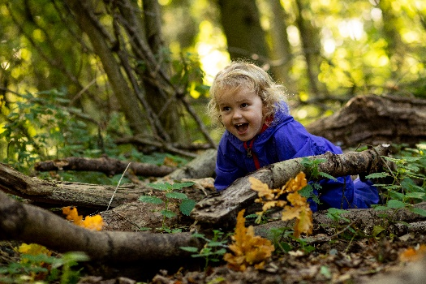
- equal, unique and valuable
- competent to explore and discover
- entitled to experience appropriate risk and challenge
- entitled to choose, and to initiate and drive their own learning and development
- entitled to experience regular success
- entitled to develop positive relationships with themselves and other people
- entitled to develop a strong, positive relationship with their natural world

Forest School principles

Fireflies Forest School is centred on the principles of kindness, democracy and permaculture to provide children with a holistic experience of education. We a member of the Forest School Association and we adhere to the six principles of Forest School.
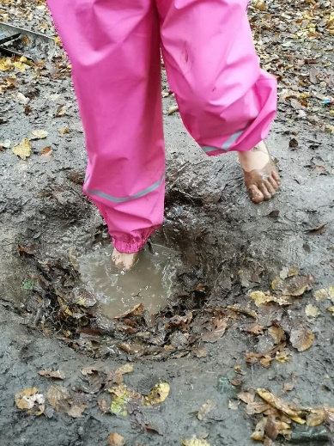
Principle 1: Forest School is a long-term process of frequent and regular sessions in a woodland or natural environment, rather than a one-off visit. Planning, adaptation, observation and review are integral elements of Forest School.
Principle 2: Forest School takes place in a woodland or natural wooded environment to support the development of a relationship between the learner and the natural world.
Principle 3: Forest School aims to promote the holistic development of all those involved, fostering resilient, confident, independent and creative learners.
Principle 4: Forest School offers learners the opportunity to take supported risks appropriate to the environment and to themselves.
Principle 5: Forest School is run by qualified Forest School practitioners who continuously maintain and develop their professional practice.
Principle 6: Forest School uses a range of learner-centred processes to create a community for development and learning

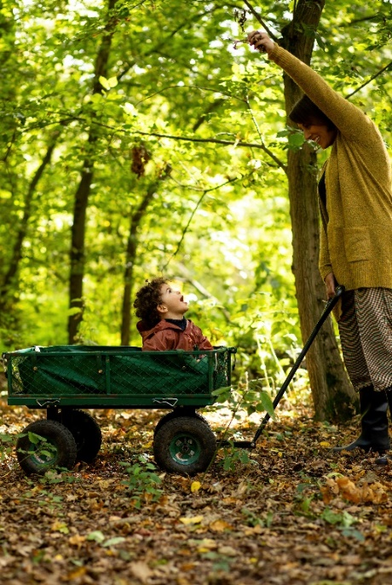
So what happens at a session?
During our sessions the children choose the activity, location, and length of time they spend on it. Left to their own devices, children are wonderfully imaginative and resourceful when it comes to play. To limit their imagination or to divert their attention towards something you think could be more ‘educational’ may be counterproductive.
Therefore, if a child chooses to lay in a hammock, sit and watch others, or repeatedly doing the same activity; this is absolutely fine! It is what they need at that moment, then there is nothing a child “should” be doing in any given session. Forest school is very much about allowing children just to “Be” rather than “do”.

All the crafts or more structured activities are always optional and we will let the children decide if it is something they would like to do or not. We would never stop a child playing to encourage them to come away and make a craft, or engage in a tool, the child will lead their learning and Play is the perfect medium for this. We encourage you to also not disrupt their play to ask if they want to do something else. We know it can be tempting as there may be a beautiful table of resources for a craft to make! But really, unless the child is showing an interest and wish to make that craft, we shouldn’t be ending their play to do this, as it could be counterproductive, they are probably learning much more from what they are currently doing!

Our Forest School setting provides a wonderfully stimulating environment, rich with learning possibilities through observing their natural systems.
Forest School facilitators may set up activities in the woods that will entice children with different interests. The role of the facilitator is to observe and engage but not interfere with the children’s learning. The challenge for the facilitator is to know when to intervene and how, and this is where Forest School training, experience and reflective practice becomes central. Safety is paramount, but managed risks are an essential part of a child’s learning.
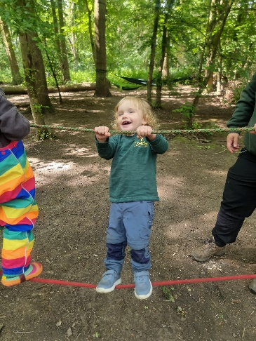
What your child might do at Twiglets:
- PLAY!
- Move our resources around
- Sit at the log circle and watch others
- Explore the mud kitchen
- Build dens
- Play on the ropes, swings, hammocks
- Read stories and explore our sheds
- Practise using tools such as a saw, drill, knife, mallet,
- Fire lighting
- Natural crafts
- Cook on a campfire
- Singing and musical instruments
- Connect with nature
And more!
What your child might develop at Twiglets:
- Resilience
- Confidence
- Independence
- Risk taking
- How to balance
- Co ordination
- Gross motor skills
- Fine moto skills
- Language and communication skills
- A deeper understanding of the world around them
- And more!
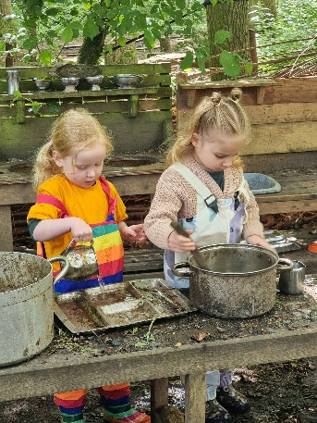
But it is important to remember that the forest school ethos is child led, so we will not impose any activity on them, there isn’t anything specific they should be doing each session! So, if your child wants to spend a session just sitting and watching others or lying in the hammock its ok! The crafts, tools, and more structured activities are completely optional.

The Team
Jessica Brocklebank owns and manages Fireflies Forest School. She is a qualified Primary school teacher and Level 3 Forest School Leader. Jessica also has qualifications and 18 years’ experience of working with children and young people who are neurodivergent or who have a mental health condition, in the classroom and in a Forest School setting and feels passionate about forest school being accessible for all. Jessica has three children from 2years old up to 12 years old! You will likely see the youngest, River, at our sessions!

Leaders and Assistants
At Fireflies we have a wide group of passionate and talented individuals. Many are trained as either a Level-3 qualified Forest School leader, a level 2 forest school assistant or are currently doing their training, more information about each of our staff can be found on our website.
Monday staff: Jenny, Katy, Annette, Charlotte
Wednesday staff: Natalie, Alison, Jenny
Friday Staff: Jess, Natalie, Anna, Jenny
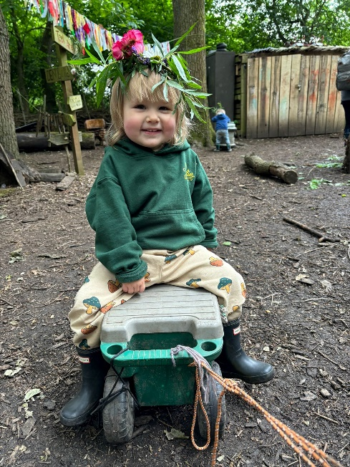
Volunteers
We are currently looking for more volunteers! If you are interested in becoming a volunteer, please just let us know! You will get FREE access to school holiday sessions for your child as a thank you!
You can read a little more and see photos on our website under the “About Us” section.

Daily Routine
Before the session
Prior to every session, the Forest School leader will have planned, and risk assessed a forest school session which may link to the current season, a weekly theme or have a nature-based topic. We will have craft and tool activities, along with ropes, swings and many “invitations of play” such as our mud kitchen, wheelbarrows and trollies, cuddly toys, books and an unlimited supply of natural resources!
Before everyone arrives, the Forest School leader and assistant checks the site over and completes a daily site check. The staff and volunteers organise the equipment and ensure that all is in safe working order.
The Forest School Forest School leader briefs the team on the daily plan, based on observations by the team of what the children enjoyed in the previous session.
On arrival…….
On the first week of term, we will send a member of staff to the café at Hinchingbrooke Country Park around 5 minutes before the start of your session to meet anyone unsure of our location. The café is signposted from the main car park.
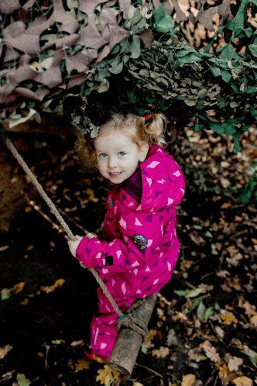
When you arrive at our site, you will see your child will have a name cookie on the table as you walk in on the left hand side. Please help your child to find their name cookie, over time (age dependent) the children begin to recognise the insect and colour on their name cookie, even if they are unable to read or recognise their name. They can then hang this up on the screws on the shed wall to register their attendance.

10-10.15am
At the start of the session we welcome everyone in, the children can explore the site and you can put your bags down and get settled. We encourage parents to step back during the sessions so that your child can explore, develop their independence and interact with their peers if possible. But we appreciate some children may not be ready for this and may need your support and reassurance, which is absolutely fine.
We have a seating area opposite the log circle with wooden chairs for you to sit with other parents and relax/chat! Or you are more than welcome to sit around the campfire in the main log circle. We want this space to be somewhere you can come and relax while your little one plays and to support them to develop independence to play with other children and engage in play independently.

10.15
The forest school leader will do a crow call “ka Ka Ka Ka” which is a sign for all the children to join the log circle for an opening log circle. We encourage all of the children to come to the log circle independently and sit on a log, however if they are a little young yet or need you to sit with them for support, then please do! We just ask that if you want to chat to other parents while the log circle talk is happening that you move away from the log circle to do so as it can be tricky for the children to hear us when part of a big group.
We sing our opening song which we repeat each week, so it is not long before the children all know it! If you are joining your child at the log circle, please do join in too!
Once the opening log circle has been done the children will be sent off to play!
Throughout the session, the staff will be observing the children’ what equipment or resources the child seeks, how their learning could progress, what their interests are, if there are any insecurities or lack of confidence in a particular skill or resource and what influence a particular activity or resource has on a child.
For example, we may notice a child seeks the hammocks at the start of every session to support their emotional regulation. Therefore, we may then ensure a hammock is always hanging at the start of a session and perhaps if needed, close to the parent area.
We will also observe personal development such as resilience, self-esteem, independence, teamwork, and perseverance. This is to enable the staff and volunteers to facilitate and support learning to promote and encourage development and reinforcement of these skills in the child/young person.
The staff and volunteers are present to facilitate and support where and if needed. They are not there to direct children or young people to follow their agenda or to instruct the group to engage in a particular activity, they are simply there to facilitate and scaffold learning, but will step back as much as possible.
We will do another crow call around 11am for snack and drink time. And then the children will have some more time to play before re grouping at the end of the session, to reflect on the day and to discuss what they would like to do the following week together.

What is a parent or Carers role during Twiglets?

Our sessions are all about bringing families together to form a little community. Pre Covid parents joined in with sessions much more and the group was more a stay and play session. However, when COVID-19 arrived we had to respond quickly to reduce any risk factors in having such a large group of people moving around the site. So, parents began to attend as more of a spectator where they would bring a camping chair and sit and watch the session (depending on the childs confidence, independence and age).
The feedback so far has been that parents have preferred this new way! It means that the children are much more independent and rather than asking to be lifted to a rope because a parent is next to them, they problem solve together and find a way to get up there, developing independence and resilience! Or the children seek support from their peers, and they help each other instead. We have also noticed that when parents stand back, more social interactions between the children occur and friendships are made much quicker. So we have a large area opposite our main log circle where there are chairs for parents to sit and relax, along with a hot drinks station!
However, we understand that not all children will be confident enough to go off and play without you, or perhaps not for the first few weeks, so if you need to play alongside your child or support them, please do! We also appreciate that some of you come along to share the session with your little one or to join them in their play, so if you want to join in please do! Everyone comes for a different reason and the children also vary in age too.

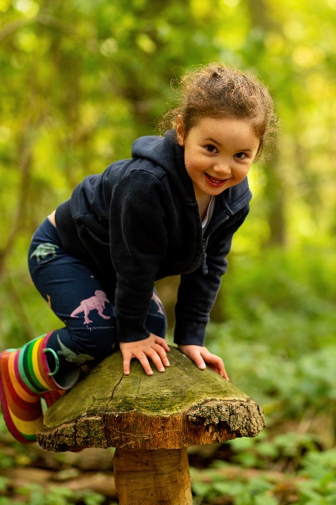
We also encourage you to join in , help out and get involved as much as you like! If you want to help with the fire, help to feed it sticks and wood, or to support us with cooking of the snack please just make the staff aware! We always welcome help!! And would love for you all to feel involved in the session so please do muck in if you’re happy to!

Language

In Forest School training there is a vast amount of time spent on the powerful impact language can have. Therefore, our staff are trained in how to support your little ones, how to encourage the next step in their learning and how to evoke curiosity and problem solving rather than just providing answers.
An important thing that we ask, is for you not to describe any weather in a negative way! It can be tempting (and trust us we all fall into this at times!) to say things like “oh the weather isn’t good today”. Although we know some of us are not so keen on the cold or wet days, language can have a huge impact on how your little one responds to weather changes, and this will then have an impact on their resilience in the colder or wetter months!
We follow the motto “there’s no such thing as bad weather, just bad clothing”. So, although it may be tempting on the wet and cold days to describe it as miserable or bad weather, some of the children’s most favourite and enjoyable sessions are in the pouring rain! So saying things like “oh look at all the rain we have today to play in!” or “we can dress really cosy today and run around lots to keep warm”.
Another word we try to avoid in forest school that is overused and very easily said is “be careful”. The term “be careful” is very vague and not extremely helpful!
When a child is balancing on a log and we say “oh be careful” it really does not tell the child anything, it does not explain the risk or danger and it doesn’t guide them to reduce the risk or make their play safer.
Instead, we would say “that log looks very slippy, are your feet in the middle? Or “you are walking close to the edge, and it looks like you are slipping” or “can you walk in the middle of the log”. These kinds of responses give ideas of how to reduce the risk, which is ultimately what we are trying to do by saying “be careful”, but just with a little more productive language!
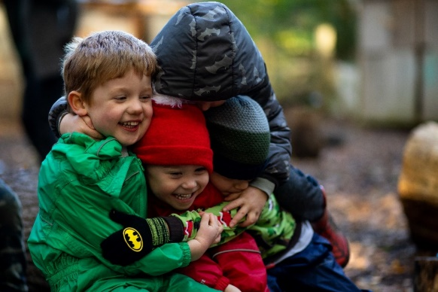

Clothing

Please ensure your child is dressed appropriately for the weather. Layers really are the key to keeping your child warm. If they have adequate warm layers, then they should be able to stay warm in any temperature.
We ask that your child is appropriately dressed so that they can engage in any of our activities or resources without the worry of clothes getting too muddy or wet and for your child not to be restricted due to feeling too cold or too hot. But it is also important to try put them in warm layers that are not super bulky! Some of the snow suits look like they are really warm, but they are so puffy and big that the children are physically restricted!
Part of the Forest School experience is that children will be active in the outdoors in all weathers, with the exception of very high winds & thunderstorms. Although we provide shelter using tarps, please assume that your child will be outside when they take part at Forest School, even in heavy rain or snow.
We know this is not always easy to encourage a 2-year-old to wear their gloves and hats, and that they may constantly be pulled off! So please do not worry, however if they have them with them, we can try!
We fully understand it may be a process, and the natural consequence of not wearing them and feeling cold will hopefully be an incentive! If you need any advice or support with ensuring your child has the right clothing please just ask us, or ask other parents. We are hoping to start a swap shop in our site soon, where you can donate old outdoor clothing and boots and swap for a bigger size from the shop when they are outgrown for free. We also have a Facebook page for selling/donating outdoor clothing.

Below is our recommended kit list:
Spring and Summer: We can have some very warm sessions in the summer, although the tree canopy offers lots of shade it is still important to keep the children as cool as possible. Cotton trousers and a thin long sleeved cotton top, sun hat, sun cream. Please avoid shorts as this increases the risk of ticks and also scrapes and grazes.
Autumn and Winter:
Base Layer: Vest or thermal top, tights or thermal leggings
Mid layer: Long sleeved T-shirt top, Fleece top/jumper, Leggings/trousers (preferably a thicker type material for really cold weeks)
Top layer: for really cold weeks: Thicker fleece /jacket

We also recommend your child has a waterproof outer layer, this can be waterproof jacket and trousers, dungarees or an all-in-one suit. Your child may also need gloves or mittens, hats and snoods in the colder months. We advise against scarves due to risks of it getting caught when climbing and swinging.
We also recommend a good pair of warm winter walking socks to keep their feet warm. Walking boots/ walking trainers are recommended over wellies as they keep their feet much warmer. If you do bring your child in wellies, please ensure they have a fleece or warm liner as ordinary wellies, whilst waterproof, are very cold!

Please also ensure all forest school kit is named so that we can return any lost items.
We have LOTS of parents who have LOTS of outdoor clothing! So before buying new, please do write on your parent whats app groups asking if anyone has any spares or grown out of clothing!
We also have Fireflies t shirts and hoodies available to buy! Please just send us a message if you are interested in buying one.

Terms and conditions
We are really sorry, but we are unfortunately unable to process refunds due to you no longer being able to attend or if you are away one week for illness, holiday etc

Payment for sessions
All sessions must be paid in full online at the point of booking. This can be done by bank transfer or through your class for kids accounts. Your childs space is not confirmed until payment is made.
Cancellation due to staff illness
If any of the Fireflies staff are too ill to run the session, we will try to replace them with another staff member to ensure the session can still go ahead. If we are unable to find a replacement the session will be postponed, and we will offer everyone an alternative date to return for their session, usually by adding 1 week onto the end of term.

Cancellation due to extreme weather
Although forest school happens in all weathers, safety will always come first. If there is strong wind or extreme thunderstorms whereby, we feel the session is exposed to unacceptable risk the session leader may decide to cancel. There may be occasions where we can offer for you to join alternative Twiglet sessions which are running on other days.

If you need to end your place mid-term, we are unable to offer a refund. You can however give your remaining weeks to a friend to use/sell as you wish but we cannot be responsible for selling the remaining sessions for you.
Notice of leaving
We kindly ask for 1 month’s notice if your child is leaving at the end of a term to give us time to offer your childs space to another family.

Safeguarding
Jessica Brocklebank is the Safeguarding Designated Lead at Fireflies Forest School, we also have Hayley Dolbear, Lucy Mutter and Clare Mc Ewan who are also designated safeguard leads.
​
All members of Fireflies Forest School are fully committed to providing a safe, secure and inclusive environment for all children and parents/carers attending our sessions.

All of our staff and volunteers undergo basic safeguarding training and DBS checks.
We provide confidentiality in relation to information shared with us by service-users, except in circumstances where disclosure makes it a legal obligation to share information with appropriate professionals.

If we have a concern about the wellbeing of a child or vulnerable adult attending Fireflies Forest School, we will follow our Safeguarding policy which can be found on our website. If you have any questions or concerns relating to safeguarding in relation to a child or vulnerable adult, then please contact us.

Jessica Brocklebank: 07557 282 113.

If your child has sustained an injury away from our provision, please just make us aware on arrival and the staff will complete a “Existing injuries Form”.

What do I need to bring to a session?

- Each week we will have a campfire snack and drink. We will provide this and the cups/bowls. (Please ensure your childs allergy/health info is up to date on class for kids) however it is always handy to have another snack and water bottle in their bag just in case.
- Spare set of clothes and socks (just in case!)
- Hand towel for drying their hands after hand washing (although most just wipe their hands on their clothes!)
- You are welcome to bring a coffee/tea but please ensure it is in a non spill flask/cup with a lid (just don’t leave it unattended as there will be toddlers exploring!)
What’s app and Facebook
We regularly post pictures on our Facebook page and Instagram page with updates on what we have been up to during our sessions so please do give us a follow! We will only post images of children who have given us consent via the Class for Kids booking page. We also have a what’s app group for all the parents of each group. We will send a link to this if you would like to join! It is very handy to be able to share messages on and for all the parents to make friends and introduce themselves to each other.
Please can we just remind everyone, when sharing images on the what’s app group, please ensure you are only sharing images of your own child unless you have consent from the other parent. Also, if you have an important message to pass onto the staff, please do this via email or direct Whats App message rather than on the groups as they can easily be missed.

