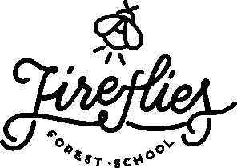

Parent/Carer Handbook
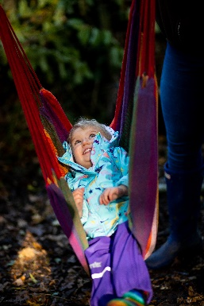
Welcome Thank you for your interest in Fireflies Forest School, based at Hinchingbrooke Country Park. This handbook outlines what we do and why we do it. Whether you are a parent or student, referrer or teacher, carer or visitor, staff member or volunteer, this handbook is for you. It will give you an insight into the Fireflies vision and values and it will help you play a meaningful role in our Forest School.
Welcome to the Fireflies community! The handbook summarises our most significant polices. All staff and volunteers must also read the full policies, which are shared on our website, printed for new staff and volunteers and are available on request.
If you are unsure of anything that you read here or come across while at the Forest School, please speak to an experienced member of staff who will be happy to support you and answer any questions.
Contact Details
Jessica Brocklebank, 07557 282 113
Enquiries@firefliesforestschool.co.uk
Founded: January 2019
Website: www.firefliesforestschool.co.uk
Facebook: https://www.facebook.com/firefliesforestschoolcambridgeshire
Liability Insurance Policy Number: SALSALIA/J211980/0332/21
Professional Indemnity Insurance supplied by Birnbeck Insurance Services/QBE

All professional photography taken of our site and during our sessions (including images used in this handbook) is by Warren Cooper Photography. More information can be found on our website.

General Information

Forest School is an inspirational process that offers all learners opportunities to achieve and develop confidence and self-esteem through hands-on learning experiences in a woodland or natural environment with trees.
Child-led Facilitation In a child-led learning environment, the child chooses the activity, location, and length of time he or she spends it. Left to their own devices, children are wonderfully imaginative and resourceful when it comes to play. To limit their imagination or to divert their attention towards something you think could be more ‘educational’ may be counterproductive.
There are several advantages to child-led education. As the children choose the activity, they are more likely to perceive the activity as play rather than as school. They are likely to be open to learning, and skills learnt may be retained for longer. Being more relaxed, they may retain more information after the event, improving their memory skills. In a Forest School, the wood provides a wonderfully stimulating environment, rich with learning possibilities through observing their natural systems.
Forest School facilitators may set up in advance activities in the woods that will entice children with different interests. The role of the facilitator is to observe, engaging but not interfering with the children’s learning. The challenge for the facilitator is to know when to intervene and how, and this is where Forest School training, experience and reflective practice becomes central. Safety is paramount, but managed risks are an essential part of a child’s learning

Learning Environment
Forest School is a specialised learning approach that sits within and complements the wider context of outdoor and woodland education.
At Forest School all participants are viewed as:
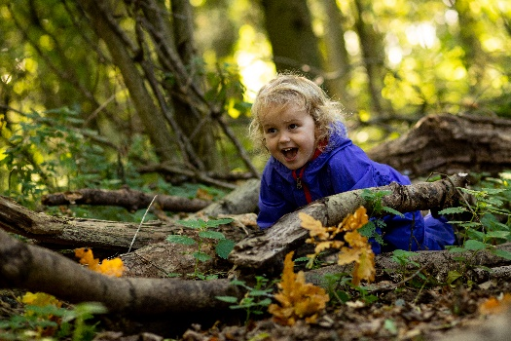
- equal, unique and valuable
- competent to explore and discover
- entitled to experience appropriate risk and challenge
- entitled to choose, and to initiate and drive their own learning and development
- entitled to experience regular success
- entitled to develop positive relationships with themselves and other people
- entitled to develop a strong, positive relationship with their natural world

Forest School principles

Fireflies Forest School is centred on the principles of kindness, democracy and permaculture to provide children with a holistic experience of education. We a member of the Forest School Association and we adhere to the six principles of Forest School.

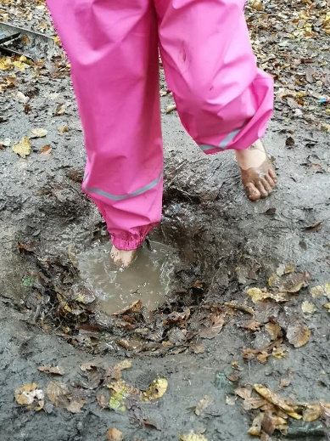
Principle 1: Forest School is a long-term process of frequent and regular sessions in a woodland or natural environment, rather than a one-off visit. Planning, adaptation, observation and review are integral elements of Forest School.
Principle 2: Forest School takes place in a woodland or natural wooded environment to support the development of a relationship between the learner and the natural world.
Principle 3: Forest School aims to promote the holistic development of all those involved, fostering resilient, confident, independent and creative learners.
Principle 4: Forest School offers learners the opportunity to take supported risks appropriate to the environment and to themselves.
Principle 5: Forest School is run by qualified Forest School practitioners who continuously maintain and develop their professional practice.
Principle 6: Forest School uses a range of learner-centred processes to create a community for development and learning
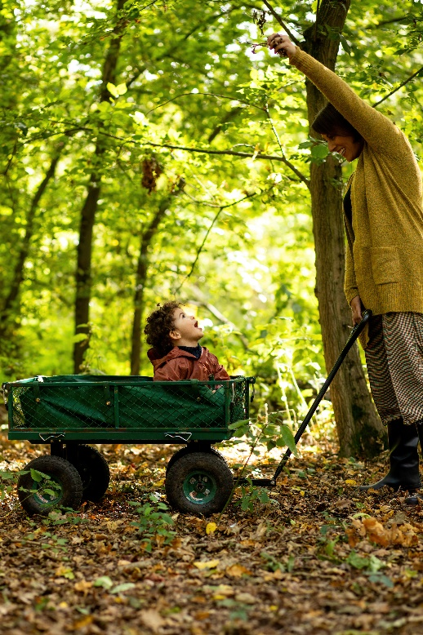
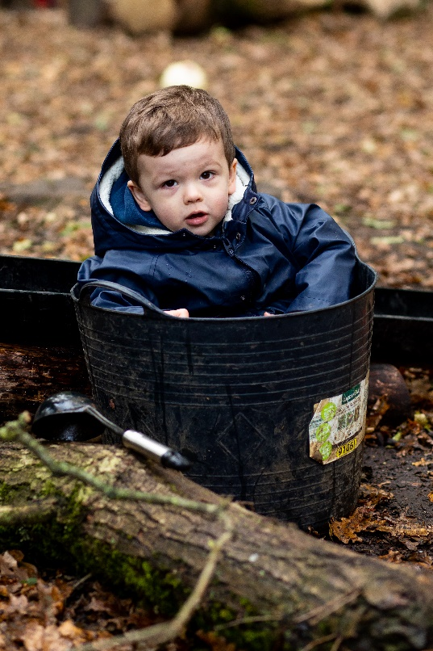

The Team
Jessica Brocklebank
Jessica Brocklebank owns and manages Fireflies Forest School. She is a qualified Primary school teacher and Level 3 Forest School Leader. Jessica also has qualifications and 12 years’ experience of working with neurodivergent children and young people in the classroom and in a Forest School setting, and feels passionate about forest school being accessible for all.
Leaders and Assistants
At Fireflies we have a wide group of passionate and talented individuals. Many are trained as either a Level-3 qualified Forest School leader, a level 2 forest school assistant or are currently doing their training. The forest school leader has ultimate responsibility for running the sessions and overall charge for decisions covering risk assessments, emergency procedures and meeting the needs of the children. The leader and assistants ensure that there is suitable equipment for the planned activities before each session and that everything is in working order.
Volunteers
At any time, there may be volunteers, carers, and visitors on site. Carers may also include parents and family members of children at the Forest School. All will be familiar with Fireflies policies and procedures as articulated in this handbook. If you would be interested in being a volunteer please let us know!!
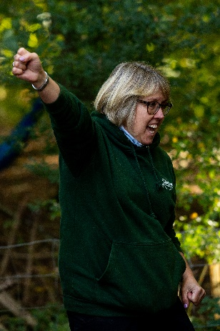
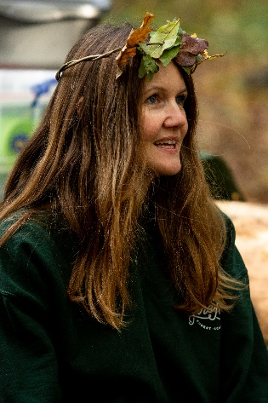
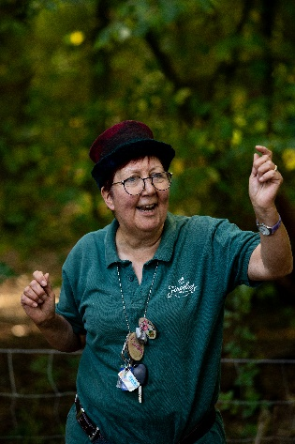
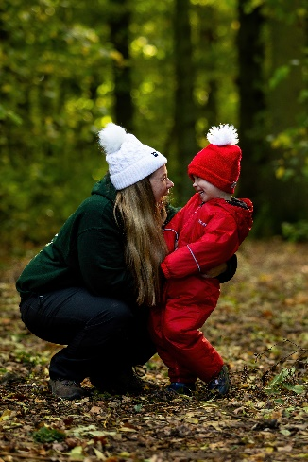

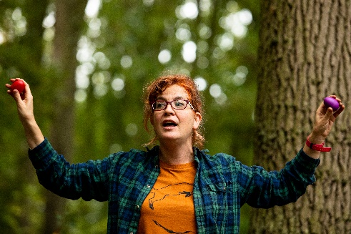
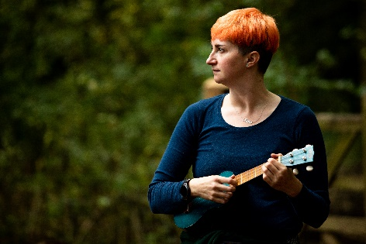

Daily Routine

Before the session
Forest Forest School leader or assistant checks the site over and completes a daily site check. The staff and volunteers organise the equipment and ensure that all is in safe working order.
Forest School Forest School leader briefs the team on the daily plan based on what the group determined the previous week. Team members prepare any equipment and materials. The leader or assistant prepares the risk assessments for each planned activity if they are not covered by the general risk assessments.

During the session
During the session, the leader or assistant will record attendance on the register at the beginning of each day.
Throughout a session all the staff will be continuously observing the children and young people, they will be observing what equipment or resources the child/young person seeks, how their learning could progress, what their interests are, if there are any insecurities or lack of confidence in a particular skill or resource and what influence a particular activity or resource has on a child. For example, we may notice a child seeks the hammocks at the start of every session to support their emotional regulation. Therefore, we may then ensure a hammock is always hanging at the start of a session and perhaps if needed, close to the parent area.
We will also observe personal development such as resilience, self-esteem, independence, teamwork, and perseverance. This is to enable the staff and volunteers to facilitate and support learning to promote and encourage development and reinforcement of these skills in the child/young person.
The staff and volunteers are present to facilitate and support where and if needed. They are not there to direct children or young people to follow their agenda or to instruct the group to engage in a particular activity, they are simply there to facilitate and scaffold learning, but will step back as much as possible.
At the end of the session, the whole group gather to reflect on the day and to discuss what they would like to do the following week.

After the session
After the session Team members collect equipment and stored it away. The Fireflies Forest School leader or assistant checks the tools to ensure that no items are missing. The Fireflies Forest School leader completes an evaluation form for the session, along with any observational records. The Forest School leader drafts the plan for the following week's session with a note of the roles and responsibilities of team members

What is a parent/carer/educational staff role during a session?

Our sessions are all about bringing families together to form a little community. Pre Covid parents joined in with sessions much more and the group was more a stay and play session. However, when COVID-19 arrived we had to respond quickly to reduce any risk factors in having such a large group of people moving around the site. So more recently we have tried to encourage parents to attend as more of a spectator where they bring a camping chair and sit and watch the session (depending on the childs confidence, independence and age).

The feedback so far has been that parents have preferred this new way! It means that the children are much more independent and rather than asking to be lifted to a rope because a parent is next to them, they problem solve together and find a way to get up there! Or the children support and help each other instead! We have also found it offers parents a chance to sit with a flask and chat to other parents whilst being able to have a little peak and watch to see the fun their little ones get up to!
However we also understand not all children will be confident enough to go off and play without you, or perhaps not for the first few weeks so if you need to play alongside your child or support them please do!
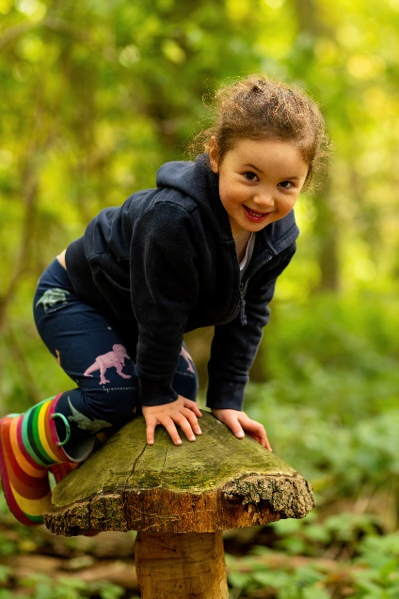
If your child is over 3 years old and confident to be dropped off, we also encourage parents to go to the café or for a walk around Hinchingbrooke Country park whilst your child is with us, however they are not able to be dropped off until they are 3 years old.
If you would like to be able to drop your child off at Twiglets please just have a chat with a member of staff.

Language

In Forest School training there is a vast amount of time spent on the powerful impact language can have. Staff will be aware, and their language used will reflect this training.

Try not to describe any weather in a negative way. Although we know some of us are not so keen on the cold or wet days, language can have a huge impact on how your little one responds to weather changes, and this will then have an impact on their resilience in the colder or wetter months! We follow the motto “there’s no such thing as bad weather, just bad clothing”. So, although it may be tempting on the wet and cold days to describe it as miserable or bad weather, some of the children’s most favourite and enjoyable sessions are in the pouring rain!

Another word we try to avoid in forest school that is overused and very easily said is “be careful”. The term be careful is very vague and not extremely helpful! When a child is balancing on a log and we say “oh be careful” it really does not tell the child anything, it does not explain the risk or danger and it doesn’t guide them to reduce the risk or make their play safer. Instead, we would say “that log looks very slippy, are your feet in the middle? Or “you are walking close to the edge, and it looks like you are slipping” or “can you walk in the middle of the log instead of by the edge”. These kinds of responses give ideas of how to reduce the risk, which is ultimately what we are trying to do by saying “be careful”, but just with a little more productive language!
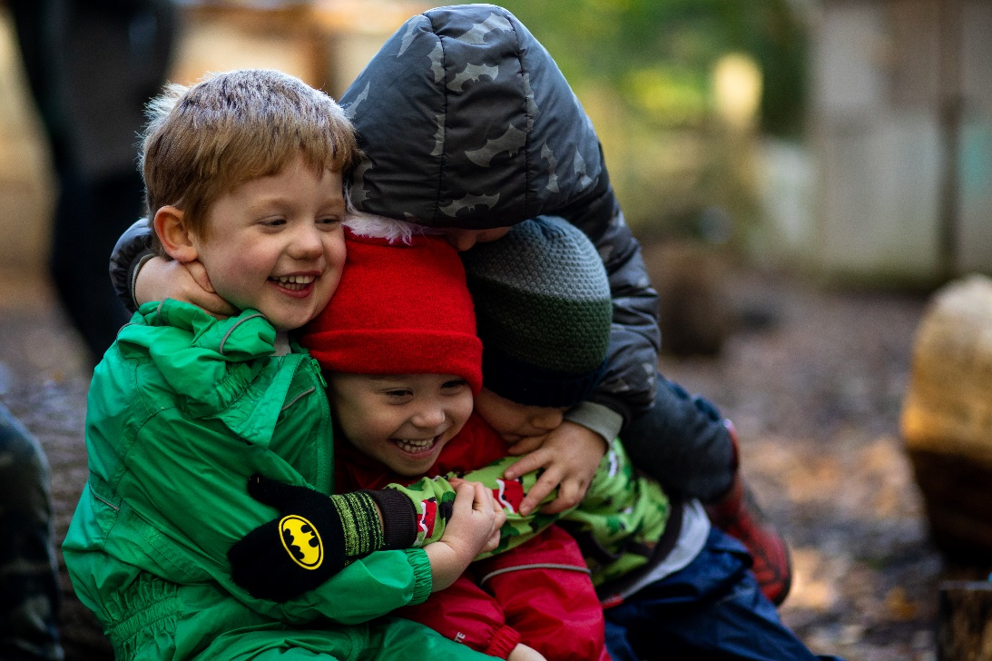

Clothing
Please ensure your child is dressed appropriately for the weather. Layers really are the key to keeping your child warm. We ask that your child is appropriately dressed so that they are able to engage in any of our activities or resources without the worry of clothes getting too muddy or wet and for your child not to be restricted due to feeling too cold or too hot.
Part of the Forest School experience is that children will be active in the outdoors in all weathers, with the exception of very high winds & thunderstorms. Although we provide shelter using tarps, please assume that your child will be outside when they take part at Forest School.
We know this is not always easy to encourage a 2-year-old to wear their gloves and hats, and that they may constantly be pulled off! So please do not worry, however if they have them with them, we can try! We fully understand it may be a process, and the natural consequence of not wearing them and feeling cold will hopefully be an incentive!
Below is our recommended kit list:
Spring and Summer: We can have some very warm sessions in the summer, although the tree canopy offers lots of shade it is still important to keep the children as cool as possible.
Cotton trousers and a thin long sleeved cotton top, sun hat, sun cream. Please avoid shorts as this increases the risk of ticks and also scrapes and grazes.
Autumn and Winter:
Base Layer: Vest or thermal top, tights or thermal leggings
Mid layer: Long sleeved T-shirt top, Fleece top/jumper, Leggings/trousers (preferably a thicker type material for really cold weeks)
Top layer: for really cold weeks: Thicker fleece /jacket

We also recommend your child has a waterproof outer layer, this can be a waterproof jacket and trousers, dungarees or an all in one suit. Your child may also need gloves or mittens, hats and snoods in the colder months. We advise against scarves. We also advice a really good pair of warm winter walking socks to keep their feet warm. Walking boots/ walking trainers are recommended over wellies as they keep their feet much warmer. If you do bring your child in wellies please ensure they have a fleece or warm liner.
Please ensure all forest school kit is named.

Terms and conditions
We are really sorry, but we are unfortunately unable to process refunds due to you no longer being able to attend. We are more than happy for you to gift the space to a friend or to sell the space. If we have enough notice we are happy to advertise the space on our Facebook page to try to re sell the space, however we cannot guarantee that we will be able to.

Payment for sessions
All sessions must be paid in full online at the point of booking. This can be done by bank transfer or through your class for kids accounts.

Cancellation due to staff illness
If any of the Fireflies staff are too ill to run the session, they will try to replace themselves to ensure the session can still go ahead. If we are unable to find a replacement the session will be postponed, and we will offer everyone an alternative date to return for their session or a refund.

Cancellation due to extreme weather
Although forest school happens in all weathers, safety will always come first. If there is strong wind or extreme thunderstorms whereby, we feel the session is exposed to unacceptable risk the session leader may decide to cancel. Unfortunately, no refunds are given. There may be occasions where we can offer for you to join alternative Twiglet sessions which are running on other days, however if you cannot make these, we are unable to refund.

If you have to end your place mid-term, we are unable to offer a refund. You can however give your remaining weeks to a friend to use/sell as you wish but we cannot be responsible for selling the remaining sessions for you.

What do I need to bring to a session?

- Each week we will have a campfire snack and drink. We will provide this and the cups/bowls. (Please ensure your childs allergy/health info is up to date on class for kids) however it is always handy to have another snack and water bottle in their bag just in case.
- Spare set of clothes and socks (just in case!)
- Hand towel for drying their hands after hand washing

Parents of children aged 3 years and over can drop their child off with us. You’re more than welcome to go for a walk or pop to the café, however we just ask that you remain on site. If your child needs the toilet, we may need to phone you to ask you to come back, depending on our staffing numbers.

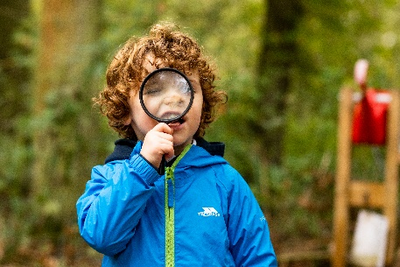
If you are staying in the session to watch please bring a camping chair to sit on, we will have logs however these can be a little uncomfortable for longer periods of time! Please feel free to bring a flask of coffee or tea for yourself and a book to relax into!

Please ensure your childs belongings are clearly named.

What’s app and Facebook
We regularly post pictures on our Facebook page and updates on what we have been up to during our sessions so please do give us a follow! We will only post images of children who have given us consent via the Class for Kids booking page.

We also have a what’s app group for all the parents of each group. We will send a link to this if you would like to join! It is very handy to be able to share messages on and for all the parents to make friends and introduce themselves to each other! Please can we just remind everyone, when sharing images on the what’s app group, please ensure you are only sharing images of your own child.

If you have any questions, please just send us an email! We look forward to welcoming you to our Forest School!

