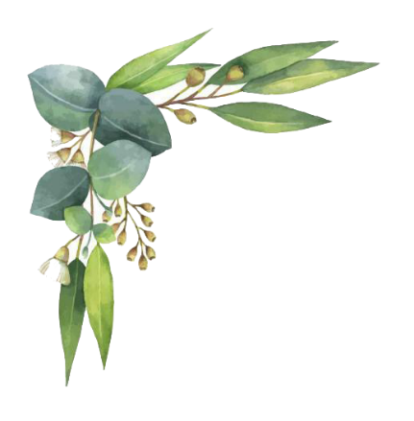
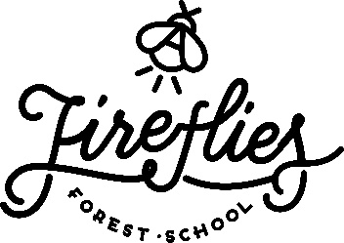

We look forward to welcoming you to celebrate …………………………(please insert birthday childs name) Birthday party on …………………. (Please include the date of party here).
We will have a selection of ropes, hammocks, mud kitchen resources, crafts to explore along with the opportunity to use a fire striker to light their own fire and tools to do woodwork.

Please could you just answer a few questions for us prior to attending:

Childs name: …………………………………..

- Would you be happy for photographs to be taken of your child during the party and shared on our social media pages?

Yes No

- Does your child have any allergies, health conditions or additional needs that we should be made aware of? (If yes please include relevant information below)

Yes No

If you are not remaining on site during the party, please provide an emergency contact name and phone number:

Name:

Phone number:

Please be aware that the party will 100% be outside! The site is muddy and uneven so please ensure your child (and yourself if staying!) is wearing suitable footwear (walking boots preferably or wellies) and warm clothes. Waterproof outer layers are also very helpful if you have them!

