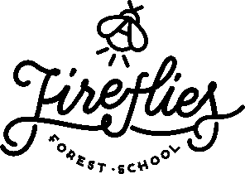

Parent/Carer Handbook: Home Ed Hawks
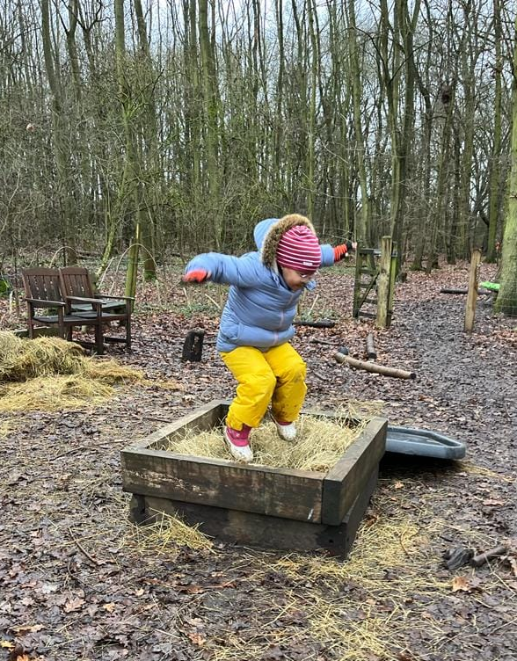
Welcome to the Fireflies community!

We look forward to meeting you and welcoming you into our Forest School provision at Hinchingbrooke Country Park.

This handbook outlines what we do and why we do it. Whether you are a parent, teacher, visitor, staff member or volunteer, this handbook is for you. It will give you an insight into the Fireflies vision and values and it will help you play a meaningful role in our Forest School.
The handbook summarises our most significant polices, with full versions uploaded onto our website, however, if there were any other policies you would like to see please just ask.
If you are unsure of anything that you read here or come across while at the Forest School, please speak to an experienced member of staff who will be happy to support you and answer any questions.

Contact Details
Jessica Brocklebank, 07557 282 113
Enquiries@firefliesforestschool.co.uk
Founded: January 2019
Website: www.firefliesforestschool.co.uk
Facebook: https://www.facebook.com/firefliesforestschoolcambridgeshire
Liability Insurance Policy Number: SALSALIA/J211980/0332/21
Professional Indemnity Insurance supplied by Birnbeck Insurance Services/QBE
Ofsted Registration number: 2725390

General Information

“Forest School is an inspirational process that offers all learners opportunities to achieve and develop confidence and self-esteem through hands-on learning experiences in a woodland or natural environment with trees”.
We are very excited to welcome you to our forest school and hope that over the terms/seasons, your child gets to truly experience the magical environment and learning opportunities the Forest School ethos and environment offers. Once your child is enrolled with us, they are then secured their space for as long as they shall like it and will be automatically re enrolled each term. Please provide us with 1 months’ notice if you are sadly withdrawing your child from the group.

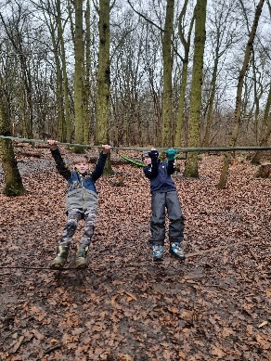
So, what exactly is Forest School?
Forest school is NOT as simple as just spending time playing in the woods (although we do lots of this!). There is much more to it than this. The staff are highly trained in how to set up learning opportunities, how to create invitations of play, how to incorporate nature into everything we do, how to support a child to help develop their self confidence and self-esteem, resilience, independence, risk taking, ability to assess a risk, and much more! It is more about how forest school makes a child feels and what it supports in terms of their personal development rather than what they might make or bring home.

It’s not so much about what activities they are doing while they are at forest school, or what craft they may be making, it’s about the learning process and journey they go through along the way, we are simply there to facilitate and provide these learning opportunities whilst securing positive relationships and connecting as a group. Creating the feel of being part of a community and a sense of belonging is a central part of our group. We want every child to feel that they have a role to play, belong in the group and to accept that each one of us are individual and unique and the importance that everyone is treated fairly and kindly first and foremost.
To really see the benefits and impact forest School can have on your child they need to experience all the seasons and experience the Forest School approach over time, it is a long-term approach.

Learning Environment
Forest School is a specialised learning approach that sits within and complements the wider context of outdoor and woodland education. We aim to create opportunities and facilitate activities which promote and develop the sense of achievement and confidence through nature based learning opportunities. We are all about raising self-esteem and confidence organically!

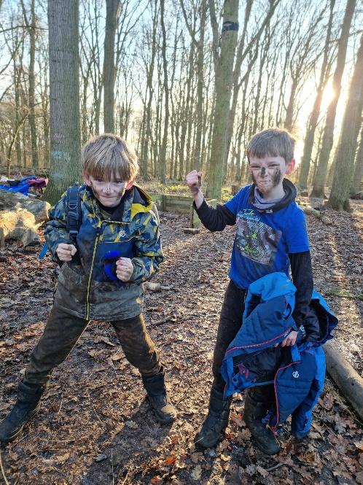
At Forest School all participants are viewed as:
- equal, unique and valuable
- competent to explore and discover.
- entitled to experience appropriate risk and challenge.
- entitled to choose, and to initiate and drive their own learning and development.
- entitled to experience regular success.
- entitled to develop positive relationships with themselves and other people.
- entitled to develop a strong, positive relationship with their natural world.

Forest School principles

Fireflies Forest School is centred on the principles of kindness, democracy and permaculture to provide children with a holistic experience of education. We a member of the Forest School Association and we adhere to the six principles of Forest School.
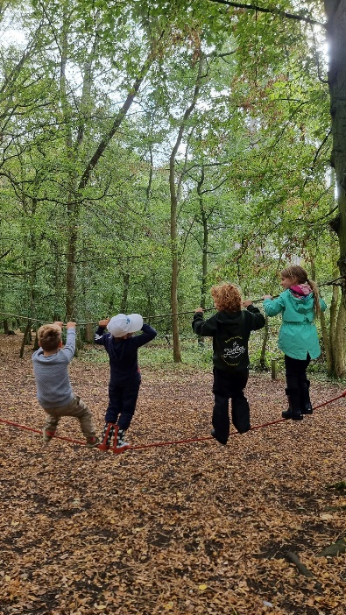
Principle 1: Forest School is a long-term process of frequent and regular sessions in a woodland or natural environment, rather than a one-off visit. Planning, adaptation, observation and review are integral elements of Forest School.
Principle 2: Forest School takes place in a woodland or natural wooded environment to support the development of a relationship between the learner and the natural world.
Principle 3: Forest School aims to promote the holistic development of all those involved, fostering resilient, confident, independent and creative learners.
Principle 4: Forest School offers learners the opportunity to take supported risks appropriate to the environment and to themselves.
Principle 5: Forest School is run by qualified Forest School practitioners who continuously maintain and develop their professional practice.
Principle 6: Forest School uses a range of learner-centred processes to create a community for development and learning

So, what happens at a session?
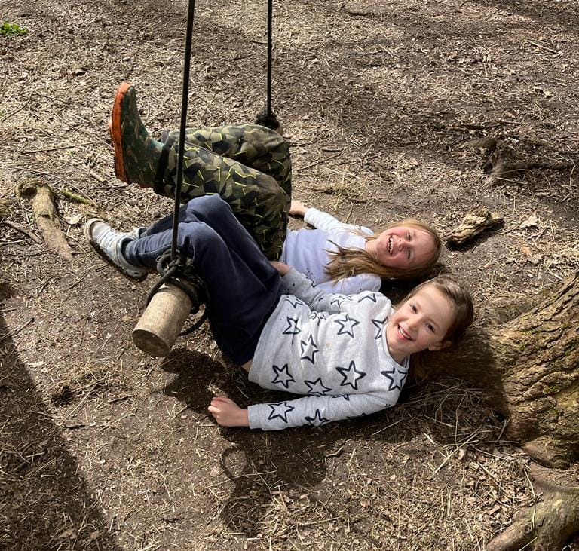
We meet everyone up in the main visitor car park at 10am, some weeks we may go straight into an activity such as a nature walk or scavenger hunt, other weeks we may just head straight to the forest school site.
We start our session all together around the log circle. This is the centre/heart of our site! We sit and chat about any news the children may want to share, what they have been up to over the week and we discuss what resources we have out today and anything they may like to make or do in todays session. Sometimes this part of the session lasts 5 minutes, other days they are keen to chat for half an hour. We take their lead on this. We send the children off to play, build, craft, make, cook etc. There is a high staff ratio in our sessions to ensure that we are able to support the children with whatever it might be that they would like to do that day.

During our Forest School sessions the children choose the activity, location, and length of time they spend on it. Left to their own devices, children are wonderfully imaginative and resourceful when it comes to play. To limit their imagination or to divert their attention towards something you think could be more ‘educational’ may be counterproductive. Therefore, if a child chooses to lay in a hammock, sit and watch others, or repeatedly doing the same activity for a session; this is absolutely fine! If it is what they need at that moment, then there is nothing a child “should” be doing in any given session. Forest school is very much about allowing children just to “Be” rather than “do”.
All of the crafts or tool activities are always optional, and we will let the children decide if it were something they would like to do or not. However we will of course try to plan our activities and tool use around their interests so that they are naturally curious!
Our Forest School setting provides a wonderfully stimulating environment, rich with learning possibilities through observing their natural systems.
Forest School facilitators may set up in advance activities in the woods that will entice children with different interests. The role of the facilitator is to observe, engage but not interfere with the children’s learning. The challenge for the facilitator is to know when to intervene and how, and this is where Forest School training, experience and reflective practice becomes central. Safety is paramount, but managed risks are an essential part of a child’s learning.
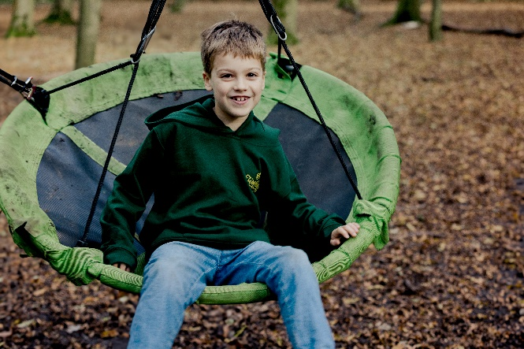
We have a wide variety of tools such as secateurs, Mora whittling knives, Bow saws, folding saws, Hatchet axe, drawer knives, palm drills and more! We will encourage the children to have a go and learn how to use these for various bushcraft activities, however they are optional, and the children can choose if they would like to take part in tool use, it will never be compulsory. Our staff also have skills in other bushcraft activities such as fire lighting, foraging, shelter building, campfire cooking, Ropes and knots, natural navigation, tool making and more!
What your child might do at Home Ed Hawks:
- Learn about nature education and Woodland management
- PLAY!
- Make Friends and feel a sense of community.
- Develop confidence, teamwork, problem solve.
- Explore the mud kitchen.
- Build dens.
- Play on the ropes, swings, hammocks.
- Read stories and explore our sheds.
- Practise using tools such as a saw, drill, knife, mallet etc.
- Fire lighting
- Natural crafts
- Cook on a campfire.
- Singing and musical instruments
- Finish with some mindfulness

And more!
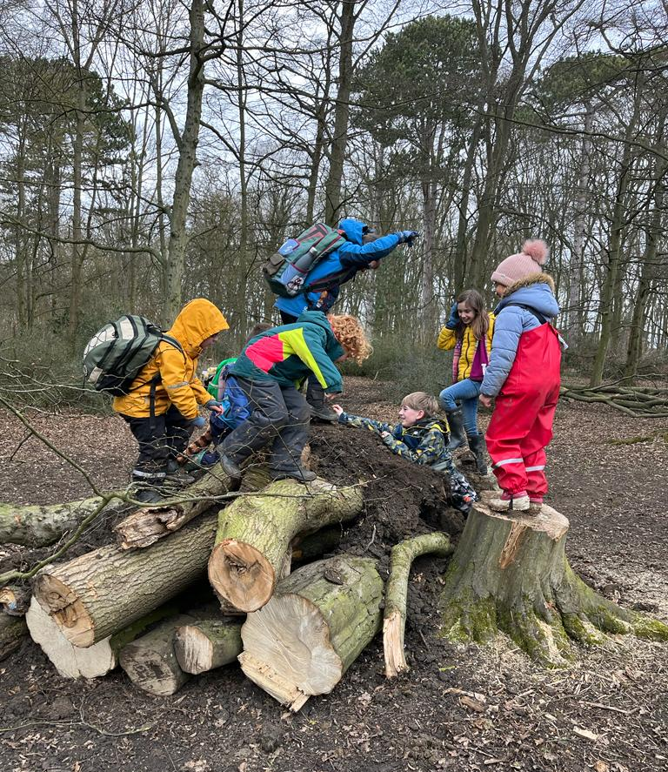
But it is important to remember that the forest school ethos is child led, so we will not impose any activity on them, there isn’t anything specific they should be doing each session! So, if your child wants to spend a session just sitting and watching others, or lying in the hammock its ok! The crafts, tools, and more structured activities are completely optional.

We stop for lunch where the children tuck into their packed lunches and we also cook campfire snacks. The session then ends again around the log circle reflecting on the session and making plans for what they would like to do next week. We then thank the woodland and say our goodbyes, and walk back up to the main visitor car park to meet their parents!
The Team
Jessica Brocklebank owns and manages Fireflies Forest School. She is a qualified Primary school teacher and Level 3 Forest School Leader. Jessica also has qualifications and 19 years’ experience of working with children and young people who are neurodivergent, in the classroom and in a Forest School setting, and feels passionate about forest school being accessible for all.

Leaders and Assistants
At Fireflies we have a wide group of passionate and talented individuals. Many are trained as either a Level-3 qualified Forest School leader, a level 2 forest school assistant or are currently doing their training, more information about each of our staff can be found on our website.
We are so lucky to have such a highly experienced and dynamic team running Home Ed Hawks: Jess, Alison, Anna and Phillipa. We also have other staff on site who may join in with our session who support children who attend our Alternative Provision sessions.
You can read a little more and see photos on our website under the “About Us” section.
Daily Routine
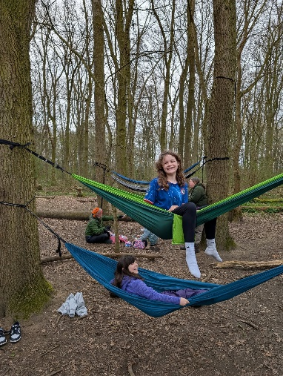
Prior to every session, the Forest School leader will have planned, and risk assessed a forest school session which may link to the current season, a weekly theme or have a nature-based topic.
Before everyone arrives, the Forest School leader and assistant checks the site over and completes a daily site check. The staff and volunteers organise the equipment and ensure that all is in safe working order.
The Forest School Forest School leader briefs the team on the daily plan, based on observations by the team of what the children enjoyed in the previous session.

Most of our sessions will be in our main site, but we have the freedom to move around the woodland, allowing the children to choose alternative spots each week to set up camp if they wish! We can also take them down to the pond dipping area and “big hill”.
Throughout the session, the staff will be observing the children what equipment or resources the child seeks, how their learning could progress, what their interests are, if there are any insecurities or lack of confidence in a particular skill or resource and what influence a particular activity or resource has on a child.
For example, we may notice a child seeks the hammocks at the start of every session to support their emotional regulation or settling in. Therefore, we may then ensure a hammock is always hanging at the start of a session to ensure the child feels comfortable and that we recognise their needs to support them to settle in.
We will also observe personal development such as resilience, self-esteem, independence, teamwork, and perseverance. This is to enable the staff and volunteers to facilitate and support learning to promote and encourage development and reinforcement of these skills in the child/young person.
The staff and volunteers are present to facilitate and support where and if needed. They are not there to direct children or young people to follow their agenda or to instruct the group to engage in a particular activity, they are simply there to facilitate and scaffold learning, but will step back as much as possible.
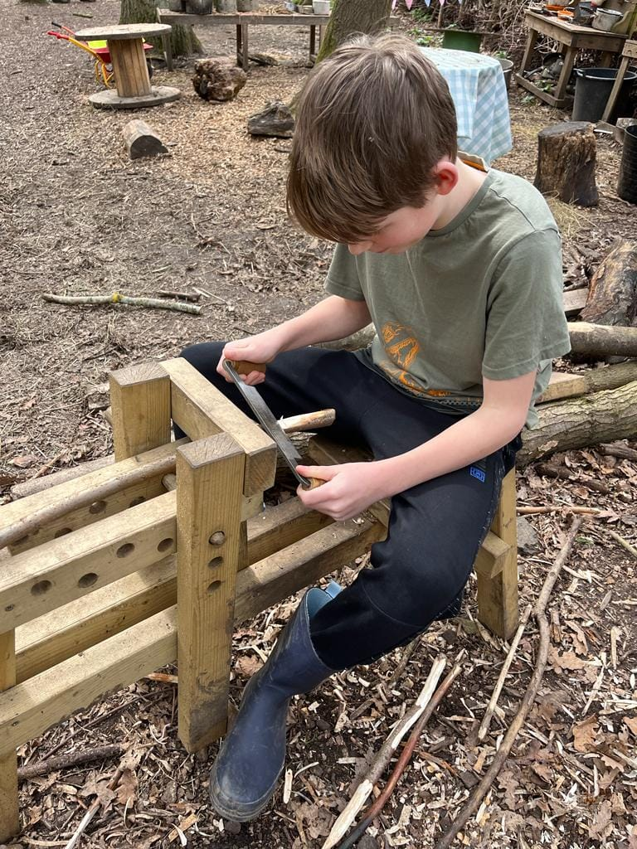
We will prepare a campfire snack together, anyone who would like to help prepare the snack and cook it can do so and we encourage communal cooking. The children will have some more time to play before re grouping for lunch. After lunch we will continue with our activities and play before re grouping at the end of the session, to reflect on the day and to discuss what they would like to do the following week.

Language

In Forest School training there is an extensive amount of time spent on the powerful impact that language can have. Therefore, our staff are trained in how to support your little ones, how to encourage the next step in their learning and how to evoke curiosity and problem solving rather than just providing answers.
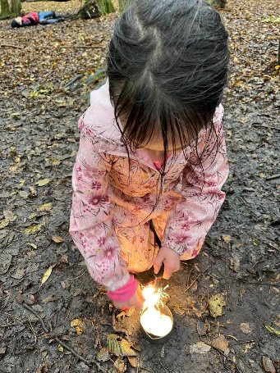
An important thing that we ask, is for you not to describe any weather in a negative way! It can be tempting (and trust us we all fall into this at times!) to say things like “oh the weather isn’t good today”. Although we know some of us are not so keen on the cold or wet days, language can have a huge impact on how your child responds to weather changes, and this will then have an impact on their resilience in the colder or wetter months!
We follow the motto “there’s no such thing as bad weather, just bad clothing”. So, although it may be tempting on the wet and cold days to describe it as miserable or bad weather, some of the children’s most favourite and enjoyable sessions are in the pouring rain! So, saying things like “oh look at all the rain we have today to play in!” or “we can dress really cosy today and run around lots to keep warm”. We always say that the weather always looks worst through the window, and its so true!
Clothing
Please ensure your child is dressed appropriately for the weather. Layers really are the key to keeping your child warm. If they have adequate warm layers, then they should be able to stay warm in any temperature.
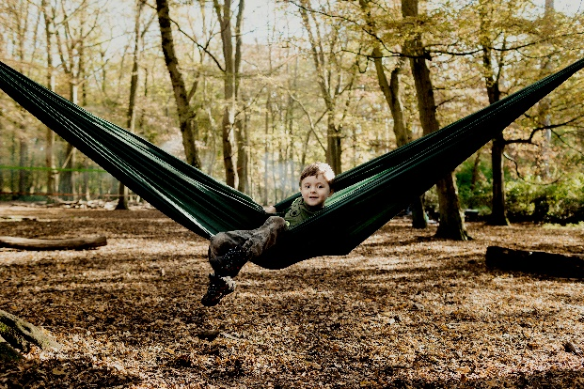
We ask that your child is appropriately dressed so that they can engage in any of our activities or resources without the worry of clothes getting too muddy or wet and for your child not to be restricted due to feeling too cold or too hot. But it is also important to try put them in warm layers that are not super bulky! Some of the snow suits look like they are really warm, but they are so puffy and big that the children are physically restricted!

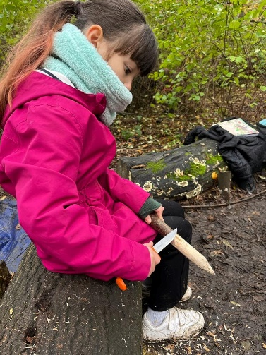
Part of the Forest School experience is that children will be active in the outdoors in all weathers, with the exception of very high winds & thunderstorms. Although we provide shelter using tarps, please assume that your child will be outside when they take part at Forest School, even in heavy rain or snow.

Below is our recommended kit list:
Spring and Summer: We can have some very warm sessions in the summer, although the tree canopy offers lots of shade it is still important to keep the children as cool as possible. Cotton trousers and a thin long sleeved cotton top, sun hat, sun cream. Please avoid shorts as this increases the risk of ticks and also scrapes and grazes.
Autumn and Winter:
Base Layer: Vest or thermal top, tights or thermal leggings
Mid layer: Long sleeved T-shirt top, Fleece top/jumper, Leggings/trousers (preferably a thicker type of material for really cold weeks)
Top layer: for really cold weeks: thicker fleece /jacket
We also recommend your child has a waterproof outer layer, this can be waterproof jacket and trousers, dungarees or an all-in-one suit. Your child may also need gloves or mittens, hats and snoods in the colder months. We advise against scarves due to risks of it getting caught when climbing and swinging.
We also recommend a good pair of warm winter walking socks to keep their feet warm. Walking boots/ walking trainers are recommended over wellies as they keep their feet much warmer. If you do bring your child in wellies, please ensure they have a fleece or warm liner as ordinary wellies, whilst waterproof, are very cold!

Please also ensure all forest school kit is named so that we can return any lost items.

Terms and conditions
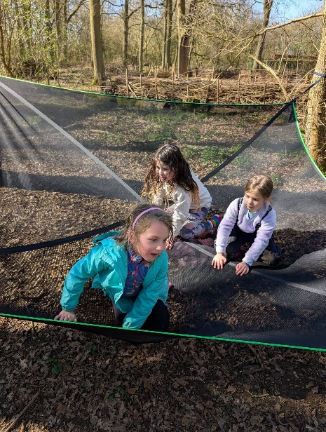
We are really sorry, but we are unfortunately unable to process refunds due to you no longer being able to attend or if you are away one week for illness, holiday etc in order to keep our sessions as affordable as possible as well as having a high staff ratio, we need a steady flow of income each week for the sessions to enable us to cover staffing costs.

Payment for sessions
All sessions must be paid in full online at the point of booking. This can be done by bank transfer or through your class for kids accounts. Your childs space is not confirmed until payment is made. We are happy to have Half termly payments if this helps. We also accept childcare vouchers.

Cancellation due to staff illness
If any of the Fireflies staff are too ill to run the session, we will try to replace them with another staff member to ensure the session can still go ahead. If we are unable to find a replacement the session will be postponed, and we will offer everyone an alternative date to return for their session, credit to next term or a refund.

Cancellation due to extreme weather
Although forest school happens in all weathers, safety will always come first. If there is strong wind or extreme thunderstorms whereby, we feel the session is exposed to unacceptable risk, then the session leader may decide to cancel. There may be occasions where we can offer for you to join alternative sessions which are running on other days or provide you with a credit to next term or a refund will be offered.

Please provide us with 1 months’ notice if you are withdrawing your child from these sessions.

Safeguarding
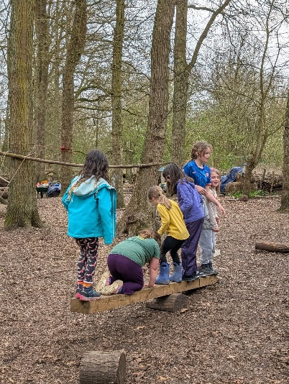
Jessica Brocklebank, Lucy Mutter and Clare Mc Ewan are the Safeguarding Designated Leads at Fireflies Forest School.
​
All members of Fireflies Forest School are fully committed to providing a safe, secure and inclusive environment for all children and parents/carers attending our sessions.

All of our staff undergo Safeguarding training, DBS checks and we follow our safer recruitment policy which includes obtaining references.
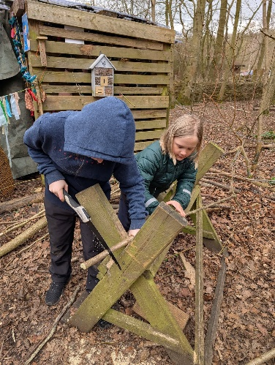
We provide confidentiality in relation to information shared with us by service-users, except in circumstances where a disclosure makes it a legal obligation to share information with appropriate professionals.

If we have a concern about the wellbeing of a child or vulnerable adult attending Fireflies Forest School, we will follow our Safeguarding policy which can be found on our website. If you have any questions or concerns relating to safeguarding in relation to a child or vulnerable adult, then please contact us.

Jessica Brocklebank: 07557 282 113
Lucy Mutter: 07888 642 199

If your child has sustained an injury away from our provision, please just make us aware on arrival and the staff will complete a “Existing injuries Form”.

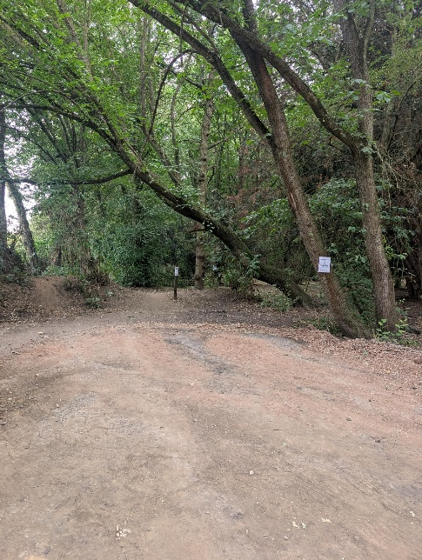
Meeting Point: We will meet everyone in the car park, by the unloading/turning bay just by the woods. We will walk the children back here at the end of the session for collection.
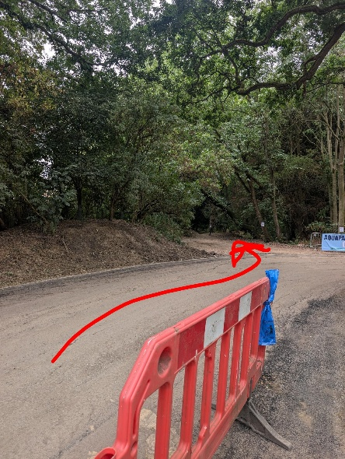
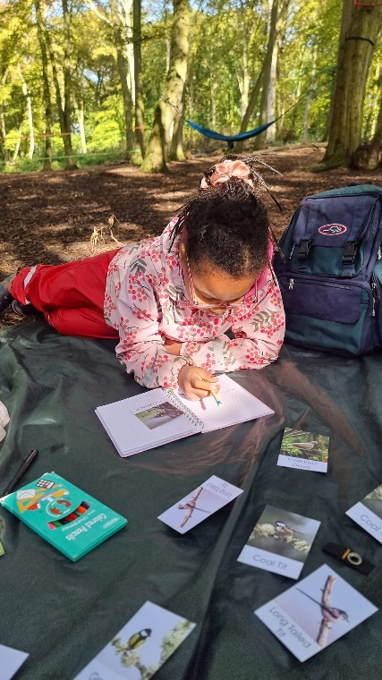
What do I need to bring to a session?

- Each week we will have a campfire snack and drink so please ensure your childs allergy/health info is up to date on class for kids, and make us aware of any allergies.
- Your child will need a packed lunch and water bottle with them. If they would like to bring cans of soup, toasties, food to warm on the fire for their lunch they are more than welcome to!
- Spare set of clothes and socks (just in case!)
- Hand towel for drying their hands after hand washing (although most just wipe their hands on their clothes!)
What’s app and Facebook.
We regularly post pictures on our Facebook page and updates on what we have been up to during our sessions so please do give us a follow! We will only post images of children who have given us consent via the Class for Kids booking page.

We also have a what’s app group for all the parents of each group. We will send a link to this if you would like to join! It is very handy to be able to share messages on and for all the parents to make friends and introduce themselves to each other.
Please can we just remind everyone, when sharing images on the what’s app group, please ensure you are only sharing images of your own child unless you have consent from the other parent. Also, if you have an important message to pass onto the staff, please do this via email or direct Whats App message rather than on the groups as they can easily be missed.
Click to join the parent whats app group here: https://chat.whatsapp.com/DU0RT3J4BnJGtmb0ROVevl

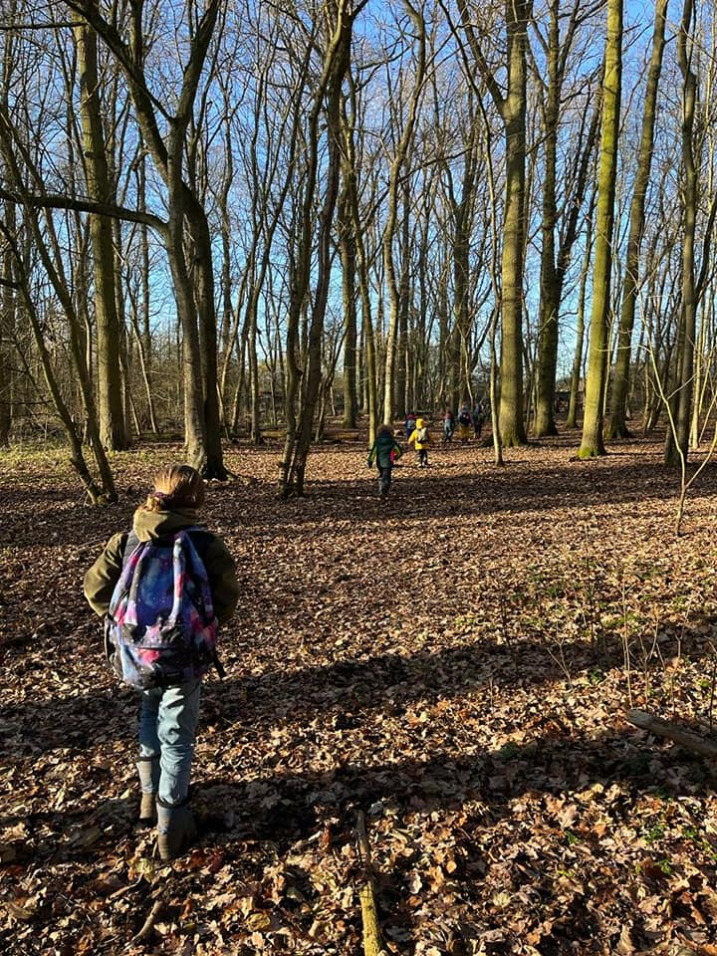
If you have any questions, please just send us an email! We look forward to welcoming you to our Forest School!

