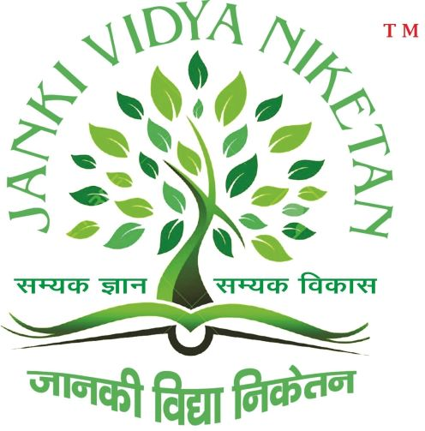
Name of the course applied for

1. Name in full
(In block letters)
(a) Father's/Husband's Name
(b) Mother's Name

2. Sex:

5. (a) Present Address
(to which communication
should be sent)
Telephone/Fax/E-mail

(b) Permanent Address (if
different from above)
Telephone/Fax/E-mail

6. Date of Birth

- Place of Birth

- Are you a member of
OBC/SC/ST/PH?

Place:

Date:

JANKI VIDYA NIKETAN
Sitanagar, Near P.W.D (I.B) Rajopatti, Sitamarhi Bihar

APPLICATION FORM

Affix a recent
Passport size
Photograph here

:

: Mr./Ms.
:
:
3. Nationality: 4. Marital Status:

:

:

:

:

: _______ ___________ ________ (In words_________________
Day Month Year
: )
: ___________________ District _______________ State _________________
: OBC SC ST PH
Sub-Caste:-
(Please attach Certificate from the Competent Authority. In case of OBC candidates, valid non-creamy layer certificate issued in the last financial year should be attached.

DECLARATION BY THE APPLICANT

I hereby declare that all statements made in this application are true, complete and correct to the best of my knowledge and belief.

Signature of the Applicant

