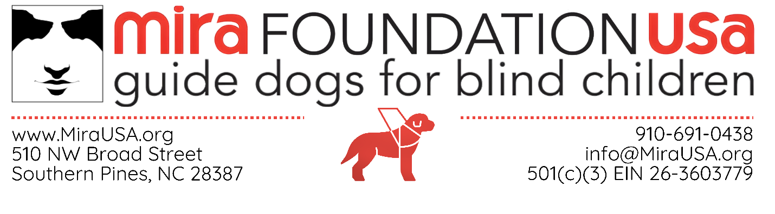
Orientation & Mobility Publicity Release Form
- I hereby irrevocably grant to MIRA Foundation USA, Inc. and Foundation Mira, and those acting with their authority, the unrestricted, absolute, perpetual, worldwide right and license to use my name, location, photograph, likeness, voice, biographical and personal background information, and statements as well as any film, video or audio recording that may be taken of me (collectively, the “Content”), without further compensation, consideration, or notice or permission to me or to any third party, and to reproduce, copy, modify, create derivative works of, display, perform, exhibit, distribute, transmit or broadcast, publicity or otherwise, and otherwise use and permit to be used the Content or any part thereof, whether alone or in combination with other materials (including but not limited to text, data, images, photographs, illustrations, and graphics, video or audio segments of any nature), in any media or embodiment now known or hereafter developed (including, but not limited to, any format of any computer-based, Internet-based, electronic, magnetic, digital, laser or optical-based media), in connection with any promotion, publicity, solicitation or fundraising activities or materials.
- I, on behalf of myself, my heirs and executors, and any other persons who may take by or through me, hereby release and forever discharge MIRA Foundation USA, Inc. and Foundation Mira and their respective promotional agencies and officers, directors, and employees from and against any and all liabilities for any and all claims, demands, losses and liabilities that I may now or hereafter be entitled to assert based on publicity rights, privacy rights, personality rights, “moral rights” or defamation.
- Any and all disputes (except the enforcement of an arbitration award hereunder) arising out of the terms of this Publicity Release shall be settled exclusively by binding arbitration, to be conducted in Pinehurst, North Carolina, in accordance with the North Carolina Revised Uniform Arbitration Act (“NCRUAA”); provided, however, that, if the Parties are unable to select an impartial and neutral arbitrator withing ten (10) days of the initial demand for arbitration, the court shall select an arbitrator who is a member in good standing of the North Carolina State Bar with a minimum of fifteen (15) years of experience in the substantive law applicable to the subject matter of the dispute to be arbitrated. The arbitrator shall determine the arbitrability and shall give effect to applicable statutes of limitation in determination of claims.

O&M Instructor Signature | Click or tap here to enter text.
Date | Click or tap to enter a date.

