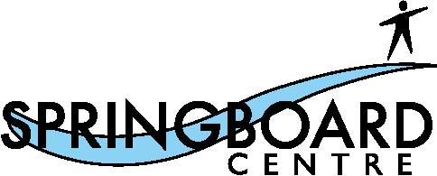

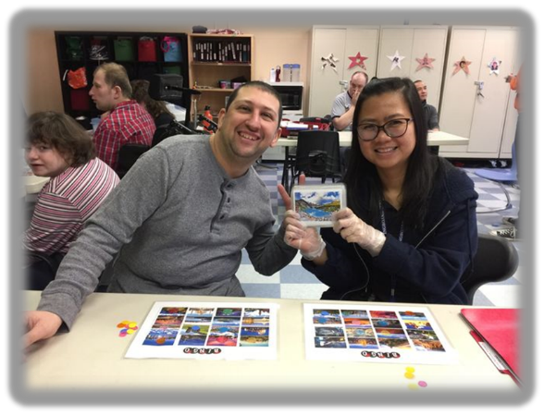

SOCIAL SKILLS PROGRAM
August & September 2019

We will begin our first session of Social Skills Programs on August 23, 2019. This session will also run on August 30 and September 6, 2019.

Painting with Friends
Fridays, 10am – 11:30am, August 23, 30, & September 6, 2019
Cost: $20
This class is designed for all abilities. You will be introduced to paint brushes, painting techniques, and canvases that will make your creative ideas come to life in the form of beautiful paintings! Please bring your bag lunch or a snack to enjoy. You can eat and visit with other participants while the paintings dry. All painting materials are included in the cost of registration.

The Beautiful Art of Henna
Fridays, 1pm – 2:30pm, August 23, 30, & September 6, 2019
Cost: $20
This class is designed for all abilities. Come to socialize and learn all about the ancient art of Henna tattooing! Refreshments will be served during each class, but feel free to bring your own snack. All materials are included in the cost of registration. *Please note, Henna ink includes the following ingredients:lawsonia, eucalyptus oil, turmeric,saffron, clove oil and distilled water.
While the ink is temporary and is only applied to the surface of the skin, it may not be suitable for those with skin sensitivities or allergies.

Card Making Fun
Fridays, 1pm – 2:30pm, August 23, 30, & September 6, 2019
Cost: $15
This class is designed for all abilities. Come meet new friends while you learn to create fun, artistic, and handmade cards. The cards you create can be customized for birthdays, special events, and as a thank you for someone you care about. Enjoy refreshments and socialize with others while the cards set. All materials are included in the cost of registration.
Registration Starts: Tuesday, August 6, 2019 Ends: Monday, August 19, 2019. If you have any questions or would like to register, please contact Marc Dunca or Edina Campbell at 403-248-7071. Spaces are limited and will be available on a first come, first serve basis. All classes will be at Springboard Centre. Classes are open to adults with developmental disabilities (with their support workers, if applicable). Support workers will be expected to assist their clients as needed. SBC is a nut free area, so please refrain from bringing any form of nuts or nut spreads into the facility. Thank you for your cooperation!

