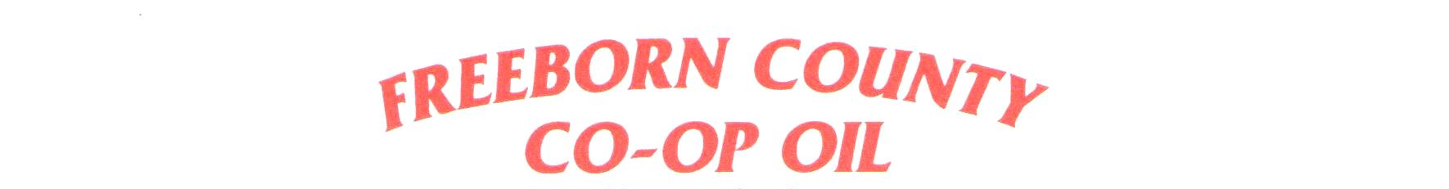
2024 Mini-Grant Program

DEADLINE: August 31, 2024

SPONSORED BY:
Freeborn County Coop Oil Co.

2024 Mini-Grant Program
WHO MAY APPLY FOR THESE GRANTS?
Any school or non-profit organization.
HOW MUCH ARE THE GRANTS?
Mini-Grants in the amount of $500 each will be given in 2024.
HOW WILL THE APPLICANTS BE JUDGED?
All applications will be reviewed and approved by our Board of Directors.
EACH PROPOSAL MUST INCLUDE THE FOLLOWING INFORMATION:
- The name and address of your school district/organization.
- The name of person submitting the application.
- A brief description of your project/what the funds will be used for and why it is important to your school/organization.
- Form 501(c)

MAIL OR EMAIL YOUR ENTRY TO:
Freeborn County Coop Oil
Attn: Amanda Garvick
1840 Margaretha Ave
Albert Lea, MN 56007
amanda@freeborncountycoop.com

Grant Proposal Cover Sheet

School/Organization Name:
Address:

City: State: Zip:

Phone:
E-mail:

Name of person submitting application:
Phone:

Please attach the following:
- A brief description of your project/what the funds will be used for and why it is important to your school/organization.
- Form 501(c)
Entries are being accepted through August 31, 2024.
MAIL YOUR ENTRY TO:
Freeborn County Coop Oil
Attn: Amanda Garvick
1840 Margaretha Ave
Albert Lea, MN 56007

