SOME COMMON SYMPTOMS OF LYME DISEASE (Early stages)
- Flu-like symptoms (fever, chills, muscle aches, joint pain, sweating, fatigue, nausea, etc.)
- Facial drooping/Bell’s palsy
- Headache and eye pain
- Stiff neck
- Sleep issues
- *Rash-If a rash is present, most Lyme rashes, called an EM(erythema migrans)Rash are not typical, like the more well-known, bull’s eye, EM rash. (Please see the examples of atypical Lyme rashes, which many times can be faint, discolored, irregular in shape, and even will resemble a bruise, pimple with a sore, blister, ringworm, insect bite or cellulitis. Rashes can appear on many sites on the body, and sometimes cannot be readily noticed on places like the head, under arms or back. Area of possible bite may be warm to the touch.) https://www.lymedisease.org/lyme-rash-not-always-bulls-eye/and https://www.bayarealyme.org/blog/lyme-disease-bullseye-rash/

CHRONIC LYME and Some Common Symptoms in Adults
Even Lyme disease that is treated early can turn into late-stage or chronic infection, with lingering symptoms. Because Lyme can exist in a body with ‘other’ infections/co-infections, pathogens and diseases, this will inevitably complicate the process, giving way to a chronic situation.
- Muscle Pain and Joint Pain
- Face and or body swelling
- Unexplained rashes, sores, lesions, bruises, cysts or skin issues
- Extreme hair, tooth or nail loss
- Extreme and constant jaw and/or ear pain
- Eye floaters and unexplained vision problems
- Unexplained sensitivity to light and sound
- Constant Sinus pressure
- Flu-like Symptoms-on and off
- Unexplained shortness of breath or wheezing
- Tail bone pain
- Inability to stay sitting or standing
- Vertigo
- Prolonged or unexplained fainting, seizures, shaking or dizziness
- Brain Fog and/or memory loss
- Unexplained sweating or inability to sweat
- Headache and eye pain
- Heart palpitations, or pains, irregular heartbeat or abnormal ekg’s
- Sleeping issues and or extreme fatigue
- Anxiety
- Depression
- Neuropathy, tingling or burning in hands or feet
- Chest Pains, breathing issues
- Nausea, vomiting, unexplained stomach pain
- Unexplained weight gain or loss
- Incontinence
- Bladder, kidney, or liver pains
- Lightening pains (pains that shoot up or down your body)
- Frequently getting lost while driving
- Trouble swallowing and/or frequent choking or gagging
- “Bugs crawling’ sensation on legs or other body parts
- Unexplained bleeding
- Chronic swollen glands

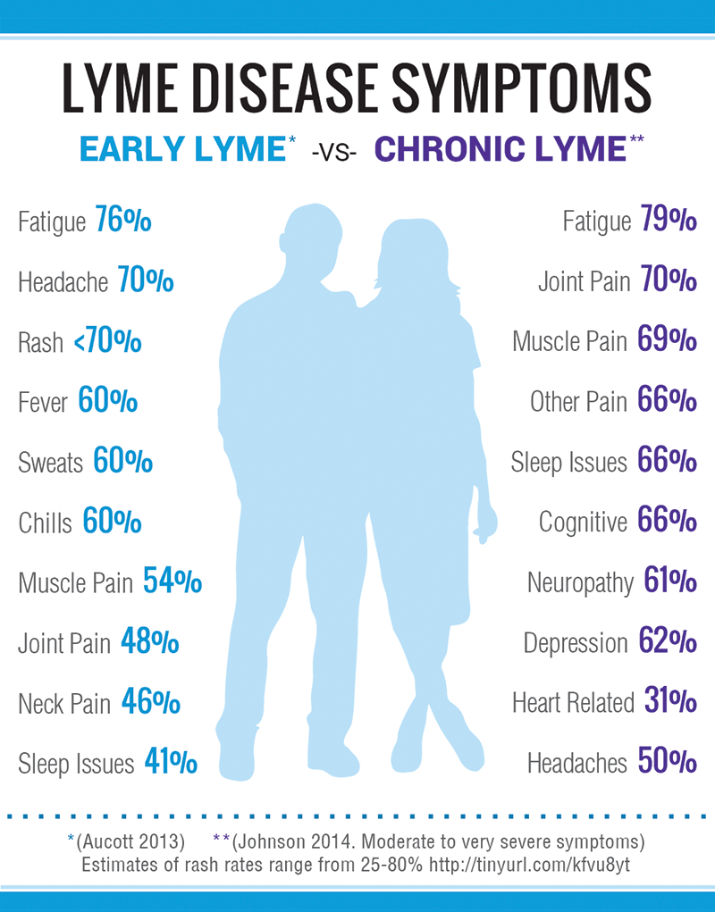

Chronic Lyme Symptoms in Children/Adolescents
*Source: Dr. Charles Ray Jones, Pediatric Lyme Specialist
- severe fatigue, unrelieved by rest
- insomnia
- headaches
- nausea, abdominal pain
- impaired concentration
- poor short-term memory
- inability to sustain attention
- difficulty thinking and expressing thoughts
- difficulty reading and writing
- being overwhelmed by schoolwork
- difficulty making decisions
- confusion
- uncharacteristic behavior
- outbursts and mood swings
- fevers/chills
- joint pain
- dizziness
- noise and light sensitivity
For additional information please visit-
https://www.lymedisease.org/lyme-basics/lyme-disease/children/

