Surf And Turf Adventure Camp Waiver and Release Contract

- I___________________________________________ (Name of the Participant) and
_______________________________________________ (If Participant is a minor, name of signing parent or guardian) acknowledge that I want to participate in recreational activities with Surf and Turf Adventure Camp Inc. Such activities include but may not be limited to Hiking,
Indoor and Outdoor Swimming, Overnight Camping, Indoor Rock Climbing, Paintball, Zoo Visits, Batting Cages, Bike Riding, Canoeing, Tubing, Rafting, Transportation to and from events, (this includes public transportation) Out of State Hikes, and Playground Horseplay.

- I understand that the activity (ies) I (my child) will participate in has associated risks and dangers, and that I (my child) could be injured, or die as the result of such risks and dangers and my participation in the activity (ies).

- I give my consent to the Surf and Turf staff, employees, directors, agents, and members (who are certified in First Aid and CPR), permission to aid my child until EMS services are available if I am not present to give consent for my child during an emergency.

- In consideration of my (my child) being permitted to participate in the above-described activity (ies), I agree to assume all risks, including both inherent and non-inherent risks, and all responsibility for myself, (my child) for any injuries, which may result from my participation in such activities.

- I further agree to release, indemnify, defend and hold harmless Surf and Turf Adventure Camp Inc., its employees, directors, agents, and members, from any and all liability for any damage or injury, cost or expense to my person (my child) (including death) and/or my property which may result from my participation in the above-described activity (ies), whether resulting from, strict liability, or some other cause.
- I agree not to sue or otherwise make a claim against Surf and Turf Adventure Camp Inc., its employees, agents, members and directors for any injury, death, loss or damage to myself resulting from the acts, omissions, of Surf and Turf Adventure Camp Inc., its employees and in the above-described activity (ies).

- I understand that all participants will be responsible for self -administering all regularly prescribed medications. Surf and Turf Adventure Camp Inc., its employees, agents, members, and directors will not be responsible for administering regularly prescribed medications.

- I also agree that if my child/children use foul language, narcotics, controlled substances such as alcohol, uses cell phones improperly or inappropriately, makes sexual comments or engages in sexual or hostile behavior towards anyone, or simply does not follow instructions from an adult, he/she/they will be sent home and not allowed to return.

- Surf and Turf Adventure Camp Inc., its employees, agents, members, and directors reserve the right to dismiss a participant for any reason which jeopardizes the safety of other campers.

- I agree that the terms of this contract shall also be binding as to my (my child’s) heirs,
personal representatives, and administrators.

- I understand that this is a contract that limits my child’s legal rights and that waives and releases Surf and Turf Adventure Camp Inc., from responsibility and blame in the event I (my child) am (is) injured participating in the above-described activity (ies).

- I hereby certify I have read, understand, and agree to this contract.

_______________________________________ Participant’s signature

_______________________________________ Parent or Guardian Signature

FORM MUST BE COMPLETED AND RETURNED TO US FOR YOUR CHILD TO ATTEND CAMP.

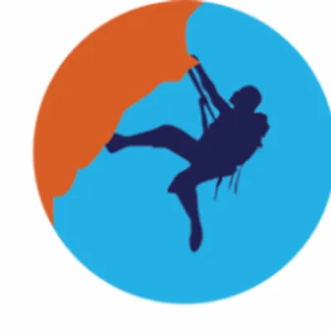
Waiver of Liability

Relating to Coronavirus/COVID-19
Surf and Turf Adventure Camp has created preventative measures and enhanced cleaning protocols to reduce the likelihood of spreading COVID-19. Surf and Turf cannot guarantee that you or your child will not become infected with COVID-19. Attending this camp session could increase your child’s risk of contracting COVID-19. I acknowledge the contagious nature of COVID-19 and voluntarily agree to my child’s participation. I assume the risk that my child, myself, and other family members may be exposed to or infected by COVID-19 by attending the camp and activities at Surf and Turf. Exposure or infection may result in personal injury, illness, permanent disability, or death.
I voluntarily agree to assume all risks and accept responsibility for any injuries that I, my child and our family may experience or incur in connection with my child’s attendance at Surf and Turf Adventure Camp.
On my behalf, and on behalf of my child, I hereby release, covenant not to sue, discharge, and hold harmless Surf and Turf Adventure Camp, its employees, volunteers, agents, and representatives, of and from the Claims, including all liabilities, claims, actions, damages, costs, or expenses of any kind arising out of or relating thereto.
I understand and agree that this release includes any Claims based on the actions, omissions or negligence of Surf and Turf Adventure Camp, its employees, volunteers, agents, and representatives, whether a COVID 19 infection occurs before, during or after participation in a summer camp program.
____________________________________________
Camper Name (print legibly)
_______________________________________________________
Name of Parent/Guardian (print legibly) Relation to Camper (print legibly)
________________________________________________________Date___________Signature of Parent/Guardian

