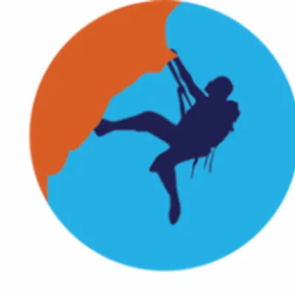
Waiver of Liability

Relating to Coronavirus/COVID-19
Surf and Turf Adventure Camp has created preventative measures and enhanced cleaning protocols to reduce the likelihood of spreading COVID-19. Surf and Turf cannot guarantee that you or your child will not become infected with COVID-19. Attending this camp session could increase your child’s risk of contracting COVID-19. I acknowledge the contagious nature of COVID-19 and voluntarily agree to my child’s participation. I assume the risk that my child, myself, and other family members may be exposed to or infected by COVID-19 by attending the camp and activities at Surf and Turf. Exposure or infection may result in personal injury, illness, permanent disability, or death.
I voluntarily agree to assume all risks and accept responsibility for any injuries that I, my child and our family may experience or incur in connection with my child’s attendance at Surf and Turf Adventure Camp.
On my behalf, and on behalf of my child, I hereby release, covenant not to sue, discharge, and hold harmless Surf and Turf Adventure Camp, its employees, volunteers, agents, and representatives, of and from the Claims, including all liabilities, claims, actions, damages, costs or expenses of any kind arising out of or relating thereto.
I understand and agree that this release includes any Claims based on the actions, omissions or negligence of Surf and Turf Adventure Camp, its employees, volunteers, agents, and representatives, whether a COVID 19 infection occurs before, during or after participation in a summer camp program.
____________________________________________
Camper Name (print legibly)
_______________________________________________________
Name of Parent/Guardian (print legibly) Relation to Camper (print legibly)
________________________________________________________Date___________Signature of Parent/Guardian

